Aligned to the following standards: AG-NR2; CS.03, CS.04; NRS.02; FFA.PL-A; FFA.CS-N; CCSS.ELA.RI.9-10.2; CCSS.ELA.RI.9-10.4; CCSS.ELA.L.W.9-10.7; CCSS.MP3; CCSS.MP6; CCSS.ELA.W.9-10.1; CCSS.ELA.W.9-10.4; CCSS.ELA.L.9-10.6; CRP.02; CRP.04; CRP.05; CRP.07; CRP.08
Appendix 7: Ag101: Water
Part 1
Directions: Read the article “Ag101: Water” in the fall/winter 2025 edition of FFA New Horizons and answer the questions below.

- According to the article, what are four ways that water affects the food we eat?

- Record the following figures from the article.
Total Number of Irrigated Farms | Total Number of Irrigated Acres in the U.S.

- Using the numbers above, calculate the average number of irrigated acres per farm.

- What is the average amount of water applied per acre in the U.S.?

- One acre-foot of water contains 325,851 gallons of water. Using that number and the number from Question 4, what is the average number of gallons of water applied per acre in the U.S.?

- Using the map below, color in and label the top five states with the greatest number of irrigated acres (in red) as well as the state that applied the most water per acre (in blue).
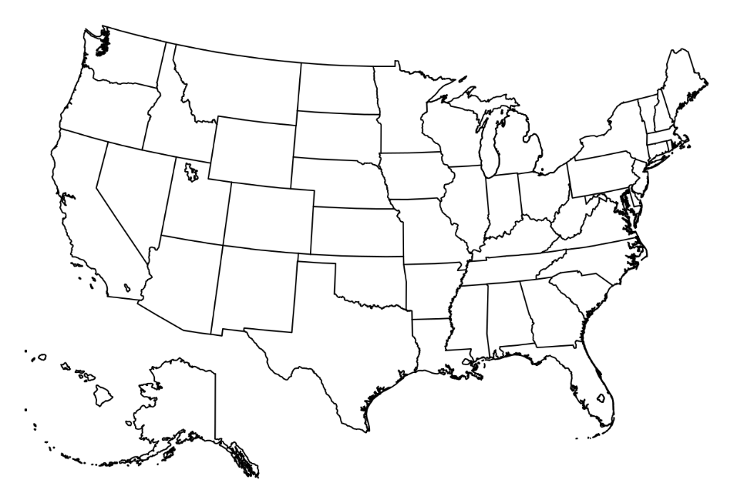

Part 2
Directions: Use the “Water Footprint of Food Guide” website (https://watercalculator.org/water-footprint-of-food-guide/) to complete the activity below.

- Select one food item from each size of water footprint (small, medium and large) and record information about them in the table below.
Food Name | Serving Size | Gallons of Water Required per Serving | Water Footprint Percentages
Food Name | Serving Size | Gallons of Water Required per Serving | Blue Water | Green Water | Gray Water

- What patterns do you notice about the types of foods that have large water footprints compared to foods with smaller ones?

- Which food item surprised you the most based on its total water use? Why?

- Are plant-based or animal-based foods generally more water-intensive? Why do you think this is the case?

- If a person were to eat one serving of each of the foods you listed above every day, how many gallons of water would be required to produce that food for a whole year?
- Does putting water use in that perspective cause you to think differently about the foods you eat?
Why or why not?

Part 3
Directions: Analyze your own water footprint based on the foods you eat. Use the “Water Footprint of Food Guide” website (https://watercalculator.org/water-footprint-of-food-guide/) to complete the activity below.

Using the foods on the “Water Footprint of Food Guide” website, record foods you might eat on a typical day for breakfast, lunch and dinner. Record the food, serving size, number of servings and gallons of water required to produce the foods you eat for each meal. Then answer the analysis questions.

Breakfast
Food Item | Serving Size | Number of Servings You Would Typically Eat | Gallons of Water to Produce One Serving | Total Gallons of Water to Produce Your Serving
TOTAL:

Lunch
Food Item | Serving Size | Number of Servings You Would Typically Eat | Gallons of Water to Produce One Serving | Total Gallons of Water to Produce Your Serving
TOTAL:

Dinner
Food Item | Serving Size | Number of Servings You Would Typically Eat | Gallons of Water to Produce One Serving | Total Gallons of Water to Produce Your Serving
TOTAL:

How many total gallons would be required to produce all three meals for the foods you listed above?

Analysis Questions:

- What other foods might you typically eat that were not listed on the website? (List three.)

- Using what you know about the water it takes to produce other foods, estimate how many additional gallons you think it would take to produce the foods you listed in Question 1.

- Were you surprised by the amount of water it takes to produce your food? Why or why not?

- Assuming you would eat similar foods each day, how many gallons of water would it take to produce a year’s supply of food for you?
- Using the numbers from Question 4, how many gallons would it take to produce a year’s supply of food for your entire household?

- Based on your findings, would you consider changing any of your food choices to conserve water?
Why or why not?

- How do you think agriculture producers could work to ensure the water they are using to produce food is being used as efficiently as possible?

- What do you value more when making food choices (cost, taste, health or sustainability)? How does water use factor into this?

