Building a Responsible Textile Supply Chain
Aligned to the following standards:
CS.01; CS.04; CS.06; FFA.PL-A; FFA.PL-C; FFA.PL-E; FFA.PL-F; FFA.PG-I; FFA.PG-J; FFA.CS-N; AG1: AG4; AG6; CCSS.ELA.RI.9-10.4; CCSS.ELA.SL.9-10.2; AFNR Career Cluster, Statement 3; AFNR Career Cluster, Statement 7; CRP.02; CRP.04; CRP.05; CRP.07; CRP.08; CRP.11
Part 1
Directions:
Read the article “Building a Responsible Textile Supply” found at https://www.ffa.org/ffa-new-horizons/building-a-responsible-textile-supply-chain/. Complete the following activities to learn more.

Now that we have defined sustainability, how would you explain sustainability to a friend or family member?
Using a dictionary or dictionary.com, define sustainability.



What role does sustainability play in the agriculture industry?

What is a “textile”?


_____________________ practices are just one piece of the puzzle.
_________________ want to know what they are contributing to.
So farmers know how their ______________ are being used.
There is an expectation that brands are doing their part in ______________________ ______________________.

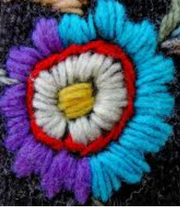
Describe textile exchange here and complete the bubbles below:

In your own words, identify how a consumer like you can impact textile sustainability.
In your own words, describe why the standards mentioned in the article are so important.
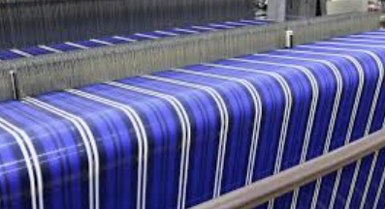
Some examples of requirement standards:
No _________ farming.

________________ grazing.
Use of ________________ content.
________________ protections.

Part 2
Directions:
The textile industry plays a very large role in the economy. Today, we are going to continue to learn about the industry. Follow the steps below to learn more about this important industry.
Find two more articles of clothing and record their material(s) below. Write the clothing item on the line and the material(s) below. (Ex. two more shirts)
Item 2: ______________________
Item 3: ______________________
Look at the tag on your shirt, and write down the material that was used to make it. Include the name of the material and the percentage. (Ex. 100% cotton)
Why is cotton such a common material used for clothing? Why might synthetic materials be used?
In red, circle the materials that are NOT synthetic.
(Ex. cotton)
In purple, circle the materials that are synthetic.
(Ex. polyester)
In green, highlight the materials the items have in common.
(Ex. rayon)

Part 3
Directions:
Follow the steps below to further explore the textile industry from field to shirt. Using the Crop to Campus website from Hanes and complete the following activities.
Watch Crop to Campus Episode 1 and answer the following questions.

- What school do the students attend? __________________________________________________

- What connection does the textiles industry have with the agriculture industry?

- Why do you think Hanes is inviting these students to follow their production process?
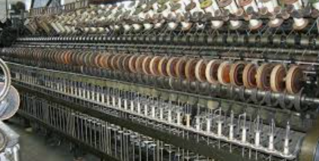


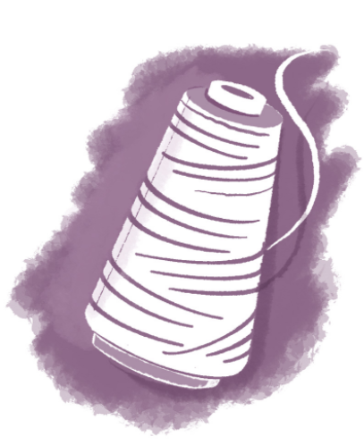

Watch Crop to Campus Episode 2. What is the first step to producing a cotton shirt? C_________________ P______________________

- What role do farmers play in producing a sustainable product? Give examples.
1
Watch Crop to Campus Episode 4. What is the next step in the production process?
K_______________________, C________________________ and S_____________, D____________________.

- To what country does Hanes send their yarn for this step?
_____________________________
- What did you find most surprising about this step of production?
3
Use your research skills and history knowledge to answer this question: Who invented the cotton gin?

_______________________
Watch Crop to Campus Episode 3. Once cotton leaves the farm and is cleaned, what is the next step? S___________________________g

- Describe the way that cotton is turned into yarn.

- What did you find most surprising about this step of production?

- How does Hanes ensure they are being sustainable during this step in the process? Why is this so important?
2
Is cotton grown in your state? Circle your answer.
Yes No

Why/why not?
Watch Crop to Campus Episode 5.

- What does Hanes do to support their community?

- What are two programs provided by Hanes to support their employees?
(1)

(2)

- How is water quality maintained at the facility? Why is water quality important?

4
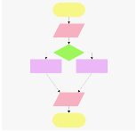

Example of what a flow chart can look like:
Think about the process you just learned for turning cotton into shirts. Use the space below to develop a flow chart that depicts the process. Each step in the process should include a label of what is happening (Ex. sewing), a brief description and an image. If needed, revisit the Crop to Campus videos to ensure you have all the steps in the process.
Watch Crop to Campus Episode 7.

- What did the students say was the most important thing companies need to do for the future generations? Be T______________________.
- What do you think about the production process of a T-shirt now that you have seen the entire process?

- What would you tell someone about the textile industry now that you have been behind-the-scenes for each step of the T-shirt production process?

5
Why do you think these programs are important?
Part 4
Directions:
There are many steps in the production of a cotton T-shirt. In the agriculture industry, we have an Agriculture, Food and Natural Resources (AFNR) Value Chain that outlines the industry from start to finish. Using the chart of the AFNR Value Chain below, read the descriptions and draw a line from each step of the T-shirt production process (listed below) to the correct step in the value chain.
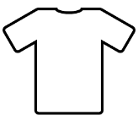
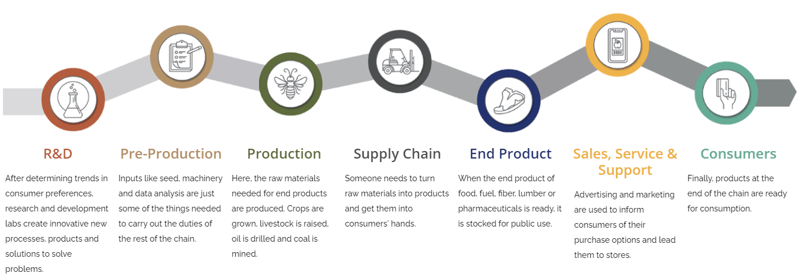
Think about the production process and what you have learned and then design a new T-shirt that could be used to share the story of farm-to-product for cotton shirts.
Front
Back
Complete the following statement: What I have learned about the textile industry is …”
Dyeing the Yarn Cotton Production Cleaning the Cotton Sewing Cutting Spinning

Knitting Purchasing the Cotton Seed Shirts Delivered to Suppliers Buying a New Shirt

