From Milk to Market
Aligned to the following standards: FFA.PL-A1; FFA.PL-A3; FFA.PL-A4; FFA.PL-C1; FFA.PL-C2; FFA.PL-F1; FFA.PL-F5; FFA.PG-I1; FFA.PG-J1; FFA.PG-J2; FFA.PG-J3; FFA.CS-N1; CCSS.ELA-RI.9-10.1; CCSS.ELA-RI.9-10.4; CCSS.ELA-RI.9-10.7; CCSS.ELA-W.9-10.1; CCSS.ELA-W.9-10.2; CCSS.ELA-W.9-10.4; CCSS.ELA-W.9-10.7; CCSS.ELA-W.9-10.8; CCSS.ELA-W.9-12.9; CRP.06; CRP.07; CRP.08

Part 1
Directions:
Answer the questions below as you watch the video “Dairy Goat Facility SAE,” available at https://vimeo.com/showcase/11832322?video=1108210299.

- Describe the school-based enterprise highlighted in the video in two or three sentences.

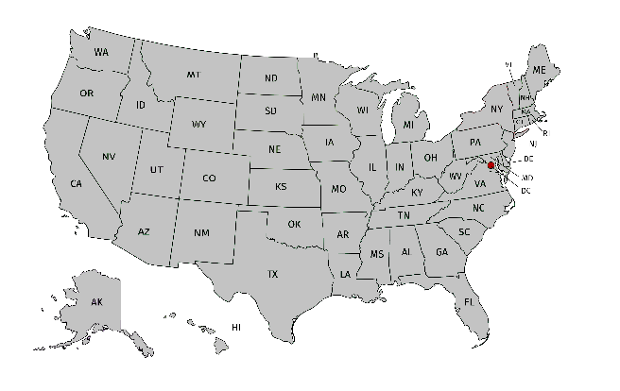
- What state are the students in the video from? Draw a star on the map.

- Who is the dairy goat facility at the school open to?

- What is the dairy goat herd used for in agriculture class?

- What role does the livestock committee play?

- What would happen if this committee didn’t exist?

- What has this SAE taught Paisley?

- List the daily tasks and responsibilities these students have, and write how that task/responsibility will help them in the future.

- What product do students create from goat milk?

- Check all of the tasks that they use the white board to track:
Vaccinations | Milking | Kidding | Dehorning | Weight
Grooming | Hoof Trims | Deworming | Feeding | Pen Cleaning

- Why does Savannah think students should join FFA?

- What does Paisley say about the bonds she’s made in FFA?

- Why is Cheyenne proud to be in agriculture and FFA?

Part 2
Directions:
Let’s dive deeper into the by-products that can be processed from goat milk. Research the by-products to complete the chart, then answer the questions.

Pre-Thinking
- What dairy products do you normally see in your grocery store that are made from cow’s milk?

- Do you think some of those products can be made with goat’s milk? Why or why not?

Inquiry Chart – Goat Milk Products
Goat Milk Product | How Is It Made? | Common Use | Interesting Fact
Yogurt/Kefir
Cheese
Butter
Ice Cream
Caramel (Cajeta)
Soap
Lotion

Reflect
- Which product surprised you most that can be made from goat milk? Why?

- Goat milk is naturally homogenized (fat globules are smaller). How might this affect the flavor, texture or processing of products?

- Animal by-products are not just used for consumption, as you learned by researching goat soap and goat milk. What are some other non-food by-products from animals that you can think of? List three.

- Select a product from the chart above. Create a flow chart that shows the steps in the production process. Include a step title, image and very short description of each step in your own words.
Part 3
Directions:
Congrats! Thanks to an FFA grant, your agriculture program now has 20 dairy goats. You’ve already learned that goat milk can be turned into a variety of products. Now, your FFA chapter wants to choose one product to make and sell as a fundraiser at the local farmers market.

Your Task:
- Choose one goat milk product from Part 2 (food or non-food).
- Explain why your chapter should make this product.
- Address each of these points in your pitch:
  - Cost and ease of production (Can high school students realistically make it?)
  - Storage and shelf life (Will it keep well until it’s sold?)
  - Target audience appeal (Will students, parents and community members want to buy it?)
  - Marketing ideas (Create a catchy name, slogan and packaging idea for your product.)

Brainstorm your ideas here:
Write your product pitch in a short paragraph (five to eight sentences) below.

Create a marketing poster for your product including the following criteria from the rubric:

Criteria | Score
Creativity and Design – The poster is eye catching, unique and creative; it also enhances the message. | _____/5
Product Information – The poster clearly explains what the product is, how it’s made and why it’s valuable, and the poster is persuasive. | _____/5
Name and Slogan – The poster shows a catchy and memorable product name and slogan that directly relates to the product. | _____/5
Organization and Effort – The poster is neat, well-organized, shows excellent effort and is ready for the public. | _____/5
 | Total: _____/20

