Get to Know the Pet Store
Aligned to the following standards:
FFA.PL-A; FFA.PL-C; FFA.PL-E; FFA.PL-F; FFA.PG-I; FFA.CS-M; CCSS.SL.9-10.1; CCSS.SL.9-10.2; CRP.04; CRP.10

Directions:
Answer the questions below as you watch the video “Denisha Washington – SAE – Pet Store.” The video is available at https://vimeo.com/315688197.
Pet Store
What is Denisha’s SAE?

What are Denisha’s daily duties?


What was Denisha’s biggest challenge at the pet store?

How did she overcome this challenge?
What types of animals does Denisha work with?
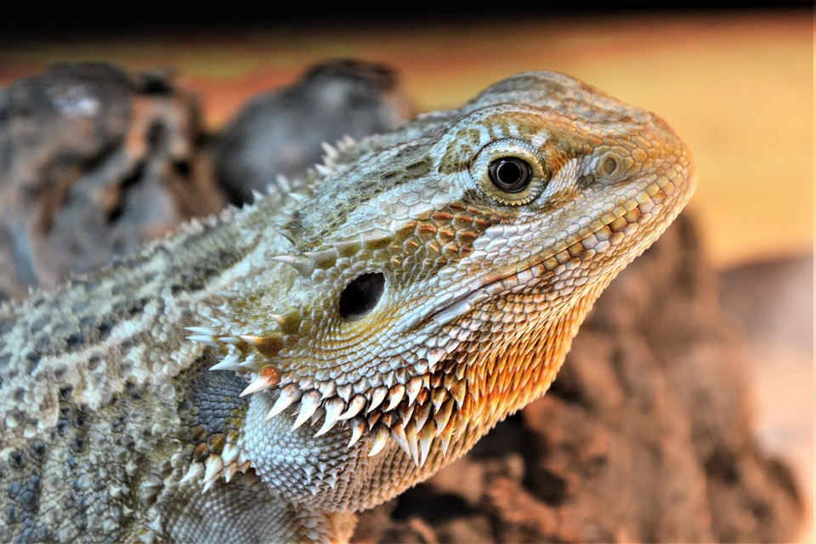

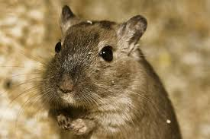
What career opportunities would match Denisha’s SAE? (Utilize AgExplorer.ffa.org.)

What Do I Need to Do?
Aligned to the following standards:
FFA.PL-A; FFA.PL-C; FFA.PL-E; FFA.PL-F; FFA.PG-I; FFA.CS-M; CCSS.SL.9-10.1; CCSS.SL.9-10.2; CRP.04; CRP.10

Directions:
Denisha has a task list she completes at her SAE workplace on a daily basis. Develop a task list for your own SAE program using the space below. (If you don’t have an SAE, choose one from the SAE Idea Cards [https://FFA.box.com/v/saeideacards] that aligns with your interests.)

Task List for ________________________ SAE

