What Do I Bring to the Table?
Aligned to the following standards:
CS.02; CS.05; FFA.PL-A; FFA.PL-E; FFA.PL-C; FFA.CS-M; FFA.CS-N; AG2; AG5; AGC10.03; CCSS.ELA.RI.9-10.1; CCSS.ELA.RI.9-10.2; CCSS.ELA.RI.9-10.3; CCSS.ELA.W.9-10.2; CCSS.ELA.W.9-10.4; CCSS.ELA.SL.9-10.2; CCSS.ELA.SL.9-10.4; CCSS.ELA.RST.9-10.1; CCSS.ELA.RST.9-10.7; CCSS.ELA.RST.9-10.8; CCSS.ELA.WHST.9.10.6; HS-ETS1-3; AFNR Career Cluster, Statement 2; AFNR Career Cluster, Statement 3; CRP.02; CRP.04; CRP.05; CRP.06; CRP.07; CRP.08
Directions:
Feeding the world can take many shapes and forms. We all can play a role. We do not have to live on a farm or grow up with an agriculture production background to contribute to making a difference. Many times, the best way to become engaged in feeding the world is to identify what we bring to the table.

Think critically about your skills, passions, life experiences and goals — do not limit yourself. Almost all experiences can help make a difference if you work to apply them. Use the diagram below to illustrate what you bring to the table.

Example: I have volunteered at a food bank.
Example: I want to be a veterinarian.
Example: I am passionate about helping elderly people and making sure they have adequate food to eat.
Example: I am good at designing advertisements.

How can these can these skills, passions, life experiences and goals combined help address needs in your community? Explain your reasoning for how they are relevant and beneficial to helping the community.
The Global Goals
Aligned to the following standards:
CS.02; CS.05; FFA.PL-A; FFA.PL-E; FFA.PL-C; FFA.CS-M; FFA.CS-N; AG2; AG5; AGC10.03; CCSS.ELA.RI.9-10.1; CCSS.ELA.RI.9-10.2; CCSS.ELA.RI.9-10.3; CCSS.ELA.W.9-10.2; CCSS.ELA.W.9-10.4; CCSS.ELA.SL.9-10.2; CCSS.ELA.SL.9-10.4; CCSS.ELA.RST.9-10.1; CCSS.ELA.RST.9-10.7; CCSS.ELA.RST.9-10.8; CCSS.ELA.WHST.9.10.6; HS-ETS1-3; AFNR Career Cluster, Statement 2; AFNR Career Cluster, Statement 3; CRP.02; CRP.04; CRP.05; CRP.06; CRP.07; CRP.08
Directions:
One step to helping feed the world is to identify challenges to feeding the world and then identify what strategies can help address those challenges. In September 2015, the United Nations adopted 17 “Sustainable Development Goals” or “Global Goals” to address large issues facing the world, including extreme poverty, challenges to sustainability, inadequate nutrition and social inequalities.

Complete the following tasks:
- Watch the U.N.’s (2016) “Numbers in Action” video, available at https://youtu.be/Mdm49_rUMgo.
  - Optional: If watching YouTube is not an option, visit the U.N.’s (2018) “The Global Goals for Sustainable Development” website directly. The URL is https://www.globalgoals.org.
- Visit the U.N.’s (2018) “The Global Goals for Sustainable Development” website, available at https://www.globalgoals.org.
- Review the statistics and resources by clicking each of the 17 Global Goals icons. Pay special attention to the “Target Areas” for each Global Goal by scrolling down the Global Goals website. Complete the following questions:

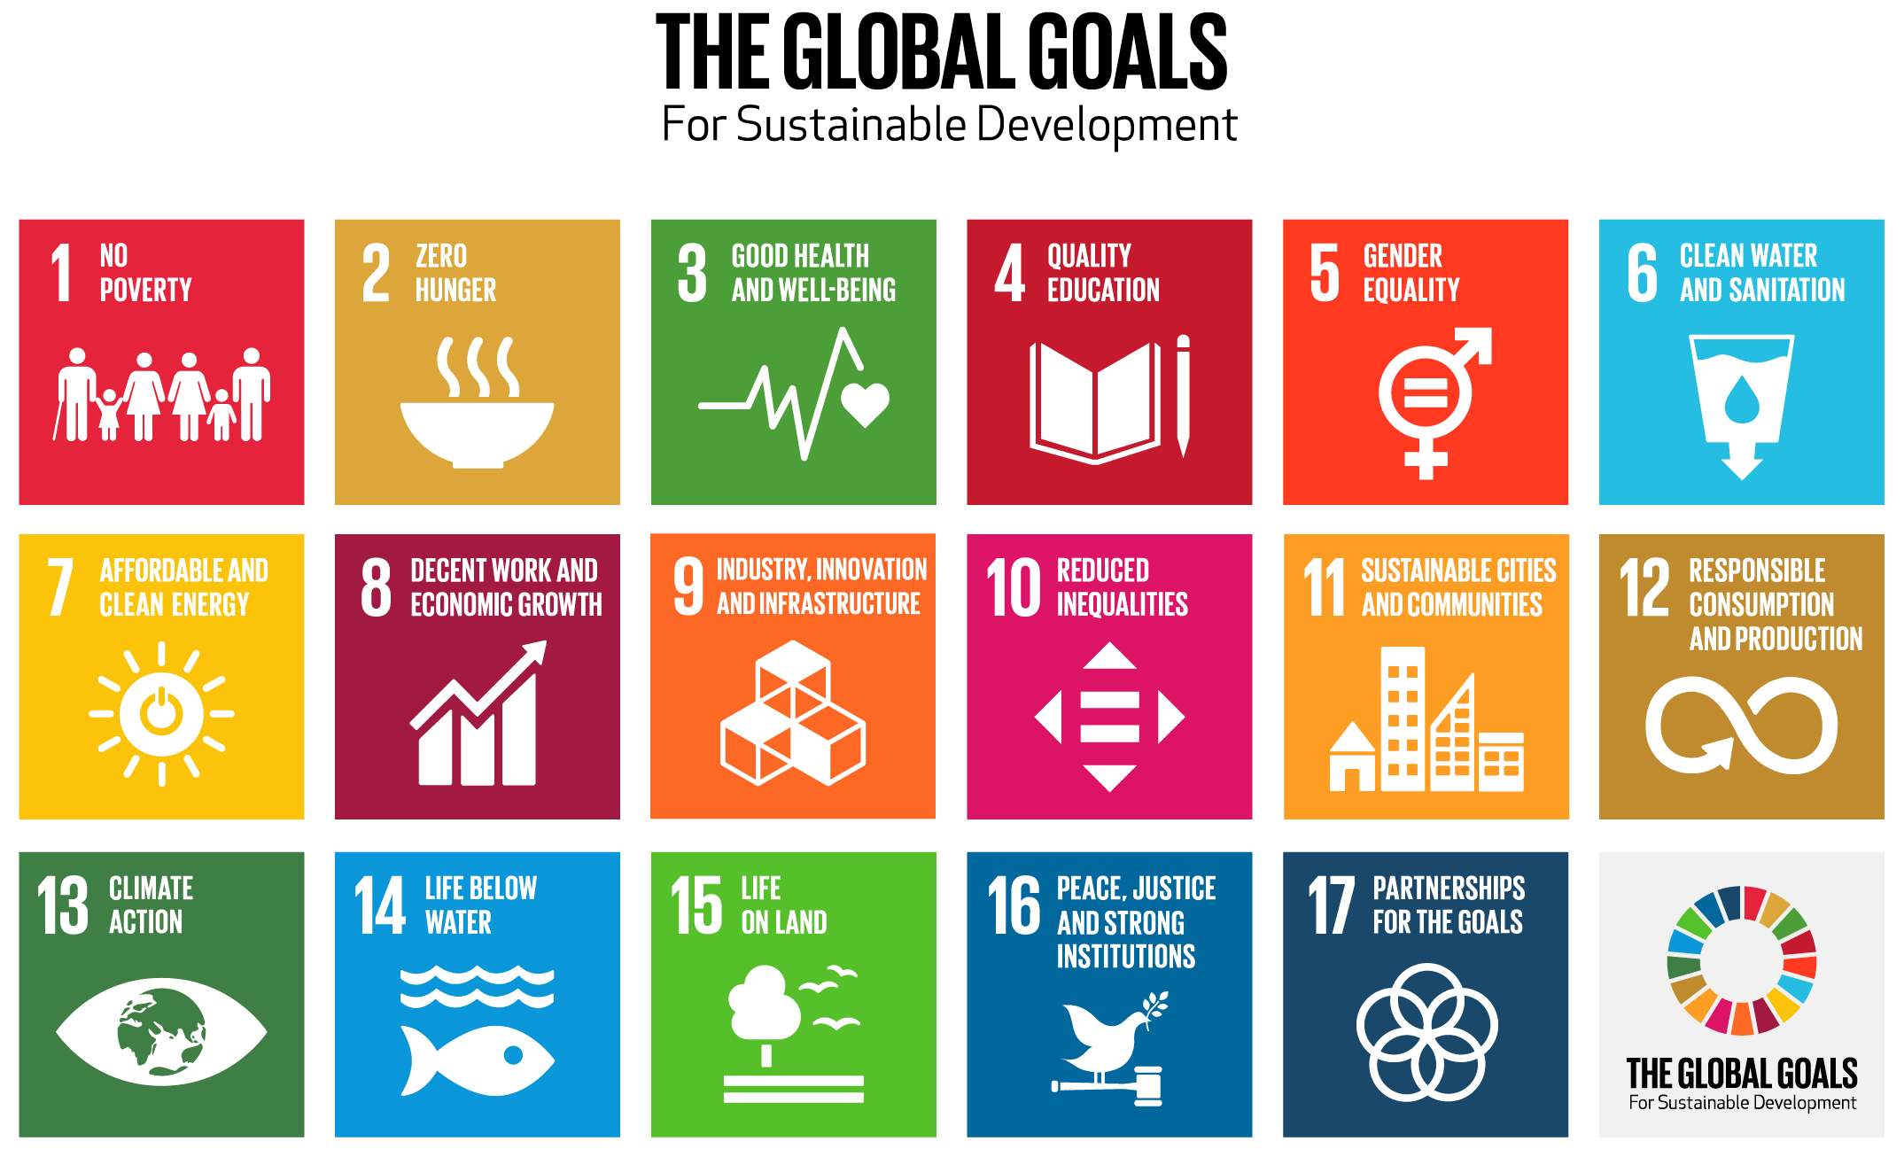

Read through the descriptions for each of the 17 goals. Click on each icon and scroll down to the “Target Areas” to read each description. List the most impactful “Target Area” for each goal. What makes them impactful?

Goal 1: Target Area

What makes this area impactful?
Goal 2: Target Area

What makes this area impactful?
Goal 3: Target Area

What makes this area impactful?
Goal 4: Target Area

What makes this area impactful?

Goal 7: Target Area

What makes this area impactful?

Goal 10: Target Area

What makes this area impactful?

Goal 13: Target Area

What makes this area impactful?

Goal 16: Target Area

What makes this area impactful?
Goal 5: Target Area

What makes this area impactful?

Goal 8: Target Area

What makes this area impactful?

Goal 11: Target Area

What makes this area impactful?

Goal 14: Target Area

What makes this area impactful?

Goal 17: Target Area

What makes this area impactful?
Goal 6: Target Area

What makes this area impactful?

Goal 9: Target Area

What makes this area impactful?

Goal 12: Target Area

What makes this area impactful?

Goal 15: Target Area

What makes this area impactful?

Think about the needs in your community. Which Target Goal relates the most to your community? How?
Needs Assessment of Local Challenges
Aligned to the following standards:
CS.02; CS.05; FFA.PL-A; FFA.PL-E; FFA.PL-C; FFA.CS-M; FFA.CS-N; AG2; AG5; AGC10.03; CCSS.ELA.RI.9-10.1; CCSS.ELA.RI.9-10.2; CCSS.ELA.RI.9-10.3; CCSS.ELA.W.9-10.2; CCSS.ELA.W.9-10.4; CCSS.ELA.SL.9-10.2; CCSS.ELA.SL.9-10.4; CCSS.ELA.RST.9-10.1; CCSS.ELA.RST.9-10.7; CCSS.ELA.RST.9-10.8; CCSS.ELA.WHST.9.10.6; HS-ETS1-3; AFNR Career Cluster, Statement 2; AFNR Career Cluster, Statement 3; CRP.02; CRP.04; CRP.05; CRP.06; CRP.07; CRP.08
Directions:
While addressing the Global Goals can seem daunting, the most effective solutions start at the local level. The first thing to do is gain a better understanding of local needs through a needs assessment. A needs assessment is a way to evaluate something for the opportunities and gaps present. Several strategies exist for how to conduct a needs assessment, but one strategy is to conduct a Strengths, Weaknesses, Opportunities and Threats (SWOT) analysis.

For additional information, visit the Community Toolbox’s (2019) “SWOT Analysis: Strengths, Weaknesses, Opportunities and Threats” website, available at
https://ctb.ku.edu/en/table-of-contents/assessment/assessing-community-needs-and-resources/swot-analysis/main.

Consider your local community’s businesses, natural resources, assets, limitations, etc. While considering these elements, look at the positives and negatives to evaluate your own community using the chart below. Include at least five statements in each box.
SWOT Analysis of your Local Community
Strengths | Weaknesses
Opportunities | Threats

Take Action
Aligned to the following standards:
CS.02; CS.05; FFA.PL-A; FFA.PL-E; FFA.PL-C; FFA.CS-M; FFA.CS-N; AG2; AG5; AGC10.03; CCSS.ELA.RI.9-10.1; CCSS.ELA.RI.9-10.2; CCSS.ELA.RI.9-10.3; CCSS.ELA.W.9-10.2; CCSS.ELA.W.9-10.4; CCSS.ELA.SL.9-10.2; CCSS.ELA.SL.9-10.4; CCSS.ELA.RST.9-10.1; CCSS.ELA.RST.9-10.7; CCSS.ELA.RST.9-10.8; CCSS.ELA.WHST.9.10.6; HS-ETS1-3; AFNR Career Cluster, Statement 2; AFNR Career Cluster, Statement 3; CRP.02; CRP.04; CRP.05; CRP.06; CRP.07; CRP.08
Directions:
After we identify challenges, we can develop a plan starting in our local community. One way to raise awareness for challenges in our community is to develop a campaign to share the background of the challenges, the mission of the campaign and action steps to get involved. Complete the questions below to guide the campaign development process.

What challenge or issue are you the most passionate about in your community? Why?

Explain the challenge or issue. How does it specifically influence your community?

How can the qualities you listed on the “What Do I Bring to the Table?” worksheet help you develop campaign awareness?

Several options exist for developing a campaign to raise awareness for each selected challenge. Think creatively and innovatively for how to deliver your campaigns. See the awareness campaign choice board below for how to address the need you identified in your community. Select one:

Adobe Spark Webpage or Video:  - Create a free online account for Adobe Spark (2019) by visiting the “Introducing Adobe Spark for Education” website at https://blog.adobespark.com/2018/  04/09/introducing-adobe-spark-for-education/.  - Watch the “Adobe Spark: Create compelling stories | Adobe Creative Cloud” video (Adobe Creative Cloud, 2018), https://youtu.be/MVShoOjDCnMInformation.  - The Adobe Spark webpage or video presentation should provide a comprehensive explanation of your awareness campaign. | Art Representation:  - Create a mural or art piece to visually represent how to address your selected challenge.  - Visit ThoughtCo’s (2019) “Promoting Peace Through Art” website for examples of art pieces that also connect a story. The URL is https://www.thoughtco.com/peace-art-projects-2578436.  - You should be prepared to write an exhibit label to accompany the art piece that describes the purpose of the art piece.
Infographic:  - Use blank paper with colored pens/markers to create an infographic or use an online infographic generator:  - Piktochart — https://piktochart.com/formats/infographics/  - Canva — https://www.canva.com  - The information shared in the infographic should represent accurate information or statistics about the selected issues. | Poem or Song:  - Create a poem or song lyrics that tell the story of your selected challenge.  - Stanzas and lyrics should be well-thought out and should reflect the background behind the selected challenge.

What is the mission of your awareness campaign? How does your selected delivery method best meet your mission statement?

