Aligned to the following standards:
CS.01; CS.02; CS.05; CS.06; FFA.CS-M; FFA.CS-N; AG1; AG2; AG5; AG6; AGC09.02; AGC10.03; AGC10.04; CCSS.ELA.RI.9-10.2; CCSS.ELA.RI.9-10.3; CCSS.ELA.W.9-10.2; CCSS.ELA.SL.9-10.2; CCSS; .SL.9-10.4; CCSS.RST.9.10.8; CCSS.ELA.WHST.9.10.6; HS-ETS1-3; AFNR Career Cluster, Statement 2; CRP.06; CRP.07; CRP.08
Creative Thinking and Abstractions
Directions:
Ensuring the food, fiber and natural resources will be able to sustain a growing human population in the future will require creative and innovative approaches to solving problems. One key to training the brain to think creatively and innovatively starts with using our imaginations to complete abstractions.

“Abstract thinking” is the ability to create a picture or idea with objects, concepts and structures that are not physically or visibly present. Using the worksheet below, complete the abstractions by using the provided shapes/lines to draw an image, symbol, animal, person, shape, etc. for each of the nine boxes. Think outside the box and get creative!

Think about 2 to 3 critical challenges the agriculture industry will face in the next 10, 20 or 50 years. How can using abstract thinking help address those critical challenges?
1. | Abstract thinking addresses critical challenges by:
2. | Abstract thinking addresses critical challenges by:
3. | Abstract thinking addresses critical challenges by:

Aligned to the following standards:
CS.01; CS.02; CS.05; CS.06; FFA.CS-M; FFA.CS-N; AG1; AG2; AG5; AG6; AGC09.02; AGC10.03; AGC10.04; CCSS.ELA.RI.9-10.2; CCSS.ELA.RI.9-10.3; CCSS.ELA.W.9-10.2; CCSS.ELA.SL.9-10.2; CCSS; .SL.9-10.4; CCSS.RST.9.10.8; CCSS.ELA.WHST.9.10.6; HS-ETS1-3; AFNR Career Cluster, Statement 2; CRP.06; CRP.07; CRP.08
Innovations in the Classroom
Directions:
As the world moves forward, finding creative and innovative ways to address key issues in agriculture will require outside-of-the-box thinking and people who are willing to take risks.

Innovation is defined as “a new method, idea, product, etc.” (Merriam-Webster, 2018). Paul Sloane, motivational speaker and innovator, also said, “Creativity is thinking of something new; innovation is the implementation of something new.” Consider the following questions, and then write your responses below each question.

- What does innovation mean to you?

- Look around the classroom. What innovative examples do you see? Illustrate them below.

- What makes them innovative? Describe what makes them different from other products or items.

- What role do you see innovation playing in the future of agriculture?

Innovations in Agriculture
Aligned to the following standards:
CS.01; CS.02; CS.05; CS.06; FFA.CS-M; FFA.CS-N; AG1; AG2; AG5; AG6; AGC09.02; AGC10.03; AGC10.04; CCSS.ELA.RI.9-10.2; CCSS.ELA.RI.9-10.3; CCSS.ELA.W.9-10.2; CCSS.ELA.SL.9-10.2; CCSS; .SL.9-10.4; CCSS.RST.9.10.8; CCSS.ELA.WHST.9.10.6; HS-ETS1-3; AFNR Career Cluster, Statement 2; CRP.06; CRP.07; CRP.08
Directions:
The agriculture industry in the 21st century is constantly changing and adapting to find ways to produce more using fewer resources. An increased access to innovative and cutting-edge technology has also changed the face of modern agriculture. Complete the following questions as you watch “The Future of Farming and Agriculture” (The Daily Conversation, 2017) at https://youtu.be/Qmla9NLFBvU.

Optional: If YouTube is unavailable, complete the worksheet using the U.S. Department of Agriculture’s “Innovations at Work in Agriculture” (2017) website at https://newfarmers.usda.gov/innovations-work-agriculture or the Forbes’ “The 25 Most Innovative AgTech Startups in 2018” website at https://www.forbes.com/sites/maggiemcgrath/2018/06/27/the-25-most-innovative-agtech-startups-in-2018/#3b8ed1262302.

Innovation | Describe the innovation. | What need does it address? | What makes it innovative? | How do you predict it will evolve over time?
Innovation | Describe the innovation. | What need does it address? | What makes it innovative? | How do you predict it will evolve over time?
Innovation | Describe the innovation. | What need does it address? | What makes it innovative? | How do you predict it will evolve over time?

Innovation | Describe the innovation. | What need does it address? | What makes it innovative? | How do you predict it will evolve over time?

Select one innovation to investigate further. Write it below. Why did you select this innovation?

Aligned to the following standards:
CS.01; CS.02; CS.05; CS.06; FFA.CS-M; FFA.CS-N; AG1; AG2; AG5; AG6; AGC09.02; AGC10.03; AGC10.04; CCSS.ELA.RI.9-10.2; CCSS.ELA.RI.9-10.3; CCSS.ELA.W.9-10.2; CCSS.ELA.SL.9-10.2; CCSS; .SL.9-10.4; CCSS.RST.9.10.8; CCSS.ELA.WHST.9.10.6; HS-ETS1-3; AFNR Career Cluster, Statement 2; CRP.06; CRP.07; CRP.08
Four Stages of Innovation
Directions:
Innovative ideas can be better implemented with the help of a model. Several individuals and businesses use models to help organize new and creative ideas. For example, Elanco’s research and development team uses four stages of innovation to enhance their vision of “Food and Companionship Enriching Life.” Elanco’s (2018) vision can be found at https://www.elanco.com/research-development.

Using the innovation selected from “The Future of Farming and Agriculture” video at https://youtu.be/Qmla9NLFBvU, describe how the innovation is using or has used each of the four stages of innovation.

Optional: If YouTube is unavailable, complete the worksheet using the U.S. Department of Agriculture’s “Innovations at Work in Agriculture” (2017) website at https://newfarmers.usda.gov/innovations-work-agriculture.

Existing Innovation Name: ___________________________________________
Identify ideas, products or technologies to address challenges.
Design specific measures that help maintain safety, efficiency and effectiveness.
Describe studies that should be conducted to ensure the quality of the products.
Describe technical expertise that will support the innovation and the customers.

Aligned to the following standards:
CS.01; CS.02; CS.05; CS.06; FFA.CS-M; FFA.CS-N; AG1; AG2; AG5; AG6; AGC09.02; AGC10.03; AGC10.04; CCSS.ELA.RI.9-10.2; CCSS.ELA.RI.9-10.3; CCSS.ELA.W.9-10.2; CCSS.ELA.SL.9-10.2; CCSS; .SL.9-10.4; CCSS.RST.9.10.8; CCSS.ELA.WHST.9.10.6; HS-ETS1-3; AFNR Career Cluster, Statement 2; CRP.06; CRP.07; CRP.08
Innovations to Address Global Issues
Directions:
Addressing critical issues in the agriculture industry requires thinking creatively and implementing new innovations to address issues. Describe 2 to 3 current issues in the agriculture industry that can only be solved with innovative solutions.

Global issue: Global issue: Global issue:

Directions:
Using the four stages of innovation, describe a new, innovative solution (a product, method, technology, etc.) to address one global issue selected from above.
New Innovation Name: ______________________________________________________
Identify ideas, products or technologies to address global issue.
Describe specific need it addresses and how it will maintain safety, efficiency and effectiveness.
Describe technical expertise that will support the innovation and the customers.
Describe studies that can be conducted to ensure the quality of the innovation.

Aligned to the following standards:
CS.01; CS.02; CS.05; CS.06; FFA.CS-M; FFA.CS-N; AG1; AG2; AG5; AG6; AGC09.02; AGC10.03; AGC10.04; CCSS.ELA.RI.9-10.2; CCSS.ELA.RI.9-10.3; CCSS.ELA.W.9-10.2; CCSS.ELA.SL.9-10.2; CCSS; .SL.9-10.4; CCSS.RST.9.10.8; CCSS.ELA.WHST.9.10.6; HS-ETS1-3; AFNR Career Cluster, Statement 2; CRP.06; CRP.07; CRP.08
Directions:
Using the four stages of innovation diagram, design and illustrate the new, innovative solution (a product, method, technology, etc.).

  - Diagram of the innovation/product (provide labels and descriptions):

  - Projected cost of the innovation/product:

Aligned to the following standards:
CS.01; CS.02; CS.05; CS.06; FFA.CS-M; FFA.CS-N; AG1; AG2; AG5; AG6; AGC09.02; AGC10.03; AGC10.04; CCSS.ELA.RI.9-10.2; CCSS.ELA.RI.9-10.3; CCSS.ELA.W.9-10.2; CCSS.ELA.SL.9-10.2; CCSS; .SL.9-10.4; CCSS.RST.9.10.8; CCSS.ELA.WHST.9.10.6; HS-ETS1-3; AFNR Career Cluster, Statement 2; CRP.06; CRP.07; CRP.08
Innovations to Address Global Issues
Part 2

DIRECTIONS:
Find information on an agricultural innovation of your choice. Choose an innovation in an area that you are interested in, such as animal science, agronomy, forestry, technology or agribusiness.

Answer the following questions to build your understanding of the innovation you chose.

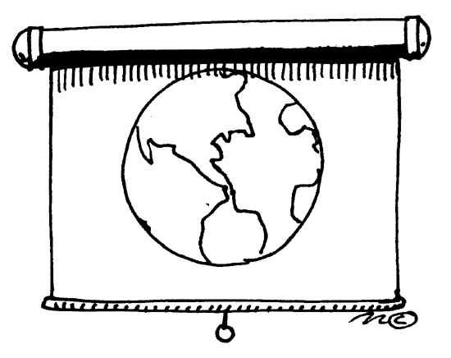Presentation Points
1. If you had 5 minutes to describe and explain your chosen agricultural innovation to your class, what would be your top 5 talking points? List these points below, and write a few sentences to describe them.

2. How will this innovation advance agriculture? How will it help use resources (natural/financial/human) more effectively? Will it help increase production?

3. Is this innovation being used effectively? Describe how it is being used.

4. How could this innovation be advanced in the future? What ideas do you have to improve this innovation? Could you use these ideas as a starting point for upcoming career development events (CDE) or your supervised agricultural experience (SAE) program?

Nine Rules of Innovation
Aligned to the following standards:
CS.01; CS.02; CS.05; CS.06; FFA.CS-M; FFA.CS-N; AG1; AG2; AG5; AG6; AGC09.02; AGC10.03; AGC10.04; CCSS.ELA.RI.9-10.2; CCSS.ELA.RI.9-10.3; CCSS.ELA.W.9-10.2; CCSS.ELA.SL.9-10.2; CCSS; .SL.9-10.4; CCSS.RST.9.10.8; CCSS.ELA.WHST.9.10.6; HS-ETS1-3; AFNR Career Cluster, Statement 2; CRP.06; CRP.07; CRP.08
Directions:
Implementing new innovations requires complex thinking and comprehensive planning. Read Greg Satell’s (qtd. in Vora, 2017) “Nine Rules for Innovation” and answer the following questions.

New Innovation Name: ______________________________________________
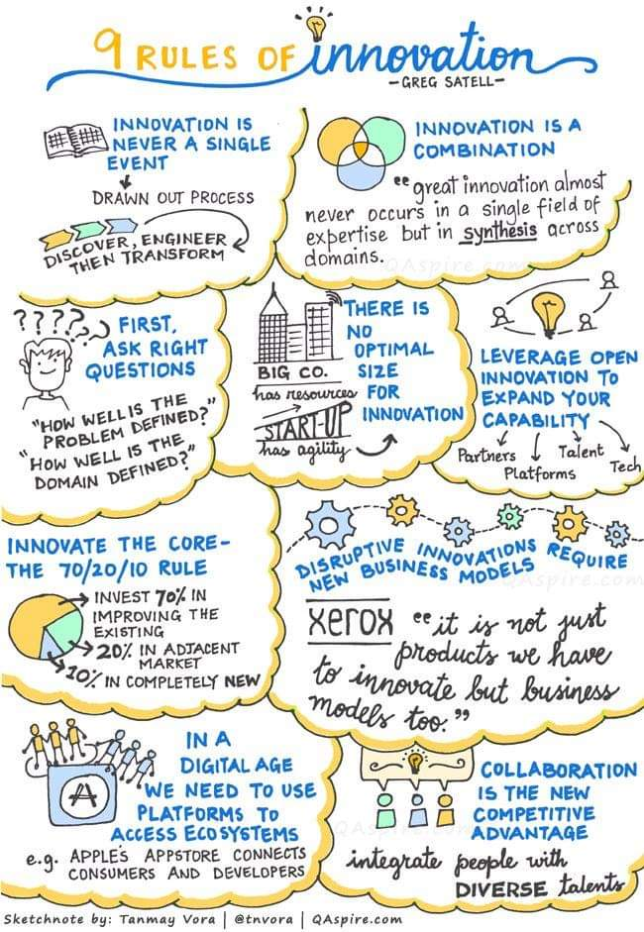
How can you combine your innovation with additional existing ideas?
After the innovation is developed, how can you incorporate the 70/20/10 rule?
What additional collaborations could you use to strengthen your network?
(Vora, 2017); URL:
http://qaspire.com/2017/10/23/the-9-rules-of-innovation-by-greg-satell/

Aligned to the following standards:
CS.01; CS.02; CS.05; CS.06; FFA.CS-M; FFA.CS-N; AG1; AG2; AG5; AG6; AGC09.02; AGC10.03; AGC10.04; CCSS.ELA.RI.9-10.2; CCSS.ELA.RI.9-10.3; CCSS.ELA.W.9-10.2; CCSS.ELA.SL.9-10.2; CCSS; .SL.9-10.4; CCSS.RST.9.10.8; CCSS.ELA.WHST.9.10.6; HS-ETS1-3; AFNR Career Cluster, Statement 2; CRP.06; CRP.07; CRP.08
Where Is Innovation in This Career?
Directions:
Agriculture has a role in everyone’s life that goes far beyond providing food and clothing. Agriculture encompasses scientists, engineers, computer programmers, mathematicians, artists, communicators, educators and many other individuals in diverse careers, and they all play a role in introducing new innovations to improve the agriculture industry.

Visit AgExplorer (AgExplorer.ffa.org) to discover different careers that interest you. Identify one to two specific examples of innovation within each different career system.

Agribusiness Systems | Animal Systems | Biotechnology Systems
Environmental Service Systems | Food Products & Processing Systems | Natural Resources Systems
Plant Systems | Power, Structural & Technical Systems | Agricultural Education

