How Does Agriculture
Improve Lives?
Aligned to the following standards:
CS.01; CS.02; CS.05; FFA.PL-A; FFA.PL-E; FFA.PL-C; FFA.CS-M; FFA.CS-N; AG1; AG2; AG3; AG5; AGC02.02; AGC10.03; CCSS.ELA.RI.9-10.1; CCSS.ELA.W.9-10.2; CCSS.ELA.SL.9-10.1; CCSS.ELA.SL.9-10.2; CCSS.ELA.SL.9-10.4; CCSS.ELA.RST.9-10.1; CCSS.ELA.RST.9-10.8; CCSS.ELA.WHST.9.10.6; HS-ETS1-3; AFNR Career Cluster, Statement 2; CRP.02; CRP.04; CRP.05; CRP.06; CRP.07; CRP.08
Directions:
Agriculture exists to sustain life. Efficient and effective agricultural systems can improve lives by providing access to food, fiber and natural resources. The agriculture industry can also improve lives by providing sustainable solutions to critical challenges. To understand how the agriculture industry can improve lives, it is important to investigate the roles agriculture plays in our lives.

Complete the following:
- Think critically about what “improving lives” means for agriculture.
- Brainstorm different ways agriculture can improve lives through food, fiber and natural resources.
- Record your responses below.

Think creatively. Brainstorm different ways agriculture can improve lives through food, fiber and natural resources. Consider this question as you brainstorm: Do certain agriculture careers exist to improve lives? List all possible options below.

Fiber
Natural Resources
Food

What elements do each sector have in common with the ways they can improve lives? What differences do they have?

How can each agriculture sector—food, fiber and natural resources—improve lives in your school? In your community?

Think critically. What steps can your agricultural education classroom specifically do to help improve lives in your school and community?

Challenges to Food
Security
Aligned to the following standards:
CS.01; CS.02; CS.05; FFA.PL-A; FFA.PL-E; FFA.PL-C; FFA.CS-M; FFA.CS-N; AG1; AG2; AG3; AG5; AGC02.02; AGC10.03; CCSS.ELA.RI.9-10.1; CCSS.ELA.W.9-10.2; CCSS.ELA.SL.9-10.1; CCSS.ELA.SL.9-10.2; CCSS.ELA.SL.9-10.4; CCSS.ELA.RST.9-10.1; CCSS.ELA.RST.9-10.8; CCSS.ELA.WHST.9.10.6; HS-ETS1-3; AFNR Career Cluster, Statement 2; CRP.02; CRP.04; CRP.05; CRP.06; CRP.07; CRP.08
Directions:
Agriculture improves lives by providing solutions to handling the biggest food and nutrition demands. One of the biggest challenges society faces across the globe is access to, quantity of, quality of, and sustainability of food products and systems. The Global Panel on Agriculture and Food Systems for Nutrition (2019) identified three elements within the food sector of agriculture that impact the quality of a diet: diversity of food types, adequacy of food sources and safety of food products.

Complete the following:
- Watch the Global Panel on Agriculture and Food Systems for Nutrition’s video “How can Agriculture and Food System Policies Improve Nutrition,” available at https://youtu.be/B2FmQgFJY6A.
  - Optional: If YouTube is not available, visit the Global Panel on Agriculture and Food Systems for Nutrition website and Technical Report, available at http://glopan.org/nutrition.
- Use the video or the Global Panel on Agriculture and Food Systems for Nutrition website and Technical Report to complete the worksheet.
- Record your responses below.

Complete the following statements:

_________________________
children under the age of 5 are stunted or wasted due to undernutrition.

_________________________
people suffer physical and cognitive effects resulting from a lack of essential vitamins and minerals in their diets.
_________________________
people are overweight or obese.

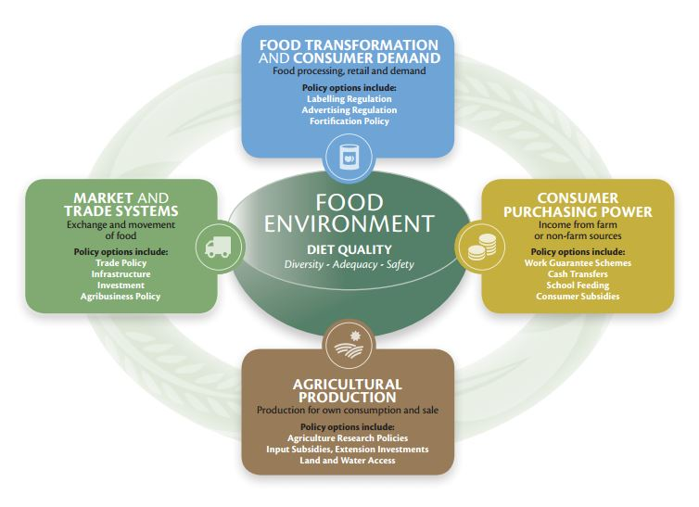
Figure 1. Reprinted from the Global Panel on Agriculture and Food Systems for Nutrition (2019) “Food Systems and Nutrition” website. The website can be accessed at http://glopan.org/nutrition.
List and define the three “food environment” components that affect the quality of a person’s diet.

The Global Panel on Agriculture and Food Systems for Nutrition listed four categories of policies that influence the “food environment”: agricultural production, market and trade systems, food transportation and consumer demand, and consumer purchasing power. Choose one of the four policy categories. Research elements that influence that category and answer the questions below.
Note. Pages 8 to 14 in the Global Panel on Agriculture and Food Systems for Nutrition Technical Report may be particularly helpful. Scroll to the bottom of the webpage to find the link for the Technical Report.

Policy Category: __________________________________________________________

What is the background of the policy category? Explain the significance of the policy category to the “food environment.”

What are the strengths of this policy category?

What are the weaknesses of this policy category?

How could this policy category influence global agriculture?

How could this policy category influence American agriculture?

What careers may exist to work with the chosen policy category?

Improving Lives Through the Diversity of Food Products
Aligned to the following standards:
CS.01; CS.02; CS.05; FFA.PL-A; FFA.PL-E; FFA.PL-C; FFA.CS-M; FFA.CS-N; AG1; AG2; AG3; AG5; AGC02.02; AGC10.03; CCSS.ELA.RI.9-10.1; CCSS.ELA.W.9-10.2; CCSS.ELA.SL.9-10.1; CCSS.ELA.SL.9-10.2; CCSS.ELA.SL.9-10.4; CCSS.ELA.RST.9-10.1; CCSS.ELA.RST.9-10.8; CCSS.ELA.WHST.9.10.6; HS-ETS1-3; AFNR Career Cluster, Statement 2; CRP.02; CRP.04; CRP.05; CRP.06; CRP.07; CRP.08
Directions:
The first step to improving lives through the food industry is to increase the diversity of nutrient-dense food products. Most Americans have access to an abundant and affordable food supply. However, what to eat and how much to eat creates a challenge for some consumers. A high-quality diet involves food sources that are diverse, adequate and safe.

The United States Department of Agriculture has several resources available to help increase the diversity of the nutrient-dense, food choices available in a diet through the “MyPlate” initiative.

Complete the following:
- Watch the USDA’s “Start Simple” video, available at https://youtu.be/W7_i5tY-5BY.
  - Optional: If YouTube is not available, go directly to the MyPlate.gov website, available at https://www.choosemyplate.gov/.
- Visit the MyPlate.gov website, available at https://www.choosemyplate.gov/.
- Record your responses below.

Draw and label the MyPlate diagram with the five food group components.

Visit the MyPlate.gov website (available at https://www.choosemyplate.gov/). Click on each food group icon and list three “tips” for each food group. Note: Tip Sheets are available for food group type after you click on the food group’s icon and then click on the attachments titled “Tips for [name of food group].”

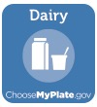
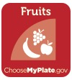

Grains:

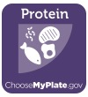
Protein:

Fruit:

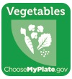
Vegetables:

Dairy:

What food group do you need to balance more in your life? How can you increase the diversity of food products in your diet?

Improving Lives Through an Adequate Diet and Lifestyle
Aligned to the following standards:
CS.01; CS.02; CS.05; FFA.PL-A; FFA.PL-E; FFA.PL-C; FFA.CS-M; FFA.CS-N; AG1; AG2; AG3; AG5; AGC02.02; AGC10.03; CCSS.ELA.RI.9-10.1; CCSS.ELA.W.9-10.2; CCSS.ELA.SL.9-10.1; CCSS.ELA.SL.9-10.2; CCSS.ELA.SL.9-10.4; CCSS.ELA.RST.9-10.1; CCSS.ELA.RST.9-10.8; CCSS.ELA.WHST.9.10.6; HS-ETS1-3; AFNR Career Cluster, Statement 2; CRP.02; CRP.04; CRP.05; CRP.06; CRP.07; CRP.08
Directions:
Healthy lifestyles require more than meeting the necessary caloric intake for the day. Consumers must also consider the types of food they are eating and how adequate nutritional value can help people live a healthy and balanced life. After analyzing what types of food make up a healthy and balanced diet, it is important to understand what lifestyle changes can be made to live a healthier lifestyle and understand what quantities of different food types should be consumed based on age, gender and physical fitness levels.

Complete the following:
- Using the MyPlate.gov resources for teen audiences (ages 13 to 19), analyze the steps for improving lifestyles through developing and using adequate nutrition plans.
- Visit the “Take Charge of Your Health: A Guide for Teenagers” webpage at https://www.niddk.nih.gov/health-information/weight-management/take-charge-health-guide-teenagers?dkrd=lglgc1334.
- Record your responses below.

Building a healthy lifestyle as a teenager is vital in helping to develop strong habits as an adult. Using the Teen Guide online, define what each section means below. List techniques or tips for how to practice each healthy habit.

What role does agriculture play in developing these strong lifestyle habits? What careers exist to help with these lifestyles?

What can agriculturists do to ensure there is an abundance of healthy options for teenagers in school?

Improving Lives
Through the Safety of Food Products
Aligned to the following standards:
CS.01; CS.02; CS.05; FFA.PL-A; FFA.PL-E; FFA.PL-C; FFA.CS-M; FFA.CS-N; AG1; AG2; AG3; AG5; AGC02.02; AGC10.03; CCSS.ELA.RI.9-10.1; CCSS.ELA.W.9-10.2; CCSS.ELA.SL.9-10.1; CCSS.ELA.SL.9-10.2; CCSS.ELA.SL.9-10.4; CCSS.ELA.RST.9-10.1; CCSS.ELA.RST.9-10.8; CCSS.ELA.WHST.9.10.6; HS-ETS1-3; AFNR Career Cluster, Statement 2; CRP.02; CRP.04; CRP.05; CRP.06; CRP.07; CRP.08
Directions:
Not only is access to diverse and adequate food supplies central to improving lives through agriculture, but the food products must also be safe to consume. American agriculture is one of the safest and most secure food systems in the world; however, on average, one in six Americans will experience food poisoning each year (FoodSafety.gov, 2019). Food safety at home can be accomplished by four simple steps—clean, separate, cook and chill.

Complete the following:
- Using the FoodSafety.gov resources, available at https://www.foodsafety.gov/keep-food-safe/4-steps-to-food-safety, analyze the steps we should take to ensure food products are safe to consume.
- Record your responses below.

List strategies households can use to accomplish each of the four food safety steps:

How can proper food safety precautions improve lives?

What can your agricultural education classroom do to help promote food safety in your school? In your community?

