World Snapshot
Aligned to the following standards:
FFA.PL-A; FFA.PG-G; FFA.PG-I; FFA.PG-J; FFA.CS-M; FFA.CS-N; CCSS.ELA.RI.9-10.4; CCSS.ELA.RI.9-10.8; CCSS.ELA.SL.9-10.1; CCSS.ELA.SL.9-10.2; CCSS.ELA.SL.9-10.4; CCSSS.ELA.RST.9-10.7; CCSS.ELA.WHST.9.10.4; MP1; MP3; MP5; MP6: CRP.02; CRP.04; CRP.07; CRP.11
Directions:
You have $500 to spend. You MUST purchase food, clothes and shelter. Once you are done making your selections, answer the follow-up questions at the bottom. Select a spokesperson that will share with the class. You will have 10 minutes to make your selections and answer the conclusion questions.

Circle the country you were assigned: United States Ireland Indonesia

Food
United States | $32.76
Ireland | $98.41
Indonesia | $247.61

Clothing
Tuxedos and ballgowns | $ 160.45
T-shirts and jeans | $ 127.61
Potato sacks with pockets | $ 78.52
Potato sacks without pockets | $ 50.37

Shelter
Large brick house | $ 301.21
Small brick house | $ 261.84
Straw hut | $ 197.54

- How much money did you have left over? What did you choose to do with the remaining money?

- How much money did you spend? _________________
- How much money do you have left? _________________
- Why did you make the selections you did for your food, clothing and shelter?



Who Is Hungry?
Aligned to the following standards:
FFA.PL-A; FFA.PG-G; FFA.PG-I; FFA.PG-J; FFA.CS-M; FFA.CS-N; CCSS.ELA.RI.9-10.4; CCSS.ELA.RI.9-10.8; CCSS.ELA.SL.9-10.1; CCSS.ELA.SL.9-10.2; CCSS.ELA.SL.9-10.4; CCSSS.ELA.RST.9-10.7; CCSS.ELA.WHST.9.10.4; MP1; MP3; MP5; MP6: CRP.02; CRP.04; CRP.07; CRP.11
Part 1
Directions:
Using the infographic available at https://docs.wfp.org/api/documents/WFP-0000071530/download/?_ga=2.90932957.634527746.1537992219-54342706.1534776277, complete the activity below to better understand world hunger.

What does undernourishment mean? _________________________________________________________________________________________________________________________________________________________________________________________________________________________________

The number of people that do not get enough to eat.

Using the map provided, color, label and place a on three countries in each of the following undernourishment categories: very low, moderately low, moderately high, high and very high.

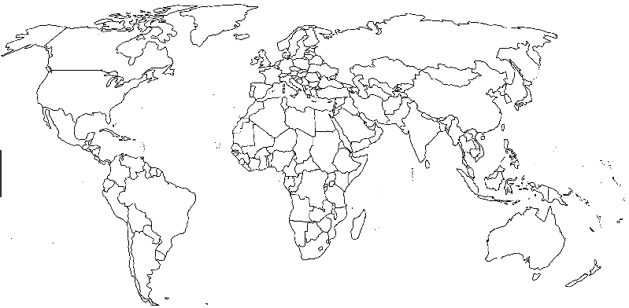
Create a key/legend for your map here:

How do you think undernourishment affects students in these countries? _________________________________________________________________________________________________________________________________________________________________________________________________________________________________
HINT: A key/legend tells you what everything means on a map. (Ex. colors and country name.)

Aligned to the following standards:
FFA.PL-A; FFA.PG-G; FFA.PG-I; FFA.PG-J; FFA.CS-M; FFA.CS-N; CCSS.ELA.RI.9-10.4; CCSS.ELA.RI.9-10.8; CCSS.ELA.SL.9-10.1; CCSS.ELA.SL.9-10.2; CCSS.ELA.SL.9-10.4; CCSSS.ELA.RST.9-10.7; CCSS.ELA.WHST.9.10.4; MP1; MP3; MP5; MP6: CRP.02; CRP.04; CRP.07; CRP.11
Part 2
Directions:
Using the paper provided, create an infographic about world hunger that you can share in your school to educate others about the global problem. Go on a webquest to research the following information to include in your infographic:
- What is hunger?
- What causes hunger?
- Where does hunger exist?
- Who experiences hunger?

**Remember that infographics are mostly pictures, are brightly colored and are informative for those that do not know anything about the topic. Use the space below to brainstorm ideas and take notes before developing your final product.
Notes and Ideas:

Infographic Rubric
Criteria | Below Average  (0–1 points) | Average  (2–3 points) | Above Average  (4–5 points)
Knowledge | Work shows little to no understanding of the topic. | Work shows some understanding of the topic. | Work shows excellent understanding of the topic.
Quality | Work is very low quality with little evidence of effort. | Work shows some effort and is mostly neat. | Work shows excellent effort and is of high quality.
Instructions | Student did not follow instructions for the task. | Student followed some of the instructions. | Student followed all instructions for the task.
Timeliness | Work was submitted more than one day late. | Work was one day late. | Work was submitted on time.
Total

Hunger Infographic
Aligned to the following standards:
FFA.PL-A; FFA.PG-G; FFA.PG-I; FFA.PG-J; FFA.CS-M; FFA.CS-N; CCSS.ELA.RI.9-10.4; CCSS.ELA.RI.9-10.8; CCSS.ELA.SL.9-10.1; CCSS.ELA.SL.9-10.2; CCSS.ELA.SL.9-10.4; CCSSS.ELA.RST.9-10.7; CCSS.ELA.WHST.9.10.4; MP1; MP3; MP5; MP6: CRP.02; CRP.04; CRP.07; CRP.11

With such a large percentage of the world being hungry, what suggestions do you now have to help feed the growing population? Describe your thoughts in three or more sentences. ________________________________________________________________________________________________________________________________________________________________________________________________
________________________________________________________________________________________________________________________________________________________________________________________________________________________________________________________________________________________________________________________________________________________________________________________________________________________________________________________________________________________________________________________________________________________________________________________________________________________________________________________________________________________________________________________________________________________________________________________________________________________________________________________________________________________________________________________________________________________________________________________________

Why Are People Hungry?
Aligned to the following standards:
FFA.PL-A; FFA.PG-G; FFA.PG-I; FFA.PG-J; FFA.CS-M; FFA.CS-N; CCSS.ELA.RI.9-10.4; CCSS.ELA.RI.9-10.8; CCSS.ELA.SL.9-10.1; CCSS.ELA.SL.9-10.2; CCSS.ELA.SL.9-10.4; CCSSS.ELA.RST.9-10.7; CCSS.ELA.WHST.9.10.4; MP1; MP3; MP5; MP6: CRP.02; CRP.04; CRP.07; CRP.11

Part 1
Directions:
Read the following passage and then choose the best answer for each multiple choice question.
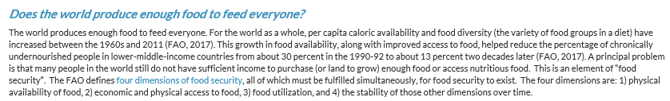
**Passage from Hunger Notes: 2018 World Hunger and Poverty Facts and Statistics

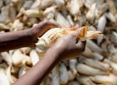
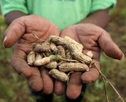
1. In the second sentence the word “caloric” means what?
a. The number of calories of heat available
b. The number of calories available for consumption
c. The number of cows available to consume
2. What does the phrase “chronically undernourished” mean?
a. They have a lot of food.
b. They have a large amount of nutrition.
c. They severely lack the nutrition required for their diet.
In one to three sentences, write exactly how you would explain the above passage to your grandma or grandpa, or someone more than 60 years old, so he or she could understand. _______________________________________________________________________________________________________________________________________________________________________________________________________________________________________________________________________________________________________________________________________________________________________________________________________________________________________________________________________________________________________________
4. “The FAO defines the four dimensions of food security, all of which must be fulfilled simultaneously, for food security to exist.” What does the underlined portion mean in this sentence?
a. The four dimensions must be listed together when reading.
b. The four dimensions must all be met for food security.
c. Food security can exist with only one of the dimensions.
3. If a person has “sufficient income” what does that mean?
a. A person has enough money coming in to meet their needs.
b. A person does not have enough money coming in to meet their needs.
c. A person does not spend their money thoughtfully.
Part 2
Aligned to the following standards:
FFA.PL-A; FFA.PG-G; FFA.PG-I; FFA.PG-J; FFA.CS-M; FFA.CS-N; CCSS.ELA.RI.9-10.4; CCSS.ELA.RI.9-10.8; CCSS.ELA.SL.9-10.1; CCSS.ELA.SL.9-10.2; CCSS.ELA.SL.9-10.4; CCSSS.ELA.RST.9-10.7; CCSS.ELA.WHST.9.10.4; MP1; MP3; MP5; MP6: CRP.02; CRP.04; CRP.07; CRP.11
Directions:
Identify the four dimensions of food security below.
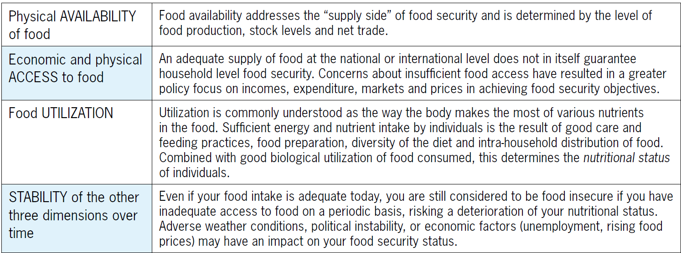
What are the four dimensions needed for food security to exist?

- ____________________________
- ____________________________
- ____________________________
- ____________________________

Directions:
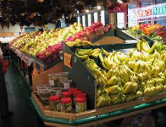
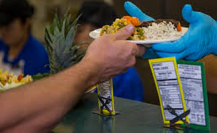
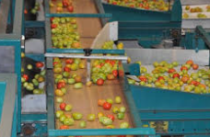





By drawing a line, match the term with the appropriate picture and common phrasing.
Physical Availability of Food

Economic and Physical Access to Food

Food Utilization

Stability Over Time
Having consistent access, funds and ability to purchase healthy and nutritious food

Having the money and ability to purchase food

Sufficient production of food

How the body uses nutrition and having good diet diversity
Rubric — Why Are People Hungry?
Aligned to the following standards:
FFA.PL-A; FFA.PG-G; FFA.PG-I; FFA.PG-J; FFA.CS-M; FFA.CS-N; CCSS.ELA.RI.9-10.4; CCSS.ELA.RI.9-10.8; CCSS.ELA.SL.9-10.1; CCSS.ELA.SL.9-10.2; CCSS.ELA.SL.9-10.4; CCSSS.ELA.RST.9-10.7; CCSS.ELA.WHST.9.10.4; MP1; MP3; MP5; MP6: CRP.02; CRP.04; CRP.07; CRP.11
Select one of the four dimensions of food security and create a one-minute speech to describe that dimension to the class. Write what you are going to say in this box so you are prepared. Be sure to answer the following questions in your speech: (1) What is the area you are covering? (2) why does this dimension need to be fulfilled to ensure food security? and (3) what does this look like in the U.S.?
Qualification | Very strong evidence of skill is present  (5–4 pts) | Moderate evidence of skill is present  (3–2 pts) | Weak evidence of skill is present  (1–0 pts) | Total Points  (20 possible)
Presentation Skills | Thorough and maintains eye contact | Somewhat professional and some preparation shown. | No evidence of preparation
Three Questions Covered | All three questions were covered thoroughly. | At least two questions were covered. | One question was covered.
Time | One minute or more | Between 30 seconds and one minute | Under 30 seconds
Overall Impression | Presentation was complete and well thought out. | Presentation was organized but lacked polish. | The presentation was not well-developed.
 |  |  | Total

Appendix 1: Bell Ringers & Exit Tickets Worksheet
Name: _________________________________________ Period: ____________
Week of: _________________________________________ Class: _________________

Bell Ringer Activity
Monday, ___________  Question:  Answer: | Tuesday, ____________  Question:  Answer:
Wednesday, ____________  Question:  Answer: | Thursday, _____________  Question:  Answer:
Friday, _____________  Question:  Answer: | 
EXIT TICKETS
Week of _____________________

Monday, ___________  Question:  Answer: | Tuesday, ____________  Question:  Answer:
Wednesday, ____________  Question:  Answer: | Thursday, _____________  Question:  Answer:
Friday, _____________  Question:  Answer: | Summarize the learning objectives for the week.
*Worksheet modified from a resource created by Chasten Bear, Indianapolis Classical School, Indianapolis, Ind.

