What Role Does Hunger Play in the United States?
Aligned to the following standards:
FFA.PL-A; FFA.PG-G; FFA.PG-I; FFA.PG-J; FFA.CS-M; FFA.CS-N; CCSS.ELA.SL.9-10.1; CCSS.ELA.SL.9-10.2; CCSS.ELA.RST.9-10.7; CCSS.WHST.9.10.4; MP1; MP5; MP6; CRP.02; CRP.04
Directions:
In Lesson 1, we learned about hunger and food insecurity around the globe. Watch the video “Illuminating Intersections: Hunger and Health,” available at https://youtu.be/q0VQjtE8vRg, and complete the following activities to get an overview of food insecurity and food access in the United States.


How many in the Unites State are food insecure?
1 in _____ or _______ million


Those that are food insecure have a greater chance for the following health issues:

- __________________________________
- __________________________________
- __________________________________
- __________________________________
How many children in the U.S. lack regular access to nutritious food?

_________ million
Using what you learned about the total number of children that are food insecure, calculate what percentage of the child population is food insecure. Show all work and circle your final answer.
Think about your home town and community. Are there people that are food insecure? What does your community do to help those that are food insecure?
_________________________________________________________________________________________________________________________________________________________________________________________________________________________________________________________________________________________________________________________________________________________________________________________________________________________________________________________________________________________________________________________________________________________________________________________________________________________________________________________________________________________
What is food insecurity?


Are People Hungry in the United States?
Aligned to the following standards:
FFA.PL-A; FFA.PG-G; FFA.PG-I; FFA.PG-J; FFA.CS-M; FFA.CS-N; CCSS.ELA.SL.9-10.1; CCSS.ELA.SL.9-10.2; CCSS.ELA.RST.9-10.7; CCSS.WHST.9.10.4; MP1; MP5; MP6; CRP.02; CRP.04
Directions:
Complete the following activities to learn about hunger in the United States.

Food Secure
“Households had access, at all times, to enough food for an active, healthy life for all household members.” (CDC, 2018)

Number of U.S. Households: 88.2%
Food Insecure
“At times during the year, these households were uncertain of having, or unable to acquire, enough food to meet the needs of all members because they had insufficient money or other resources for food (includes low and very low insecurity).” (CDC, 2018)

Number of U.S. Households:
Low: 7.3%
Very low: 4.5%
In the box, create a graph to depict the percentage of households that are food secure, have low food insecurity and have very low food insecurity for your state. Be sure to use color and to include all labels.
What do these percentages imply about the chance of kids in your school/community being hungry? ___________________________________________________________________________________________________________________________________________________________________________________________________________________________________________________________________________________________________
Use the following resource to find information for your state: https://www.ers.usda.gov/data-products/state-fact-sheets/

Access to Food
Aligned to the following standards:
FFA.PL-A; FFA.PG-G; FFA.PG-I; FFA.PG-J; FFA.CS-M; FFA.CS-N; CCSS.ELA.SL.9-10.1; CCSS.ELA.SL.9-10.2; CCSS.ELA.RST.9-10.7; CCSS.WHST.9.10.4; MP1; MP5; MP6; CRP.02; CRP.04
Directions:
As we have learned, having access to healthy and affordable food is important. However, what happens when healthy and affordable food is not accessible? Complete the following activities to learn about this important component to food security.

Find your way through to the star at the end in each of the three mazes:



Which maze would you prefer to go through to find something, such as your cell phone/tablet? How do you think these mazes relate to people’s access to food? Using a minimum of two sentences, explain. ______________________________________________________________________________________________________________________________________________________________________________________________________________________________________________________________________________________________________________________________________________________________________________________________________________________________________________________________________________________________________________________________________________________________________________________________________

C.

Directions:
Aligned to the following standards:
FFA.PL-A; FFA.PG-G; FFA.PG-I; FFA.PG-J; FFA.CS-M; FFA.CS-N; CCSS.ELA.SL.9-10.1; CCSS.ELA.SL.9-10.2; CCSS.ELA.RST.9-10.7; CCSS.WHST.9.10.4; MP1; MP5; MP6; CRP.02; CRP.04
Answer each of the true/false questions to the best of your ability to see how much you already know!

- True or False: Upper and middle income communities tend to have 3 times as many grocery stores as neighborhoods with lower incomes.

- True or False: Food is traveling farther each year to reach the consumer.

- True or False: Those living with low incomes are less likely to own cars than those from middle and upper income households.

*Sourced from UEPI 2002.
Directions:




Watch the video “Mississippi ‘Food Deserts’ Fuel Obesity Epidemic,” available at https://youtu.be/_g-X8GNBYCM, and answer the following questions.
What is a food desert? ____________________________________________________________________________________________________________________________________________________________________________________________________________________________________________________________________________________________
How do food deserts impact rural and urban families? Provide three impacts for each.
Rural Families

- _____________________________________________________________________________________________________________________

- _____________________________________________________________________________________________________________________

- _____________________________________________________________________________________________________________________
Urban Families

- _____________________________________________________________________________________________________________________

- _____________________________________________________________________________________________________________________

- _____________________________________________________________________________________________________________________

Circle how would you feel if maze C were the path you and your family had to take to purchase food each week.

Using a minimum of two sentences, explain why you feel this way.
Directions:
Aligned to the following standards:
FFA.PL-A; FFA.PG-G; FFA.PG-I; FFA.PG-J; FFA.CS-M; FFA.CS-N; CCSS.ELA.SL.9-10.1; CCSS.ELA.SL.9-10.2; CCSS.ELA.RST.9-10.7; CCSS.WHST.9.10.4; MP1; MP5; MP6; CRP.02; CRP.04
Now that you better understand food deserts, let’s look at where you currently live. Utilize the map below to complete the activity.
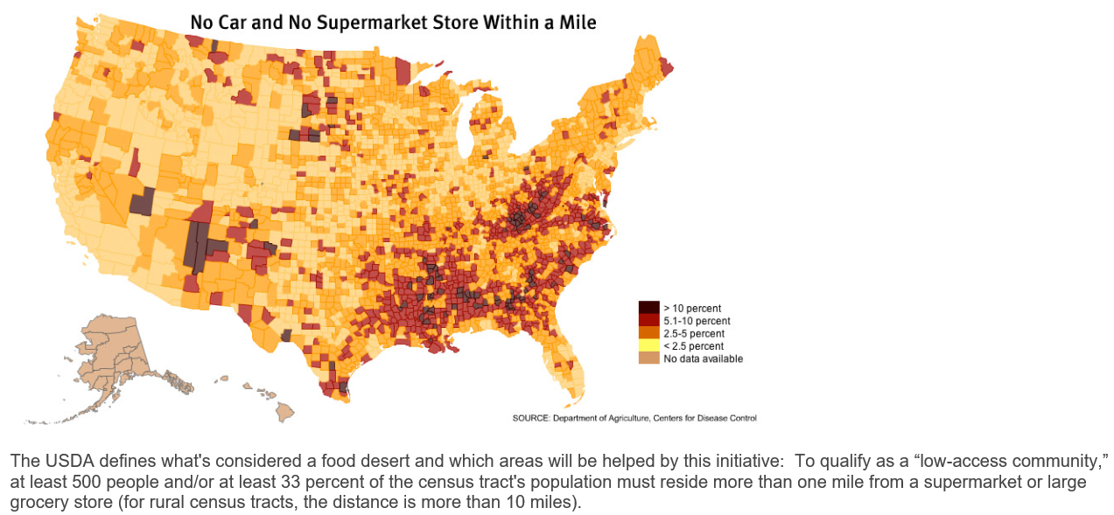

- Do you live in a state with any food deserts? Yes No
- Do you live in a state with levels greater than 10%? Yes No
- Where are the greatest number of food deserts in your state? ___________________________________________
- According to the USDA, how do they determine if an area is a food desert?

- Using the USDA website, https://www.ers.usda.gov/data/fooddesert/, do you live in a food desert? Yes No
  - How does, or could, living in a food desert impact you, your family, and your community?

- In the space below, draw a map of a town or county that would have a food desert. Include the following: a family and their home, a convenience store, a large grocery store, a farmers market, roads and distances between objects. Include a description of the town or county and how that family is impacted by its location. Be sure to reference your picture in your explanation.
Can You Make It 30 Days?
Aligned to the following standards:
FFA.PL-A; FFA.PG-G; FFA.PG-I; FFA.PG-J; FFA.CS-M; FFA.CS-N; CCSS.ELA.SL.9-10.1; CCSS.ELA.SL.9-10.2; CCSS.ELA.RST.9-10.7; CCSS.WHST.9.10.4; MP1; MP5; MP6; CRP.02; CRP.04
Directions:
Imagine you have lost your job and your savings are down to $1,500. How will you make it through the month?

- Select and circle a job from the options provided. This will be your job and salary throughout the game.
Waiter/Waitress Needed!
Be kind and courteous to guests while meeting their dining needs.
$2.75/hour + tips
Hours will vary each week.
Farm Hand Wanted Immediately!
Drive equipment during harvest, transport grain to the local elevator, apply pesticides to crops, transport livestock to market.
$8.50/hour – 6 a.m. to 2 p.m.

School Custodian Needed
Responsible for cleaning and maintenance throughout the school. Lifting boxes of various weights is a requirement.
$7.50/hour – 3 p.m. to 11 p.m. + sporting events

- Keep track of your budget for the month. Use a red pen or colored pencil for costs and a green pen or colored pencil for money coming in (ex. pay day):

Day | Item Purchased/Paid | Cost | Total ($1,500)
1 | Apartment Rent
 | Electricity
 | Water
 | Renter’s Insurance
 | Health Insurance
 | Car Insurance
 | Groceries (for the month)
2
3
4
5
6
7
8
9
10 | PAY DAY!
 | Health Insurance
11
12
13
14
15
16
17
18
19
20 | Pay Day!
 | Health Insurance
21
22
23
24
25
26
27
28
29
30
 | Total left:

Aligned to the following standards:
FFA.PL-A; FFA.PG-G; FFA.PG-I; FFA.PG-J; FFA.CS-M; FFA.CS-N; CCSS.ELA.SL.9-10.1; CCSS.ELA.SL.9-10.2; CCSS.ELA.RST.9-10.7; CCSS.WHST.9.10.4; MP1; MP5; MP6; CRP.02; CRP.04

How did you make your decisions? ___________________________________________________________________________________________________________________________________________________________________________________________________________________________________________________________________________________________________________________________________________________________________________________________________________________________________________________________________________________________________________________________________________________________________________________________________________________________________________________


Circle how you felt at the end of this game:

Based on what you have learned about food insecurity, what impact would this have on your ability to acquire healthy, nutritious food? ____________________________________________________________________________________________________________________________________________________________________________________________________________________________________________________________________________________________________________________________________________________________________________________________________________
Why do you have these feelings after completing the game? What do you think this would be like each month for a year? ________________________________________________________________________________________________________________________________________________________________________________________________________________________________________________________________________________________________________________________________________________________________________________________________________________________________________________________________________________________________________________________________________________________________________________________________________________________________________________________________________________________________
Where Do We Go from Here?
Aligned to the following standards:
FFA.PL-A; FFA.PG-G; FFA.PG-I; FFA.PG-J; FFA.CS-M; FFA.CS-N; CCSS.ELA.SL.9-10.1; CCSS.ELA.SL.9-10.2; CCSS.ELA.RST.9-10.7; CCSS.WHST.9.10.4; MP1; MP5; MP6; CRP.02; CRP.04
Directions:
With a partner, complete the following chart to sum up what you know, what you can do to help your community and what you still need to know about food insecurity.

What do I know about food security? | What can I do to help combat food insecurity in my community?
What do I still need to know about food insecurity in the United States?

