Match
Aligned to the following standards:
AS.02; AS.05; AS.08; CS.01; FFA.PL-A; FFA.PG-J; FFA.CS-M; FFA.CS-N; AG1; AG.ANI2; AG.ANI5; AG.ANI8; AGC10.03; CCSS.ELA.RI.9-10.4; CCSS.ELA.W.9-10.2; CCSS.ELA.SL.9-10.1; CCSS.ELA.SL.9-10.2; CCSS.ELA.SL.9-10.4; CCSS.ELA.WHST.9.10.2; CCSS.ELA.WHST.9.10.4; MP1; MP3; MP5; MP6; HS-ETS1-3; CRP.02; CRP.04; CRP.05; CRP.06; CRP.07; CRP.08
Directions:
Match the meals to the species that produced the food. There may be multiple species per food dish.

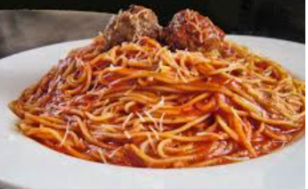
- Beef production
- Broiler (meat) chicken production
- Dairy production
- Egg production
- Pork production
- Sheep/Goats production
- Turkey production

________________________

Spaghetti and Turkey Meatballs

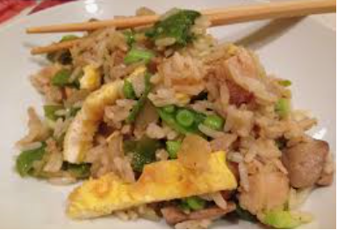

________________________

Chicken Fried Rice

Should you care about where your food comes from? Explain.
________________________

Breakfast Sandwich

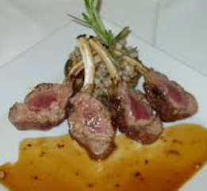
________________________

Lamb Chops

Teach the World
Aligned to the following standards:
AS.02; AS.05; AS.08; CS.01; FFA.PL-A; FFA.PG-J; FFA.CS-M; FFA.CS-N; AG1; AG.ANI2; AG.ANI5; AG.ANI8; AGC10.03; CCSS.ELA.RI.9-10.4; CCSS.ELA.W.9-10.2; CCSS.ELA.SL.9-10.1; CCSS.ELA.SL.9-10.2; CCSS.ELA.SL.9-10.4; CCSS.ELA.WHST.9.10.2; CCSS.ELA.WHST.9.10.4; MP1; MP3; MP5; MP6; HS-ETS1-3; CRP.02; CRP.04; CRP.05; CRP.06; CRP.07; CRP.08
Part 1
Directions:
Today, you and your partners will be placed in the role of a news broadcaster. You will report to the rest of the class about the production of a specific food-animal species: (1) beef, (2) broiler (meat) chickens, (3) dairy, (4) egg production, (5) pork, (6) turkey and (7) sheep/goats. During this news report, you need to be sure to only use reliable sources (sources have been provided). You will report about the farm-to-fork production process as well the welfare management practices that are in place for the species. Follow the template below to complete your research. Once you have completed your research, you will put together your broadcast. Be sure to implement the positive elements of a broadcast you discussed during the bell ringer activity. Your news broadcast should be 5 minutes long and have equal participation from all group members. Be creative and have fun!
Beef
Beef Check Off: Beef, It’s What’s for Dinner: https://www.beefitswhatsfordinner.com/

Hot topic: Grass fed vs. Feed lot production
Dairy
National Dairy Council: https://www.nationaldairycouncil.org/

Hot topic: Usage of rBST (artificial growth hormone) vs. no use of rBST
Pork

Pork Check Off: https://www.pork.org/

Hot topic: gestation crate usage vs. no gestation crates
Sheep/Goats
American Goat Federation: https://americangoatfederation.org/
American Lamb Board: https://lambresourcecenter.com/

Hot topic: Docking tails vs. not docking tails
Turkey

National Turkey Federation: https://www.eatturkey.org/

Hot topic: GMO feed vs. Non-GMO feed
Eggs
American Egg Board: https://www.incredibleegg.org/?utm_source=bing&utm_medium=cpc&utm_campaign=Int_General&utm_term=%5Bamerican%20egg%20board%5D&utm_content=American%20Egg%20Board_Exact

Hot topic: cage-free eggs vs. caged
Broiler (meat) Chickens
National Chicken Council: https://www.nationalchickencouncil.org/

Hot topic: Antibiotic use vs. no antibiotics
Additional Resources for All Species

American Humane Association: https://www.americanhumane.org/program/farms/

Animal Health Institute: https://www.ahi.org/issues-advocacy/animal-antibiotics/

Department of Agriculture’s Animal and Plant Health Inspection Service: http://www.aphis.usda.gov/animal_welfare/

Department of Agriculture’s National Agriculture Library Animal Care Guidelines: https://www.nal.usda.gov/awic/standards-and-guidelines

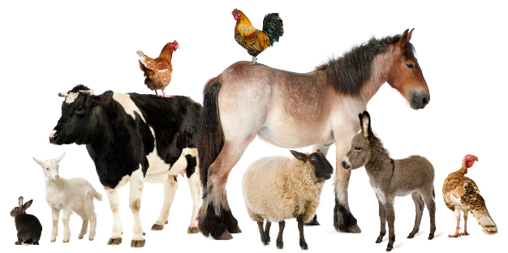

Directions:
Aligned to the following standards:
AS.02; AS.05; AS.08; CS.01; FFA.PL-A; FFA.PG-J; FFA.CS-M; FFA.CS-N; AG1; AG.ANI2; AG.ANI5; AG.ANI8; AGC10.03; CCSS.ELA.RI.9-10.4; CCSS.ELA.W.9-10.2; CCSS.ELA.SL.9-10.1; CCSS.ELA.SL.9-10.2; CCSS.ELA.SL.9-10.4; CCSS.ELA.WHST.9.10.2; CCSS.ELA.WHST.9.10.4; MP1; MP3; MP5; MP6; HS-ETS1-3; CRP.02; CRP.04; CRP.05; CRP.06; CRP.07; CRP.08
Record information in each box to help you prepare your news broadcast.
What is the purpose of your species for food production?
Hot topic research: What are both sides of the issue? Why is this issue a concern? What is the industry doing to address this issue?
Describe the housing and management practices of your species. Where do they live? How do they live (cages, etc.)? What considerations have to be made for their housing?
How is good animal welfare (the way an animal is treated) maintained during production? Give specific examples of how and why.
What is the impact on the environment by this species? Ex. water usage
Part 2
Aligned to the following standards:
AS.02; AS.05; AS.08; CS.01; FFA.PL-A; FFA.PG-J; FFA.CS-M; FFA.CS-N; AG1; AG.ANI2; AG.ANI5; AG.ANI8; AGC10.03; CCSS.ELA.RI.9-10.4; CCSS.ELA.W.9-10.2; CCSS.ELA.SL.9-10.1; CCSS.ELA.SL.9-10.2; CCSS.ELA.SL.9-10.4; CCSS.ELA.WHST.9.10.2; CCSS.ELA.WHST.9.10.4; MP1; MP3; MP5; MP6; HS-ETS1-3; CRP.02; CRP.04; CRP.05; CRP.06; CRP.07; CRP.08
Directions:
Now that you have learned about the different food-producing species, compare and contrast your species with two others to visually see how they are similar and different.
What surprised you the most about the similarities and differences among the three species you compared and contrasted?
Which species/production practices surprised you the most overall? Why?
Which production practices could be the most misunderstood by the general consumer? Why?

Part 3
Aligned to the following standards:
AS.02; AS.05; AS.08; CS.01; FFA.PL-A; FFA.PG-J; FFA.CS-M; FFA.CS-N; AG1; AG.ANI2; AG.ANI5; AG.ANI8; AGC10.03; CCSS.ELA.RI.9-10.4; CCSS.ELA.W.9-10.2; CCSS.ELA.SL.9-10.1; CCSS.ELA.SL.9-10.2; CCSS.ELA.SL.9-10.4; CCSS.ELA.WHST.9.10.2; CCSS.ELA.WHST.9.10.4; MP1; MP3; MP5; MP6; HS-ETS1-3; CRP.02; CRP.04; CRP.05; CRP.06; CRP.07; CRP.08
Directions:
You have learned how food-animal species are produced, why they are produced the way that they are and hot topic issues. Now, let’s look at some products you would purchase locally. Using a local grocery store (ex. Kroger, Walmart, etc.), research the costs of the products below.
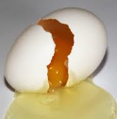
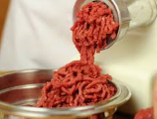

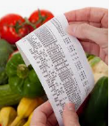
$______________

Store-Brand Large Grade A Eggs
$______________

Cage-Free Large Grade A Eggs
vs.
vs.
$______________

1 lb Store-Brand 80% Ground Beef
$______________

1 lb Grass-Fed 80% Ground Beef
$______________

1 Gallon Store-Brand 2% Milk
$______________

1 Gallon Organic 2% Milk
vs.
What impact did the production practices have on the price you would pay at the grocery store for a food product? Why?
What is the difference in production between cage-free and store-brand eggs?
What is the difference in production between grass-fed and store-brand ground beef?
What is the difference in production between organic and store-brand milk?

Nutrition Choices
Aligned to the following standards:
AS.02; AS.05; AS.08; CS.01; FFA.PL-A; FFA.PG-J; FFA.CS-M; FFA.CS-N; AG1; AG.ANI2; AG.ANI5; AG.ANI8; AGC10.03; CCSS.ELA.RI.9-10.4; CCSS.ELA.W.9-10.2; CCSS.ELA.SL.9-10.1; CCSS.ELA.SL.9-10.2; CCSS.ELA.SL.9-10.4; CCSS.ELA.WHST.9.10.2; CCSS.ELA.WHST.9.10.4; MP1; MP3; MP5; MP6; HS-ETS1-3; CRP.02; CRP.04; CRP.05; CRP.06; CRP.07; CRP.08
Part 1
Directions:
Circle the following foods according to the nutritional category they fall into. Some may have multiple categories, so add multiple circles in their assigned color. You can use the MyPlate website for help: https://www.choosemyplate.gov/.
- Protein = Purple
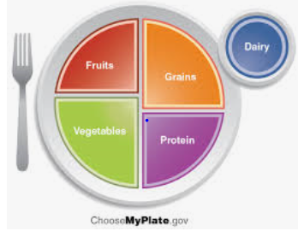
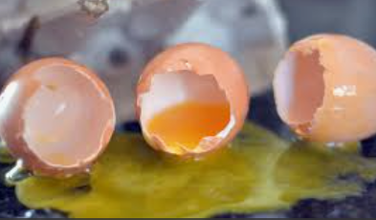
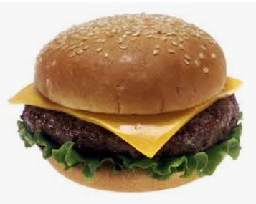
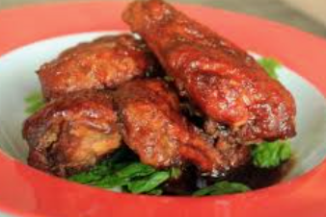
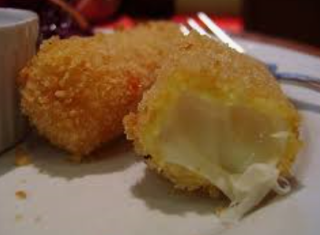
- Vegetable = Green
Eggs
Cheeseburger
Buffalo Wings
Mozzarella Stick
What role do food animals play in the nutrition we consume?
Select your favorite main course (ex. French toast) and identify the food animals involved in the production of that food.
- Grain = Orange
- Fruits = Red
- Blue = Dairy

Part 2
Aligned to the following standards:
AS.02; AS.05; AS.08; CS.01; FFA.PL-A; FFA.PG-J; FFA.CS-M; FFA.CS-N; AG1; AG.ANI2; AG.ANI5; AG.ANI8; AGC10.03; CCSS.ELA.RI.9-10.4; CCSS.ELA.W.9-10.2; CCSS.ELA.SL.9-10.1; CCSS.ELA.SL.9-10.2; CCSS.ELA.SL.9-10.4; CCSS.ELA.WHST.9.10.2; CCSS.ELA.WHST.9.10.4; MP1; MP3; MP5; MP6; HS-ETS1-3; CRP.02; CRP.04; CRP.05; CRP.06; CRP.07; CRP.08
Directions:
Now that we know the impact food animals have in our daily meal consumption, let’s determine how much we should be eating to maintain proper health and nutrition! Using the Nutrition.gov website, https://www.nutrition.gov/subject/whats-in-food, determine what the essential dietary components are, how much you should consume each day and where they come from.

Component | Why is it important? | How much do I need? | Examples
Protein
Carbohydrates
Fat
Vitamins and Minerals
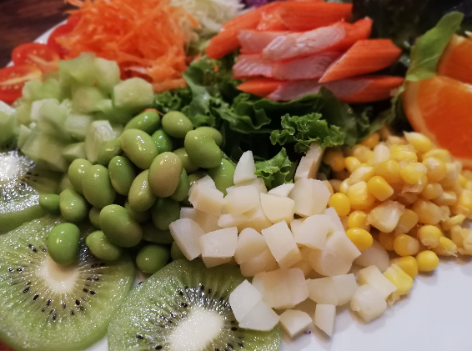
What could happen if you do not consume the needed nutrition? Give specific examples.
Part 3
Aligned to the following standards:
AS.02; AS.05; AS.08; CS.01; FFA.PL-A; FFA.PG-J; FFA.CS-M; FFA.CS-N; AG1; AG.ANI2; AG.ANI5; AG.ANI8; AGC10.03; CCSS.ELA.RI.9-10.4; CCSS.ELA.W.9-10.2; CCSS.ELA.SL.9-10.1; CCSS.ELA.SL.9-10.2; CCSS.ELA.SL.9-10.4; CCSS.ELA.WHST.9.10.2; CCSS.ELA.WHST.9.10.4; MP1; MP3; MP5; MP6; HS-ETS1-3; CRP.02; CRP.04; CRP.05; CRP.06; CRP.07; CRP.08
Directions:
Using the nutritional information we just learned about, evaluate the nutrition for each of the following foods.
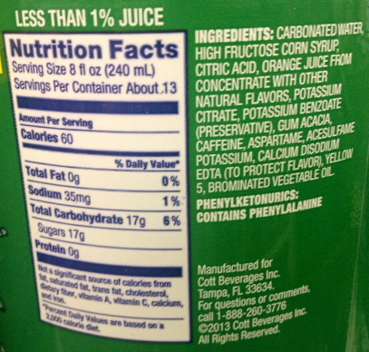
Why is it so important to include food-animal products in your everyday diet?
What is the role of food-animal products in meeting the needs of those who are food insecure?
If a person is unable to consume animal-based products due to health concerns, how can they ensure a healthy diet?
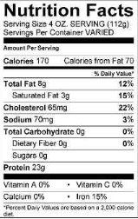
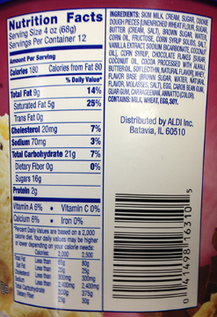
Identify the amounts of the following:
Ice Cream
Ground Beef
Mountain Dew Soda

Carbohydrates: _______

Protein: _______

Write down another fact you find
interesting about this food label.
Identify the amounts of the following:

Carbohydrates: _______

Protein: _______

Write down another fact you find
interesting about this food label.
Identify the amounts of the following:

Carbohydrates: _______

Protein: _______

Write down another fact you find
interesting about this food label.
Teach the World Rubric
Aligned to the following standards:
AS.02; AS.05; AS.08; CS.01; FFA.PL-A; FFA.PG-J; FFA.CS-M; FFA.CS-N; AG1; AG.ANI2; AG.ANI5; AG.ANI8; AGC10.03; CCSS.ELA.RI.9-10.4; CCSS.ELA.W.9-10.2; CCSS.ELA.SL.9-10.1; CCSS.ELA.SL.9-10.2; CCSS.ELA.SL.9-10.4; CCSS.ELA.WHST.9.10.2; CCSS.ELA.WHST.9.10.4; MP1; MP3; MP5; MP6; HS-ETS1-3; CRP.02; CRP.04; CRP.05; CRP.06; CRP.07; CRP.08

Indicator | Strong  (5–4 points) | Moderate  (3–2 points) | Weak  (1–0 points) | Points Earned
Species Purpose | Included | Included, but difficult to understand | Not included
Describe the Housing and Management Practices | Demonstrates thorough research and understanding of accurate production practices by giving 3 or more examples | Demonstrates moderate research and understanding of accurate production practices by giving 2 examples | Demonstrates limited research and understanding of accurate production practices by giving less than 2 examples
Hot Topic Research | Demonstrates thorough research and understanding of the hot topic by giving 3 or more examples | Demonstrates moderate research and understanding of the hot topic by giving 2 examples | Demonstrates limited research and understanding of the hot topic by giving less than 2 examples
Animal Welfare | Demonstrates thorough research and understanding of animal welfare | Demonstrates moderate research and understanding of animal welfare | Demonstrates limited research and understanding of animal welfare
Environmental  Concerns | Demonstrates thorough research and understanding of the environmental concerns by giving 3 or more examples | Demonstrates moderate research and understanding of the environmental concerns by giving 2 examples | Demonstrates limited research and understanding of the environmental concerns by giving less than 2 examples
Used Valid Sources | All sources were valid. | Half of the resources were valid. | Less than half of the resources were valid.
Demonstrates Knowledge of Topic | Presentation shows strong knowledge of the subject with good evidence of support. | Presentation shows some knowledge of the subject with fair evidence of support. | Presentation shows little knowledge of the subject with poor evidence of support.
Team Participation | All team members took an active role in the presentation. | One to two team members did not participate. | Less than three team members took an active role in the presentation.

Total: __________
Comments:

