Addressing Hunger
Aligned to the following standards:
CS.05; FFA.PL-A; FFA.PL-E; FFA.PL-F; FFA.PG-I; FFA.PG-J; FFA.CS-N; AG5; CCSS.ELA.RI.9-10.4; CCSS.ELA.SL.9-10.2; CCSS.ELA.WHST.9.10.4; MP1; MP5; MP6; CRP.02; CRP.04; CRP.06; CRP.07; CRP.08
Directions:
There are three levels of responsibility that work to address hunger and food insecurity: public, private and civic. Read each definition and brainstorm the possible pros and cons of each type of responsibility.
Civic Responsibility

This type of responsibility falls to each individual person and the desire to make our communities better. (Example: roadside clean-up)
Private Responsibility

This type of responsibility falls to private business corporations. (Example: annual fundraisers for a cause put on by a private business.)
Public Responsibility

This type of responsibility falls to the federal, state or local government. (Example: Supplemental Nutrition Assistance Program [SNAP] and Women, Infants and Children [WIC])
*https://www.fns.usda.gov/snap/supplemental-nutrition-assistance-program-snap

How do each of these levels (private, public and civic) work together to meet the food insecurity and hunger issues that exist in the U.S.?
What are the pros and cons of this type of responsibility for meeting the hunger needs in the U.S.?
What are the pros and cons of this type of responsibility for meeting the hunger needs in the U.S.?

What are the pros and cons of this type of responsibility for meeting the hunger needs in the U.S.?

Philanthropy
Aligned to the following standards:
CS.05; FFA.PL-A; FFA.PL-E; FFA.PL-F; FFA.PG-I; FFA.PG-J; FFA.CS-N; AG5; CCSS.ELA.RI.9-10.4; CCSS.ELA.SL.9-10.2; CCSS.ELA.WHST.9.10.4; MP1; MP5; MP6; CRP.02; CRP.04; CRP.06; CRP.07; CRP.08
Part 1
Directions:
Philanthropy is a crucial component in any country. Watch the video “Philanthropy and Service-Learning: Why Do They Matter?,” https://youtu.be/MIf-Em7dmvw, and answer the questions below to learn more about philanthropy and its importance in society.
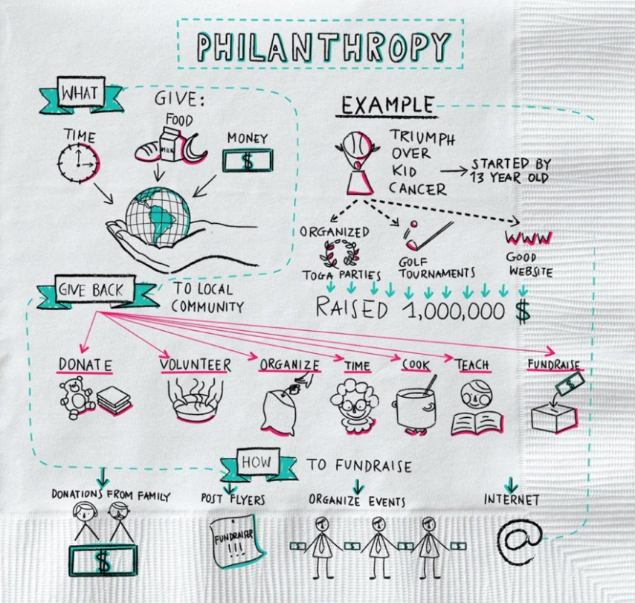

Using the example provided, draw out (like in the picture) a philanthropic activity you have participated in, witnessed or would like to start.
Philo = ________________________________________
Philanthropy is helping others by …

- T__________ Example:
- T__________ Example:
- T__________ Example:
Why should you engage in philanthropy?

Part 2
Directions:
Watch the video “Cayden, a Philanthropist,” https://youtu.be/UDe1xuQFwPE, and answer the following questions on a separate sheet of paper: (1) What is Cayden doing? Why? and (2) What have you witnessed in your community that embodies the same ideals as what Cayden is doing?

Now that we understand the overarching meaning of philanthropy, what types of philanthropic options exist to address food insecurity? Research each of the following organizations and then select two you would like to learn more about. (1) AARP and AARP Foundation, (2) Feeding America, (3) Meals on Wheels, (4) UNICEF and (5) World Food Programme.

- Select 2 organizations of most interest to you.

- _____________________________________________
- _____________________________________________
- Using the space below, record information about each organization

- Using the template below, create a Snapchat story for each organization.

- Using the template below, create an Instagram post for each organization. You will add and caption two pictures to represent the account.

(2)

Organization 2: ______________________________
Organization 1: ______________________________

(3) Each screen will be a different part of your Snapchat story for the organization listed. If you need more space for your description for each screen, you can write it under the phone image.


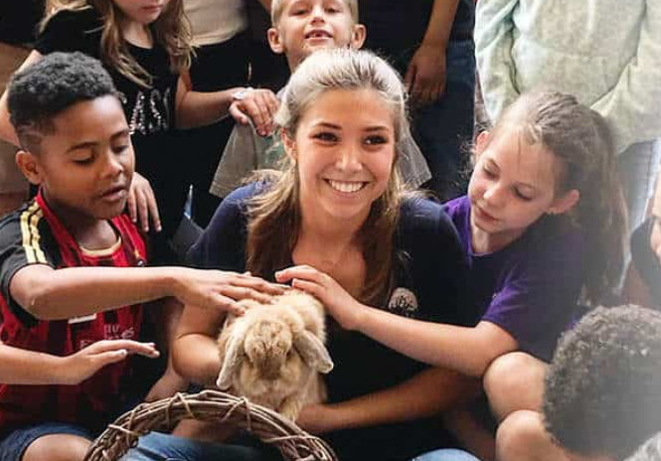
Donated dwarf goats, rabbits help FFA chapter spread happiness.
Example:

Organization 1: __________________
Organization 2: __________________________

(4) Develop two Instagram posts for each organization. Be sure to include a one- to two-sentence post to accompany your picture.



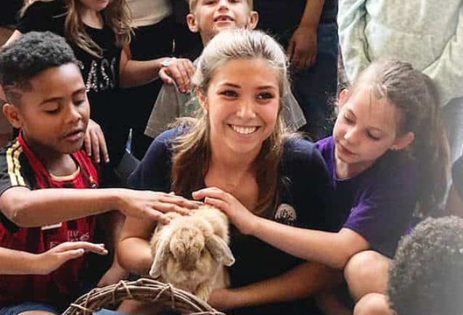
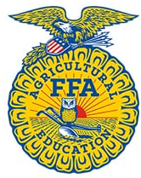

We learn best through hands-on experiences. These donated dwarf goats and rabbits help this FFA chapter spread happiness.
National FFA Organization …

Example:
Organization 1: _____________________

______________________________________________________________________________________________________________________________________________________________________________________________________________________________
_____________________ …

______________________________________________________________________________________________________________________________________________________________________________________________________________________________
_____________________ …

Organization 2: _____________________

______________________________________________________________________________________________________________________________________________________________________________________________________________________________
_____________________ …

______________________________________________________________________________________________________________________________________________________________________________________________________________________________
_____________________ …
What impact and role do these organizations have in solving food insecurity issues?

_______________________________________________________________________________________________________________________________________________________________________________________________________________________________________________________________________________________________________________________________________________________________________________________________________________________________________________________________________________________________________________________________________________________________________________________________________________________________________________________________________________________________________
_________________________________________________________________________________________________

What impact does social media have on an organization?

_______________________________________________________________________________________________________________________________________________________________________________________________________________________________________________________________________________________________________________________________________________________________________________________________________________________________________________________________________________________________________________________________________________________________________________________________________________________________________________________________________________________________________
_________________________________________________________________________________________________



What Does It All Mean?
What impact do these organizations have in solving food insecurity issues?

_______________________________________________________________________________________________________________________________________________________________________________________________________________________________________________________________________________________________________________________________________________________________________________________________________________________________________________________________________________________________________________________________________________________________________________________________________________________________________________________________________________________________________
_________________________________________________________________________________________________
Aligned to the following standards:
CS.05; FFA.PL-A; FFA.PL-E; FFA.PL-F; FFA.PG-I; FFA.PG-J; FFA.CS-N; AG5; CCSS.ELA.RI.9-10.4; CCSS.ELA.SL.9-10.2; CCSS.ELA.WHST.9.10.4; MP1; MP5; MP6; CRP.02; CRP.04; CRP.06; CRP.07; CRP.08
Directions:
Now that we know more about philanthropy and some of the philanthropic options available to decrease food insecurity, let’s take a look at the impact. Feeding America is a large organization working to lessen food insecurity.

- Using the Feeding America Annual Report, answer the following questions.
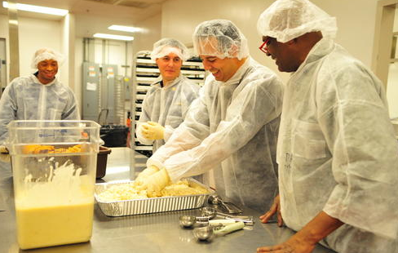

How do you think this process compares with how other food banks outside of the Feeding America network may work?
How many meals did Feeding America provide to those facing hunger and food insecurity?

_________ billion
How much food was prevented from becoming waste?

_________ billion pounds
What connection does food insecurity and hunger have with overall human health?
Overall, what impact do food banks have on local communities? Have you seen any in your local community? Explain.

- Using this website, https://www.feedingamerica.org/our-work/food-bank-network, read the information and summarize what you have read by drawing the process of how a food bank works to supply food to others. (Your illustration must look different than the website).

- Using the Feeding America food bank finder, find a food bank located near you!
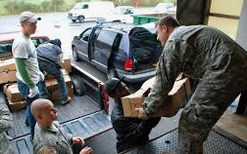

Where is the location of the closest Feeding America food bank to you?
What impact do you think this food bank has or could have on your local community?
What does your local community do to help with hunger and food insecurity?
What impact do you think your community food bank has or could have on your local community?
What can your school do to help food insecurity in your community?
What can you do to help food insecurity in your community?

- To assist in the fight against food insecurity and hunger, the U.S. will continue to need good-hearted people with a passion for service. Using AgExplorer, identify three careers
directly connected to fighting hunger and food insecurity.

- ___________________________________________
- ___________________________________________
- ___________________________________________

