Member Rides the Waves of Award-Winning Crabbing SAE
Aligned to the following standards:
FFA.PL-A; FFA.PL-C; FFA.PL-E; FFA.PG-J; FFA.CS-M; FFA.CS-N; AG5; CCSS.RI.9-10.2; CCSS. RI.9-10.4; CCSS.ELA.W.9-10.2; CCSS.ELA.W.9-10.4; CCSS.SL.9-10.2; CCSS.SL.9-10.4; CRP.02; CRP.04;CRP.06, CRP.08; CCSS.WHST.9.10.4; CCSS.WHST.9.10.6, CS.05
Part 1
Directions:
Read the article “Member Rides the Waves of Award-Winning Crabbing SAE” found at https://www.ffa.org/ffa-new-horizons/member-rides-the-waves-of-award-winning-crabbing-sae/and complete the following activities.

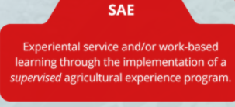

- What is Tanner’s SAE?
2. What are his main tasks?
3. Additionally, Tanner obtained his

_____________ license, which included a

_____-week course and a ___________ test in

the ____________ Bay.
4. How did his experience in FFA help?
6. What two areas does Tanner harvest blue crabs from?
7. Tanner also serves as a ________

for ___________ Tug Co., and in the

future, he hopes to continue

expanding his skill ______ and

attend the _________ Mechanic

Institute.
5. Tanner says, “I’m so
glad I did because I really
enjoy _________, and I’ve
been able to use the
_____________ skills I
developed in FFA to help
with the _________
relations ________ of the
business.
Why are the crabs blue? https://www.thoughtco.com/blue-crab-facts-4770253
Part 2
Directions:
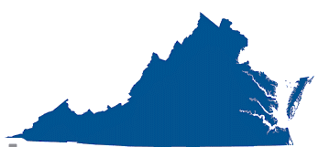
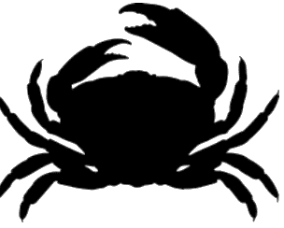

Follow this link, http://www.virginiaseafood.org/about-virginia-seafood/, to learn about the economic impact of the seafood/crab industry in Virginia and then answer the questions below.
- Virginia is the nation’s _________ largest producer

of _________ products and is only out paced by what two states?

___________________ and ____________________

2. Fish and shellfish are harvested, processed and shipped

within _________ hours to domestic and

__________________ markets.
3. According to data from the U.S. Department of Commerce, Americans consume ____________
pounds of fish and ______________ per person.

Using the space below, identify the top ten most popular seafood items:
4.
Virginia commercial watermen __________________ harvest
enough seafood to produce over ___________________ meals.
7. How much seafood did Virginia export in 2017 and to how many countries?
5. Virginia’s watermen harvest _________ commercially valuable species.
- 60 c. 65
- 50 d. 75
6.. Identify and list the species that are harvested in order of economic value:
1. 5. 9.
2. 6.
3. 7.
4. 8.

Part 3
Directions:

Follow this link, AgExplorer.FFA.org/ to learn about careers related to the fish/seafood industry and complete the following activities. Research four careers related to fish/seafood and respond below.
For additional careers related to fish/seafood industry, here is a direct link to additional possible careers: https://agexplorer.ffa.org/search/fish
Career Title:

________________________
What are two of the responsibilities of this career?

Who are potential employers?

What education/training is required?
Career Title:

________________________
What are two of the responsibilities of this career?

Who are potential employers?

What education/training is required?

Which career did you find most interesting and why?
Career Title:

________________________
What are two of the responsibilities of this career?

Who are potential employers?

What education/training is required?
Career Title:

________________________
What are two of the responsibilities of this career?

Who are potential employers?

What education/training is required?

Part 4
Directions:

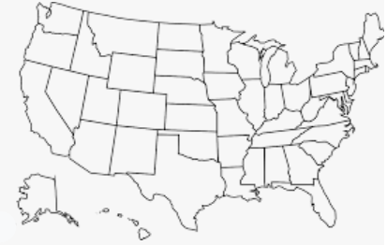
Follow this link, https://www.fisheries.noaa.gov/species/blue-crab, to answer the questions below.
3. List the equipment used when harvesting blue crabs. https://www.fisheries.noaa.gov/species/blue-crab#commercial
1. 4.
2. 5.
3.
- Draw a picture of a crab in the space below:

Draw a star next to the locations where blue crabs live.

2. What is the scientific name of the blue crab?

Follow these links, https://ncseagrant.ncsu.edu/coastwatch/previous-issues/2010-2/spring-2010/naturalists-notebook-how-to-nab-a-crab/ and FFA.org/value-chain/, to answer the questions below.
4. What are the steps commercial fisherman take to catch blue crabs?

Step 1:
Step 2:

Step 2: Once inside and unable to reach the food, they swim to the upper portion of the pot, called “the parlor” to try and escape. Undersized crabs escape through special openings called cull rings.
5. Explain recreational crabbing methods:

In the AFNR Food Value Chain, where does Step 1 of blue crab production fall?
In the AFNR Food Value Chain, where does Step 2 of blue crab production fall?

What is similar about commercial and recreational crabbing methods?

What is different about commercial and recreational crabbing methods?
When fishermen market their product, what does that fit in the AFNR Food Value Chain?

