What Is Respect?
Aligned to the following standards:
CS.01; CS.02; CS.05; CS.06; ESS.03; FFA.PL-A; FFA.PL-C; FFA.CS.M; FFA.CS-N; AG1; AG2; AG5; AG6; AGC09.02; AGC10.03; CCSS.ELA.RI.9-10.1; CCSS.ELA.RI.9-10.2; CCSS.ELA.RI.9-10.3; CCSS.ELA.W.9-10.2; CCSS.ELA.SL.9-10.2; CCSS.ELA.SL.9-10.4; CCSS.ELA. RST. 9-10.7; CCSS.ELA.RST.9.10.8; CCSS.ELA.WHST.9.10.6; HS-ETS1-3; AFNR Career Cluster, Statement 2; CRP.04; CRP.05; CRP.06; CRP.07; CRP.08
Directions:
Agriculturists are well suited to be the primary caretakers of the planet, and the need for caretakers is critical. Because the food and fiber industries rely on the efficiency and sufficiency of the world’s natural resources, it is vital for the agriculture industry to ensure individuals are equipped with the skills needed to best respect the planet.

Define and illustrate what respecting the planet means to you. Think creatively. Consider what challenges face the world and what it might look like if people (you, your peers, family, teachers, etc.) took steps to address them.

Define what respecting the planet means to you:

Illustrate what respecting the planet means to you:

Carbon Footprint
Aligned to the following standards:
CS.01; CS.02; CS.05; CS.06;ESS.03; FFA.PL-A; FFA.PL-C; FFA.CS.M; FFA.CS-N; AG1; AG2; AG5; AG6; AGC09.02; AGC10.03; CCSS.ELA.RI.9-10.1; CCSS.ELA.RI.9-10.2; CCSS.ELA.RI.9-10.3; CCSS.ELA.W.9-10.2; CCSS.ELA.SL.9-10.2; CCSS.ELA.SL.9-10.4; CCSS.ELA. RST. 9-10.7; CCSS.ELA.RST.9.10.8; CCSS.ELA.WHST.9.10.6; HS-ETS1-3; AFNR Career Cluster, Statement 2; CRP.04; CRP.05; CRP.06; CRP.07; CRP.08

Directions:
To understand the impact of challenges facing the planet, we must first understand our individual impact on the environment. Examining our carbon footprint is one way to assess our individual impact on the planet.

Complete the following:
- Visit the Environmental Protection Agency’s (EPA; 2016) “Carbon Footprint Calculator” website. The URL is https://www3.epa.gov/carbon-footprint-calculator/.
- Estimate your household’s average monthly usage of home energy, transportation and waste.
  - To gain the most accurate information, ask your head of household for your household’s average figures for each section.
- Complete the following questions about your carbon footprint.
  - After reviewing your report, adjust the figures in the sections to reduce your emissions and note the changes it makes on your overall scores.

What is your total estimated pounds of CO2 emitted per year? You may need to estimate your household’s figures or double-check figures with your current head of household to get the most accurate numbers.
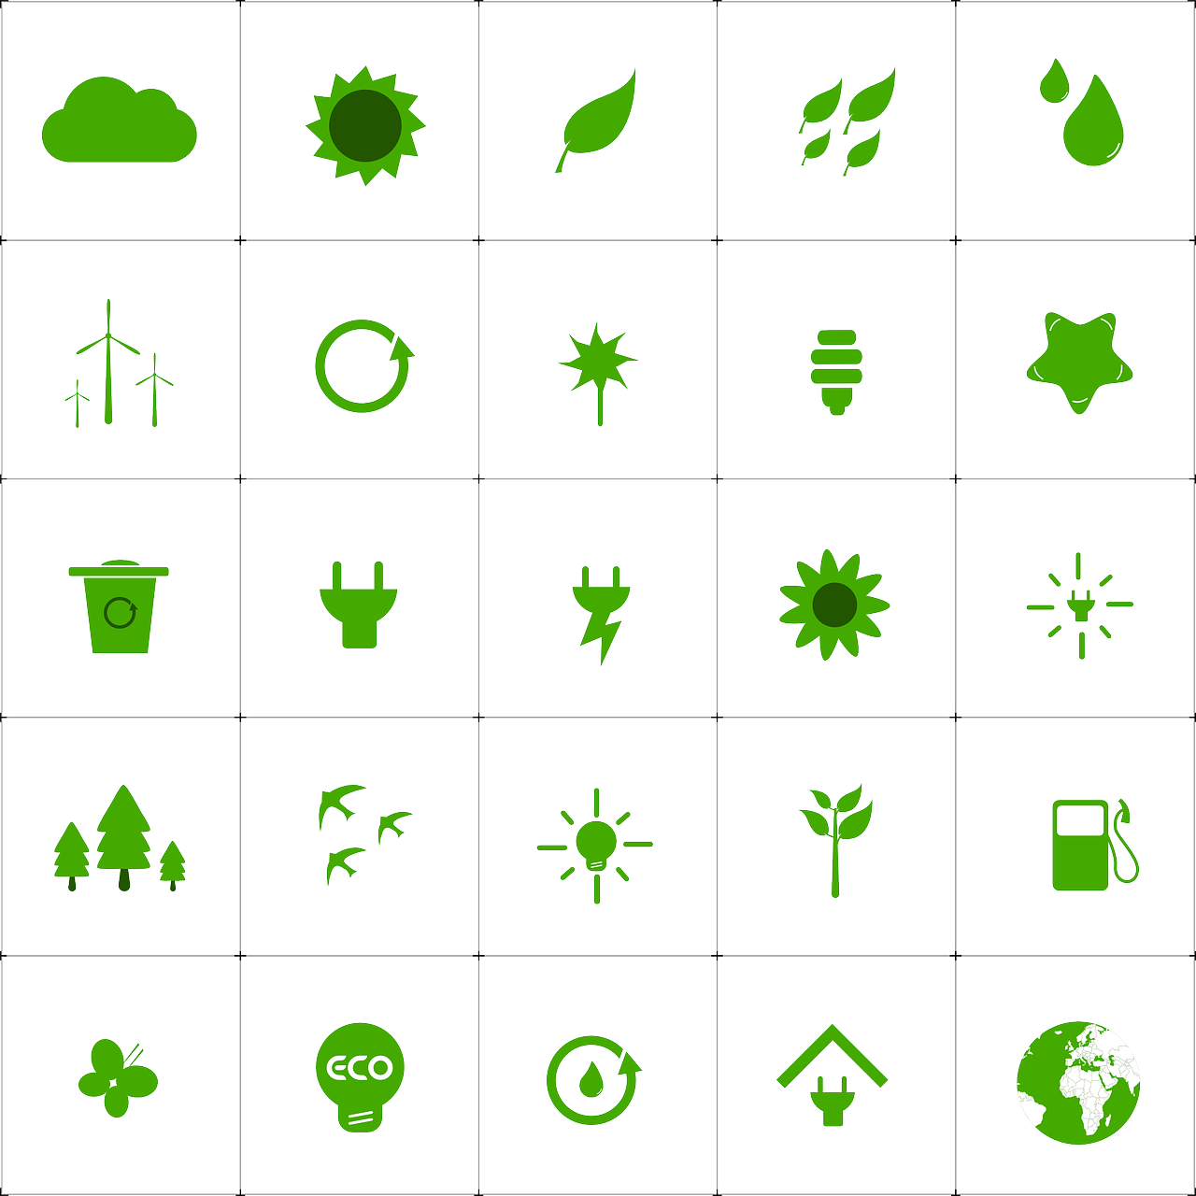
Home Energy: Transportation: Waste:
___________ ___________ ___________

After reviewing your report, what steps could you take to reduce your carbon emission’s impact?

What surprised you the most? Did any of the findings not surprise you? Why?

Respecting the Planet Globally
Aligned to the following standards:
CS.01; CS.02; CS.05; CS.06; ESS.03; FFA.PL-A; FFA.PL-C; FFA.CS.M; FFA.CS-N; AG1; AG2; AG5; AG6; AGC09.02; AGC10.03; CCSS.ELA.RI.9-10.1; CCSS.ELA.RI.9-10.2; CCSS.ELA.RI.9-10.3; CCSS.ELA.W.9-10.2; CCSS.ELA.SL.9-10.2; CCSS.ELA.SL.9-10.4; CCSS.ELA. RST. 9-10.7; CCSS.ELA.RST.9.10.8; CCSS.ELA.WHST.9.10.6; HS-ETS1-3; AFNR Career Cluster, Statement 2; CRP.04; CRP.05; CRP.06; CRP.07; CRP.08

Directions:
Understanding which challenges the earth faces across the globe gives a broad perspective to how to best respect the planet from an international perspective.

Complete the following:
- Visit the Schooled by Science “Top 10 Environmental Issues” (Nichols, 2017) website, available at https://schooledbyscience.com/environmental-issues/.
  - Another resource that explains these issues more in-depth is the United States Environmental Protection Agency’s (EPA, 2017) “Environmental Issues” website. The URL is https://www.epa.gov/environmental-topics.
- Review the list of issues facing the globe in the next 10 years.
- Consider which challenges are most relevant to your passions and/or future career.
- Complete and discuss the “Respecting the Planet Globally” questions below.

After reviewing the list of key issues facing the world, what three issues stood out the most to you? Why?

Select one issue that stands out the most. Research and list four key statistics about your selected issue and list its global impact below. Note: Be mindful of which articles or websites you are viewing. Is the website using accurate information to describe the issue? If not, continue researching until you find a website that uses scientific research to describe the issue.

What can agriculturists do to address the challenge you selected? Think creatively. How can producers or consumers make lifestyle changes to help address the challenge you highlighted?

Respecting the Planet Nationally
Aligned to the following standards:
CS.01; CS.02; CS.05; CS.06; ESS.03; FFA.PL-A; FFA.PL-C; FFA.CS.M; FFA.CS-N; AG1; AG2; AG5; AG6; AGC09.02; AGC10.03; CCSS.ELA.RI.9-10.1; CCSS.ELA.RI.9-10.2; CCSS.ELA.RI.9-10.3; CCSS.ELA.W.9-10.2; CCSS.ELA.SL.9-10.2; CCSS.ELA.SL.9-10.4; CCSS.ELA. RST. 9-10.7; CCSS.ELA.RST.9.10.8; CCSS.ELA.WHST.9.10.6; HS-ETS1-3; AFNR Career Cluster, Statement 2; CRP.04; CRP.05; CRP.06; CRP.07; CRP.08

Directions:
Agriculturists are the primary stewards of the land. However, the agriculture industry faces several challenges to be able to successfully and efficiently feed the world. The United States faces unique challenges to respecting the planet, but they all revolve around analyzing how to strengthen and prepare American agriculture to be more efficient and sustainable in production.

Complete the following:
- Watch “The Future of Farming and Agriculture” video by The Daily Conversation (2017). The URL is https://www.youtube.com/watch?v=Qmla9NLFBvU.
  - If YouTube is not available, move to the next bullet point.
- Visit UC Davis’ (2019) “Agricultural Sustainability Institute” website, available at https://asi.ucdavis.edu/programs/ucsarep/about/what-is-sustainable-agriculture.
- Consider the various innovative ideas, practices and technologies you saw in the video and on the website. In what ways can American agriculturists improve and strengthen the way they steward the land?
- Complete and discuss the “Respecting the Planet Nationally” questions below.

After watching the video and reviewing the content on the website, what agricultural innovations and ideas stood out as being the most valuable to American agriculture? Why?

Define sustainable agriculture. What can be done to support sustainable production agriculture in the United States? Visit UC Davis’ (2019) “Agricultural Sustainability Institute” website for resources to support your answer.

What solutions can American agriculturists implement to better respect the planet in the areas below? (Record your answers below the images for each area.)

Conservation: Water Usage: Energy Usage: Wildlife Habitat
Respecting the Planet Locally
Aligned to the following standards:
CS.01; CS.02; CS.05; CS.06; ESS.03; FFA.PL-A; FFA.PL-C; FFA.CS.M; FFA.CS-N; AG1; AG2; AG5; AG6; AGC09.02; AGC10.03; CCSS.ELA.RI.9-10.1; CCSS.ELA.RI.9-10.2; CCSS.ELA.RI.9-10.3; CCSS.ELA.W.9-10.2; CCSS.ELA.SL.9-10.2; CCSS.ELA.SL.9-10.4; CCSS.ELA. RST. 9-10.7; CCSS.ELA.RST.9.10.8; CCSS.ELA.WHST.9.10.6; HS-ETS1-3; AFNR Career Cluster, Statement 2; CRP.04; CRP.05; CRP.06; CRP.07; CRP.08

Directions:
Direct impact to respecting the planet starts with getting involved and invested at the local level. However, the environmental issues vary based on the part of the country in which you live.

Review the map of American agricultural commodities (Taxomita.com, 2017).
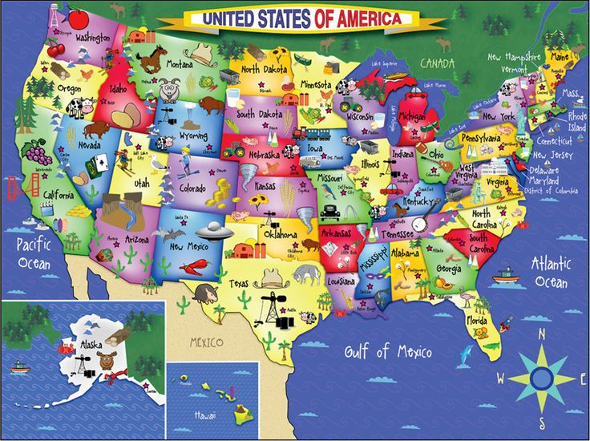
In your opinion, what type of agriculture is most prominent in your state?

Using the EPA website, https://www.epa.gov/environmental-topics, identify three environmental concerns you think impact your state’s agricultural production the most.

Using Unity College’s (2018) “Brainstorming Ways to Solve Environmental Problems” website (https://online.unity.edu/ways-to-solve-environmental-problems/), list three strategies in agriculture to lessen environmental impact in your state.

1)

2)

3)

