What Can I Be Used For?
Aligned to the following standards:
CS.02; CS.05; FFA.PL-A; FFA.PL-E; FFA.PL-C; FFA.CS-M; FFA.CS-N; AG2; AG5; AGC10.03; CCSS.RI.9-10.1; CCSS.RI.9-10.2; CCSS.RI.9-10.3; CCSS.W.9-10.2; CCSS.SL.9-10.2; CCSS.SL.9-10.4; CCSS.ELA.RST.9-10.1; CCSS.RST.9-10.7; CCSS.RST.9-10.8; CCSS.WHST.9.10.6; HS-ETS1-3; AFNR Career Cluster, Statement 2; AFNR Career Cluster, Statement 3; CRP.02; CRP.04; CRP.05; CRP.06; CRP.07; CRP.08
Directions:
Respecting the planet can be accomplished in many ways. Some strategies to respect the planet include reducing our carbon footprint by using cleaner energy, recycling waste, growing our own food sources and conserving water. The possibilities to improve the way we respect the planet are endless. To make the most profound impact respecting the planet, we must think creatively and innovatively.

Complete the following:
- Find one object or item in the classroom that can be used for multiple functions in addition to its normal use.
  - For example, a solid-walled trashcan is used for collecting paper or product waste, but it could also be used to collect rainwater or as a mulch container.
- Brainstorm as many different uses or functions that the selected object or item can be used for.
- Record your responses below.

Name of Object or Item: ______________________________________________

Think creatively. Brainstorm what other functions the object can be used for. List all possible options below.

What is the value of finding multiple purposes for different objects?

How does finding multiple purposes for different objects help us respect the planet?
Who Is Sealed Air?
Aligned to the following standards:
CS.02; CS.05; FFA.PL-A; FFA.PL-E; FFA.PL-C; FFA.CS-M; FFA.CS-N; AG2; AG5; AGC10.03; CCSS.RI.9-10.1; CCSS.RI.9-10.2; CCSS.RI.9-10.3; CCSS.W.9-10.2; CCSS.SL.9-10.2; CCSS.SL.9-10.4; CCSS.ELA.RST.9-10.1; CCSS.RST.9-10.7; CCSS.RST.9-10.8; CCSS.WHST.9.10.6; HS-ETS1-3; AFNR Career Cluster, Statement 2; AFNR Career Cluster, Statement 3; CRP.02; CRP.04; CRP.05; CRP.06; CRP.07; CRP.08
Directions:
Implementing strategies to respect the planet can often be daunting, especially when the stakes are high. Making a difference starts one step at a time. One strategy to identify how to help is to learn from companies and/or individuals who provide an example for sustainable lifestyles. Sealed Air sets the stage for respecting the planet.

Complete the following:
- Visit the Sealed Air website at https://sealedair.com/company/who-we-are.
- Watch the “Sealed Air Helps Businesses Succeed” video. The video is embedded in Paragraph 6 at https://sealedair.com/company/who-we-are.
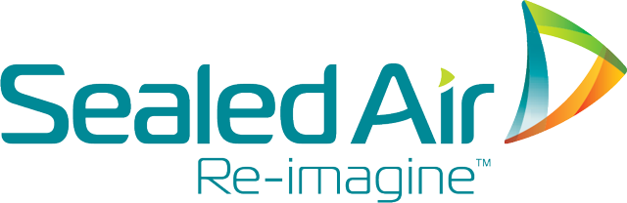
- Using the Sealed Air website as a resource, record your responses below.

Who we are:

Describe Sealed Air’s vision, mission and values.

Vision: | Mission: | Values:  1)  2)  3)  4)

Sustainability:

List and describe 3 sustainability initiatives that Sealed Air is currently involved in:

Careers:

Browse through the Careers tab on Sealed Air’s website. List 3 careers that interest you and relate to respecting the planet. Describe how each career helps with respecting the planet.

Identifying the Food Waste Problem
Aligned to the following standards:
CS.02; CS.05; FFA.PL-A; FFA.PL-E; FFA.PL-C; FFA.CS-M; FFA.CS-N; AG2; AG5; AGC10.03; CCSS.RI.9-10.1; CCSS.RI.9-10.2; CCSS.RI.9-10.3; CCSS.W.9-10.2; CCSS.SL.9-10.2; CCSS.SL.9-10.4; CCSS.ELA.RST.9-10.1; CCSS.RST.9-10.7; CCSS.RST.9-10.8; CCSS.WHST.9.10.6; HS-ETS1-3; AFNR Career Cluster, Statement 2; AFNR Career Cluster, Statement 3; CRP.02; CRP.04; CRP.05; CRP.06; CRP.07; CRP.08
Directions:
The first step in making a sustainable impact on the planet is to identify a need in your community, such as food waste. In the Blue 365 presentation, Dr. Ron Cotterman, vice president of corporate innovation and sustainability for Sealed Air, described food packaging innovations and practices to help extend freshness, ensure food safety and reduce waste.

Complete the following:
- Watch the Blue 365 Video by Dr. Ron Cotterman at Sealed Air. The video URL is https://vimeo.com/319978220.
  - For additional resources, review the presentation slide deck for Dr. Cotterman’s Blue 365 video and visit Sealed Air’s (2019) website on food waste. The URL is https://sealedair.com/topics/food-waste.
- Record your responses below.

What are the key takeaways in Dr. Ron Cotterman’s Blue 365 presentation? Why did these points stand out to you?

Dr. Cotterman discussed the need to extend freshness, ensure food safety and reduce waste. What is the value of helping food last longer on the shelf? In what ways could this influence your community and/or your school?

How can you limit food waste in your home or in your school? Identify the problem and provide a step-by-step solution. Your solution should include at least 3 steps.

Sustainable packaging plays a crucial role in protecting our food across the supply chain and protecting the resources that go into producing the food. Being environmental stewards requires that we address both of these issues; it cannot be one or the other. Visit the Green Education Foundation website for ideas to limit our plastic use at https://bit.ly/1mVir6c.

On average, how many plastic products do you throw away every day?
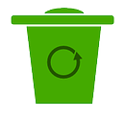

What are at least 5 ways you can personally limit your plastic waste?

On average, how many plastic products do you estimate students in your classroom throw away every day?

What are at least 5 ways your classroom can limit plastic waste?

Make It Local – Make a Change
Aligned to the following standards:
CS.02; CS.05; FFA.PL-A; FFA.PL-E; FFA.PL-C; FFA.CS-M; FFA.CS-N; AG2; AG5; AGC10.03; CCSS.RI.9-10.1; CCSS.RI.9-10.2; CCSS.RI.9-10.3; CCSS.W.9-10.2; CCSS.SL.9-10.2; CCSS.SL.9-10.4; CCSS.ELA.RST.9-10.1; CCSS.RST.9-10.7; CCSS.RST.9-10.8; CCSS.WHST.9.10.6; HS-ETS1-3; AFNR Career Cluster, Statement 2; AFNR Career Cluster, Statement 3; CRP.02; CRP.04; CRP.05; CRP.06; CRP.07; CRP.08
Directions:
Understanding the magnitude of an issue can help us better understand common myths associated with it. Making a real impact to increase respect for our planet starts at the local level.

Complete the following:
- Watch the “World Food Day 2017: Food Waste Myths” video available at https://sealedair.com/topics/food-waste.
  - Scroll to the bottom of the page and find the queued video section. Choose the video titled “World Food Day 2017: Food Waste Myths.”
- If audio is not available, visit commonly held misconceptions about food waste, outlined by Sealed Air’s, Karl Deily, https://sealedair.com/blog/dispelling-food-waste-myths-protect-our-food-supply.
- Record your responses below.

What are some common misconceptions about food waste? What are the real issues with food waste?

Using Sealed Air’s “World Food Waste Facts” map, https://sealedair.com/topics/food-waste, describe the food waste issue in each region listed below.
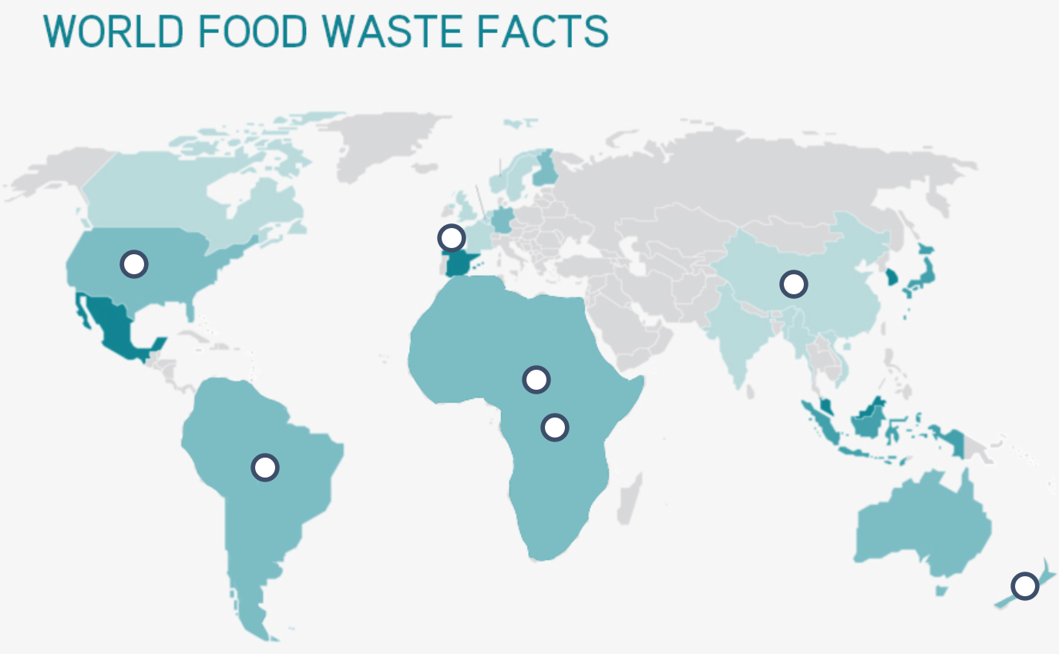
3

7

6

4

5

2

1

Figure 1. Sealed Air’s “World Food Waste Facts” map.

Think about your home community. In what ways can your community reduce food and plastic waste? How can your agricultural education classroom help?

Take Action
Aligned to the following standards:
CS.02; CS.05; FFA.PL-A; FFA.PL-E; FFA.PL-C; FFA.CS-M; FFA.CS-N; AG2; AG5; AGC10.03; CCSS.RI.9-10.1; CCSS.RI.9-10.2; CCSS.RI.9-10.3; CCSS.W.9-10.2; CCSS.SL.9-10.2; CCSS.SL.9-10.4; CCSS.ELA.RST.9-10.1; CCSS.RST.9-10.7; CCSS.RST.9-10.8; CCSS.WHST.9.10.6; HS-ETS1-3; AFNR Career Cluster, Statement 2; AFNR Career Cluster, Statement 3; CRP.02; CRP.04; CRP.05; CRP.06; CRP.07; CRP.08
Directions:
After we identify challenges, we can develop a plan to solve the problem by starting in our local community. One way to raise awareness for challenges in our community is to develop a campaign to share the background of the challenges, the mission of the campaign and action steps to get involved. Complete the questions below to guide the campaign development process.

What challenge or issue are you the most passionate about in your community? Why?

Explain the challenge or issue. How does it specifically influence your community?

How can the information you listed on the “Make It Local – Make a Change” worksheet help you develop a campaign in your own community?

What is the mission of your campaign? How does your selected delivery method best meet your mission statement?

Several options exist for developing a campaign to raise awareness for each selected challenge. Think creatively and innovatively about how to deliver your campaign. See the awareness campaign choice board below for how to address the need you identified in your community. Select one:
Adobe Spark Webpage or Video:  - Create a free online account for Adobe Spark by visiting the “Introducing Adobe Spark for Education” website at https://blog.adobespark.com/2018/  04/09/introducing-adobe-spark-for-education/.  - Watch the “Adobe Spark: Create compelling stories | Adobe Creative Cloud” video (Adobe Creative Cloud, 2018), https://youtu.be/MVShoOjDCnMInformation.  - The Adobe Spark webpage or video presentation should provide a comprehensive explanation of your awareness campaign. | Art Representation:  - Create a mural or art piece to visually represent how to address your selected challenge.  - Visit ThoughtCo’s (2019) “Promoting Peace Through Art” website for examples of art pieces that also connect a story. The URL is https://www.thoughtco.com/peace-art-projects-2578436.  - You should be prepared to write an exhibit label that describes the purpose of the art piece.
Infographic:  - Use blank paper with colored pens or markers to create an infographic or use an online infographic generator:  - Piktochart, https://piktochart.com/formats/infographics/  - Canva, https://www.canva.com  - The information shared in the infographic should represent accurate information or statistics about the selected issues. | Poem or Song:  - Create a poem or song lyrics that tell the story of your selected challenge.  - Stanzas and lyrics should be well-thought out and should reflect the background behind the selected challenge.

Rubric: Respecting the Planet Awareness Campaign
Aligned to the following standards:
CS.02; CS.05; FFA.PL-A; FFA.PL-E; FFA.PL-C; FFA.CS-M; FFA.CS-N; AG2; AG5; AGC10.03; CCSS.RI.9-10.1; CCSS.RI.9-10.2; CCSS.RI.9-10.3; CCSS.W.9-10.2; CCSS.SL.9-10.2; CCSS.SL.9-10.4; CCSS.ELA.RST.9-10.1; CCSS.RST.9-10.7; CCSS.RST.9-10.8; CCSS.WHST.9.10.6; HS-ETS1-3; AFNR Career Cluster, Statement 2; AFNR Career Cluster, Statement 3; CRP.02; CRP.04; CRP.05; CRP.06; CRP.07; CRP.08
Directions:
It is important to present new ideas and gain constructive feedback from peers when trying to overcome challenges, especially those facing our planet. Using the rubric below, rate your classmates on their “Respecting the Planet Awareness Campaign” presentations.

Think about the value of their presentations and provide quality positive feedback to them. Avoid simple “Good job” statements. What specific things made their presentations good?

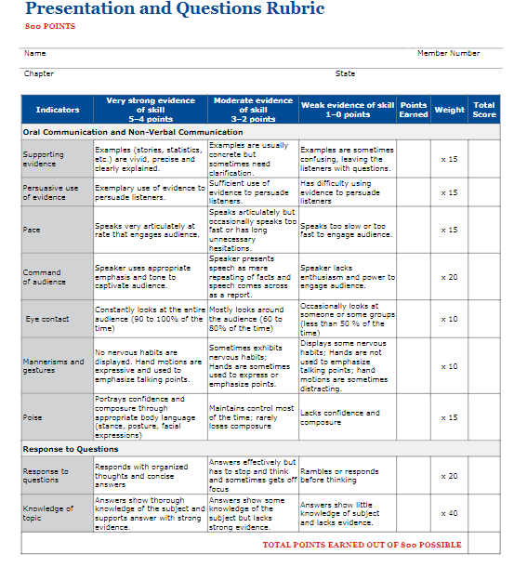
*Rubric is taken from the 2017–2021 National FFA Prepared Public Speaking Handbook.
Comments:

