Critical Challenges 2050
Aligned to the following standards:
CS.01; CS.05; CS.06; FFA.CS-M; FFA.CS-N; AG1; AG5; AG6; AGC10.03; AGC10.04; CCSS.ELA-RI.9-10.3; CCSS.ELA-W.9-10.2; CCSS.ELA.SL.9-10.4; CCSS.ELA.RST.9-10.7; CCSS.ELA.WHST.9.10.6; HS-ETS1-3; AFNR.CC.S.3; AFNR.CC.S.7; CRP.05; CRP.06
Directions:
Visit the Organisation for Economic Co-operation and Development’s website on 2050 projections, available at http://www.oecd.NFFA66org/env/indicators-modelling-outlooks/oecdenvironmentaloutlookto2050theconsequencesofinaction-keyfactsandfigures.htm. Draw a scene of how the world might look in 2050. Include what the scenery might look like. What might the people be doing? What are their jobs? How do they travel to and from their destinations? Use pictures, illustrations and words to capture your thoughts.

Watch Factnomenal’s “15 Amazing Statistics for 2050!” video, available at https://www.youtube.com/watch?v=sw2qBtnrQxQ. List 2 to 3 projections about the year 2050 that were the most surprising/alarming and explain why. What critical area(s) did the projections best align with? How?
Surprising projection:

Critical Area:
Surprising projection:

Critical Area:
Surprising projection:

Critical Area:


Critical Challenges — Infographic
Aligned to the following standards:
CS.01; CS.05; CS.06; FFA.CS-M; FFA.CS-N; AG1; AG5; AG6; AGC10.03; AGC10.04; CCSS.ELA-RI.9-10.3; CCSS.ELA-W.9-10.2; CCSS.ELA.SL.9-10.4; CCSS.ELA.RST.9-10.7; CCSS.ELA.WHST.9.10.6; HS-ETS1-3; AFNR.CC.S.3; AFNR.CC.S.7; CRP.05; CRP.06
Directions:
The first step in addressing critical challenges is understanding how to respect the planet’s land, air, water and natural resources. Answer the brainstorming questions in the section below.

1) What issue(s) are you most passionate about solving?

2) What do you currently know about the topic?

3) What would it take to communicate that issue to a non-scientific audience or one that might not be thinking about the future of the planet?

Directions:
Research current statistics about respecting our planet and sustainability by visiting the American Farm Bureau website (http://www.agfoundation.org/resources/food-and-farm-facts-2017) or the Food and Agriculture Organization’s website (http://www.fao.org/nr/sustainability/food-loss-and-waste/en/).

List 2 to 3 statistics you find the most interesting.

1) | 2) | 3)

Directions:
Design an infographic illustrating 2 to 3 statistics about respecting the planet and how agriculture can help improve sustainability. Sketch your ideas and thoughts in the space below. Then, use a clean piece of paper or an online infographic design system to create the final product.

Innovations for a Changing Globe
Aligned to the following standards:
CS.01; CS.05; CS.06; FFA.CS-M; FFA.CS-N; AG1; AG5; AG6; AGC10.03; AGC10.04; CCSS.ELA-RI.9-10.3; CCSS.ELA-W.9-10.2; CCSS.ELA.SL.9-10.4; CCSS.ELA.RST.9-10.7; CCSS.ELA.WHST.9.10.6; HS-ETS1-3; AFNR.CC.S.3; AFNR.CC.S.7; CRP.05; CRP.06
Directions:
Using a global issue you are passionate about (see the Critical Challenges — Infographic worksheet), describe one possible solution that could help to resolve the issue. Do any innovations/products currently exist to address this need? If so, what are they?

The issue: One possible solution: Solutions that exist:

Directions:
Create a business plan for an innovation or product to address this issue.

  - Name of the innovation/product:

  - What need does it address?

  - Describe the environmental, social and economic impact of the innovation/product.

  - How will it be accessed by or provided to agricultural producers? How will it benefit agricultural producers?

  - Projected cost of the innovation/product:

  - Projected release timeline:

  - Diagram of the innovation/product (provide labels and description):

Brainstorming Solutions for Critical Challenges
Aligned to the following standards:
CS.01; CS.05; CS.06; FFA.CS-M; FFA.CS-N; AG1; AG5; AG6; AGC10.03; AGC10.04; CCSS.ELA-RI.9-10.3; CCSS.ELA-W.9-10.2; CCSS.ELA.SL.9-10.4; CCSS.ELA.RST.9-10.7; CCSS.ELA.WHST.9.10.6; HS-ETS1-3; AFNR.CC.S.3; AFNR.CC.S.7; CRP.05; CRP.06
Directions:
Complete the concept map by listing at least five challenges that will be faced by the agriculture industry in the next 50 to 100 years, and research solutions to be practiced by individuals, businesses and/or communities.
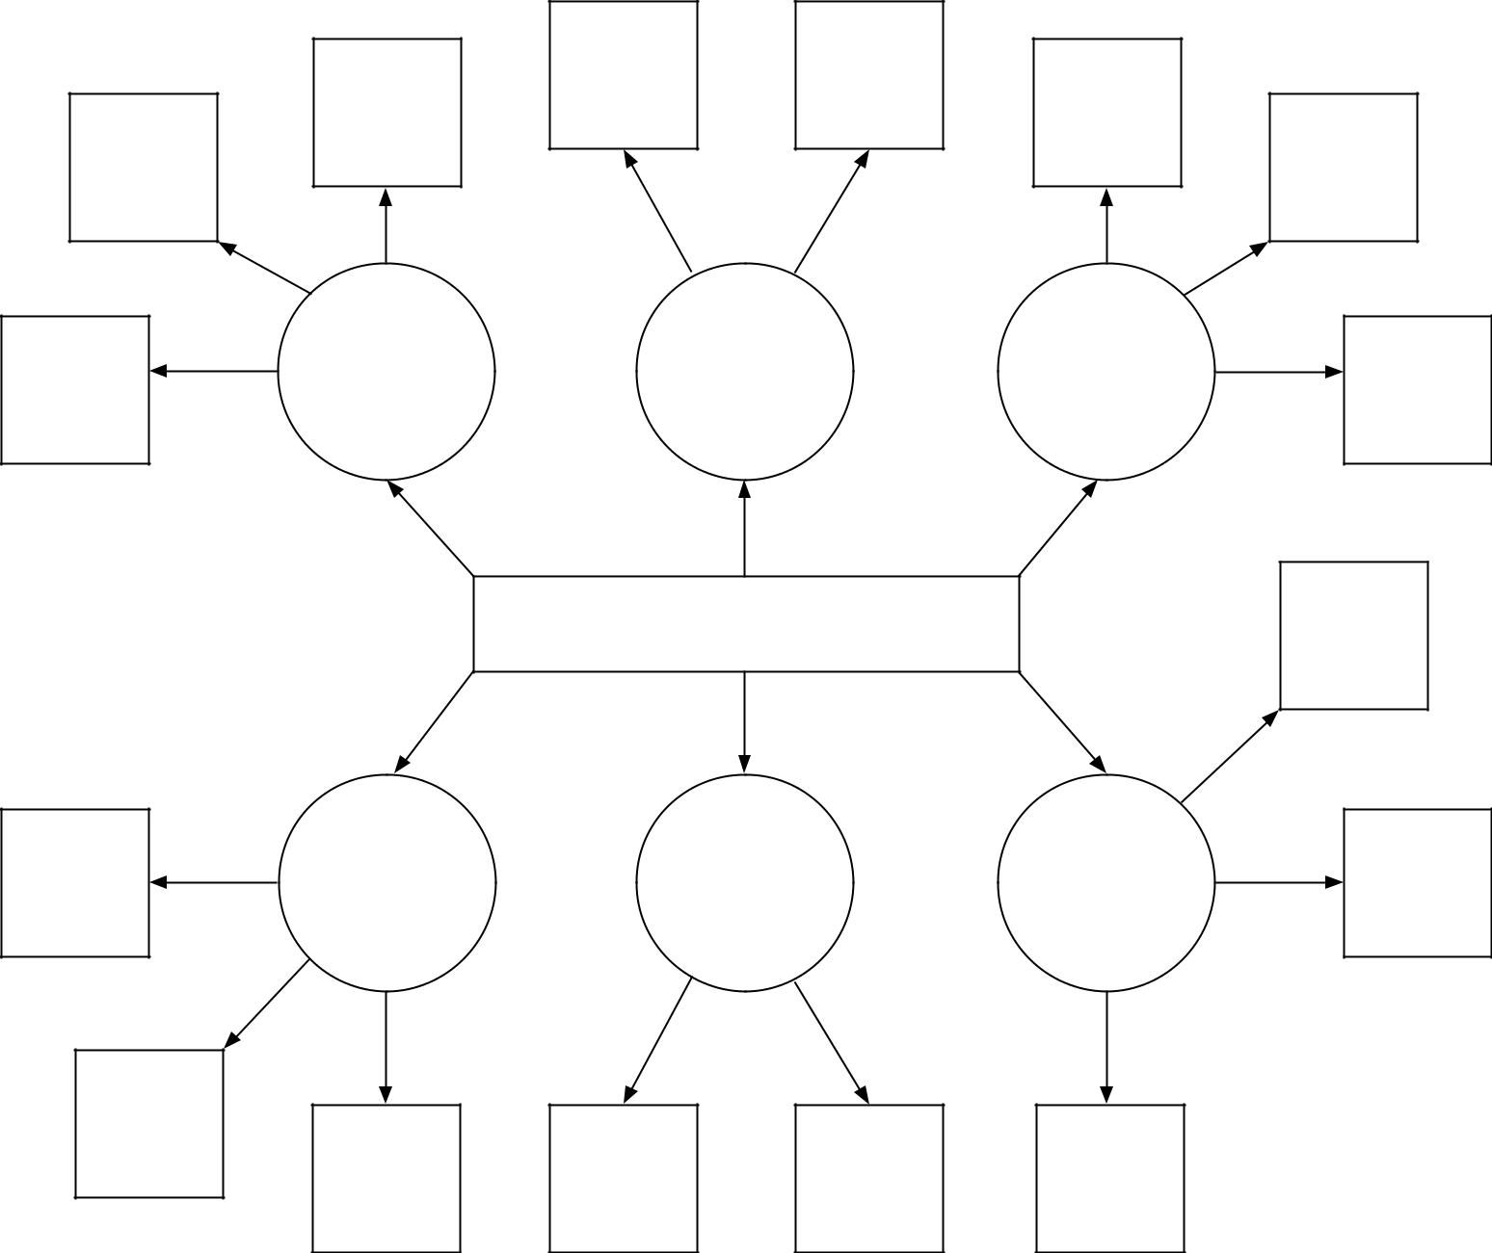
Critical Challenges and Solutions
Example Challenge:
Clean Water Shortage
Recycle
(i.e., gray water collection; rain water; recycle)
Reduce
(i.e., turn water off when brushing teeth; xeriscape)
Conserve
(i.e., drip irrigation; use mulch landscaping)

Agricultural Careers Exploration
Aligned to the following standards:
CS.01; CS.05; CS.06; FFA.CS-M; FFA.CS-N; AG1; AG5; AG6; AGC10.03; AGC10.04; CCSS.ELA-RI.9-10.3; CCSS.ELA-W.9-10.2; CCSS.ELA.SL.9-10.4; CCSS.ELA.RST.9-10.7; CCSS.ELA.WHST.9.10.6; HS-ETS1-3; AFNR.CC.S.3; AFNR.CC.S.7; CRP.05; CRP.06
Directions:
Visit AgExplorer (AgExplorer.ffa.org) to find different careers that interest you. Select one career for each critical challenge area (respecting the planet, feeding the world and improving lives) that you think will have a significant role in addressing the challenge. Explain the connection between the career and the challenge area in the second column on the handout.

Respecting the Planet
Career Interest: | Connection to Challenge Area:
Feeding the World
Career Interest: | Connection to Challenge Area:
Improving Lives
Career Interest: | Connection to Challenge Area:

What Is My Role?
Aligned to the following standards:
CS.01; CS.05; CS.06; FFA.CS-M; FFA.CS-N; AG1; AG5; AG6; AGC10.03; AGC10.04; CCSS.ELA-RI.9-10.3; CCSS.ELA-W.9-10.2; CCSS.ELA.SL.9-10.4; CCSS.ELA.RST.9-10.7; CCSS.ELA.WHST.9.10.6; HS-ETS1-3; AFNR.CC.S.3; AFNR.CC.S.7; CRP.05; CRP.06
Directions:
Agriculture has a role in everyone’s life that goes far beyond providing food and clothing. Agriculture encompasses scientists, engineers, computer programmers, mathematicians, artists, communicators, educators and many other careers, and everyone plays a role in respecting our planet, feeding the world and improving lives.

Describe your role or what you can do to help the agriculture industry address critical challenges. Use pictures, words, phrases, etc. to illustrate your role in each area.

Respecting the Planet
Feeding the World
Improving Lives

