Role of Consumers in the Market
Aligned to the following standards:
CS.01;CS.02;CS.05; CS.06; FFA.PL-A; FFA.PL-C.; FFA.PL-E.; FFA.CS-M; FFA.CS-N; AG1; AG2; AG3; AG5; AG6; AGC05.02; AGC09.02; AGC10.03; CCSS.ELA.RI.9-10.1; CCSS.ELA.RI.9-10.2; CCSS.ELA.RI.9-10.4; CCSS.ELA.W.9-10.2; CCSS.ELA.SL.9-10.1; CCSS.ELA.SL.9-10.2; CCSS.ELA.SL.9-10.4; CCSS.ELA.RST.9.10.1; CCSS.ELA.RST.9.10.4; CCSS.ELA.RST.9.10.8; CCSS.ELA.WHST.9.10.6; HS-ETS1-3; AFNR Career Cluster, Statement 2, AFNR Career Cluster, Statement 7; CRP.04; CRP.05; CRP.06; CRP.07, CRP.08
Directions:
In a free market, Agriculture, Food and Natural Resources (AFNR) systems are driven by consumer demands. Consumer demands are shaped by several factors. Grasping how consumers influence the markets begins with understanding consumer purchasing power and motivations for buying agricultural products in a capitalist economy.

Complete the following:
- Visit the “Supply and Demand” and “Markets and Prices” webpages by The Library of Economics and Liberty (n.d.), available at https://www.econlib.org/library/Topics/College/supplyanddemand.html and “Economic Systems” by The Library of Economics and Liberty (n.d.), available at https://www.econlib.org/library/Topics/HighSchool/EconomicSystems.html.
- Visit the “Five Common Factors Influencing Consumer Behavior” by iResearch Services (2018) website, available at https://www.iresearchservices.com/5-common-factors-influencing-consumer-behavior/.
- Record your responses below.

Visit the “Supply and Demand,” “Markets and Prices” and “Economic Systems” webpages (links listed above) and define the following economic terms:

Capitalism | Supply | Demand | Equilibrium Prices | Market-Clearing Price

Based on what you learned from these definitions, explain the role of a consumer in a capitalist economy.

What is the role of a consumer in supply and demand?

Visit the “Five Common Factors Influencing Consumer Behavior” by the iResearch Services (2018) website, available at https://www.iresearchservices.com/5-common-factors-influencing-consumer-behavior/.

Define each of the factors pertaining to the purchasing patterns of consumers in a free market.

What is a consumer’s role in each of these steps?

Importance of the
Food Value Chain
Aligned to the following standards:
CS.01;CS.02;CS.05; CS.06; FFA.PL-A; FFA.PL-C.; FFA.PL-E.; FFA.CS-M; FFA.CS-N; AG1; AG2; AG3; AG5; AG6; AGC05.02; AGC09.02; AGC10.03; CCSS.ELA.RI.9-10.1; CCSS.ELA.RI.9-10.2; CCSS.ELA.RI.9-10.4; CCSS.ELA.W.9-10.2; CCSS.ELA.SL.9-10.1; CCSS.ELA.SL.9-10.2; CCSS.ELA.SL.9-10.4; CCSS.ELA.RST.9.10.1; CCSS.ELA.RST.9.10.4; CCSS.ELA.RST.9.10.8; CCSS.ELA.WHST.9.10.6; HS-ETS1-3; AFNR Career Cluster, Statement 2, AFNR Career Cluster, Statement 7; CRP.04; CRP.05; CRP.06; CRP.07, CRP.08
Directions:
In addition to consumer purchasing power, technology also drives what and how agricultural items are produced. Personal health, sustainability and nutrition play key roles in driving Agriculture, Food and Natural Resources (AFNR) systems. Economics, governmental regulations and policies, environment and demographics also influence the market. Even still, the food value chain supports the transportation of goods from the producer to the consumer.

Complete the following:
- Watch Bayer Crop Science’s (2017) video “Food Chain Partnership: Trends in Modern Agriculture,” available at https://youtu.be/YkmCQvd6_Nk.
  - Optional: If YouTube is not available, browse the Bayer Crop Science’s (2017) Food Chain Partnership website, available at https://www.foodchainpartnership.cropscience.bayer.com.
- Visit the Agricultural Marketed Resource Center (AMRC) website at https://www.agmrc.org/business-development/getting-prepared/valueadded-agriculture/articles.
- Using the Agricultural Marketed Resource Center (AMRC) website as a guide, record your responses below.

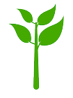1) What is the definition of “value added”? What does the process of “adding value” to a product entail?

2) Compare and contrast commodities and products. Why do we “add value” to raw commodities?

Introduction to the
Agriculture, Food and Natural Resources Value Chain
Aligned to the following standards:
CS.01;CS.02;CS.05; CS.06; FFA.PL-A; FFA.PL-C.; FFA.PL-E.; FFA.CS-M; FFA.CS-N; AG1; AG2; AG3; AG5; AG6; AGC05.02; AGC09.02; AGC10.03; CCSS.ELA.RI.9-10.1; CCSS.ELA.RI.9-10.2; CCSS.ELA.RI.9-10.4; CCSS.ELA.W.9-10.2; CCSS.ELA.SL.9-10.1; CCSS.ELA.SL.9-10.2; CCSS.ELA.SL.9-10.4; CCSS.ELA.RST.9.10.1; CCSS.ELA.RST.9.10.4; CCSS.ELA.RST.9.10.8; CCSS.ELA.WHST.9.10.6; HS-ETS1-3; AFNR Career Cluster, Statement 2, AFNR Career Cluster, Statement 7; CRP.04; CRP.05; CRP.06; CRP.07, CRP.08
Directions:
The agricultural food chain engages several players from production to the consumer.

Complete the following:
- Review the National FFA Organization’s “Agriculture, Food and Natural Resources Value Chain” diagram, and record your responses below.
  - If needed, use the Agricultural Marketed Resource Center (AMRC) website as an additional resource (https://www.agmrc.org/business-development/getting-prepared/valueadded-agriculture/articles).

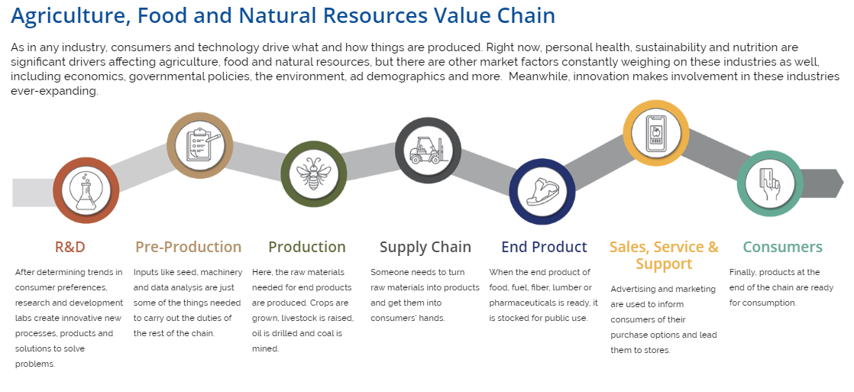

To best understand value chains, it is helpful to outline how products move from production to consumer in other contexts. For example, consider the steps it would take to send a birthday card to a family member who lives in a different state. As you read each step, refer to the Agriculture, Food and Natural Resources Value Chain diagram shown above.

        - R&D: What type of card should you buy? What does your family member like? Is there a particular design that would appeal to him or her?
        - Pre-Production: How would the card get to the shelf? How would you travel to the store to get the card?
        - Production: What message will you write? What size stamp would it take?
        - Supply Chain: How will the letter get to your family member? How will you get it in the mail?
        - End Product: Once the letter gets to the postal service, who are the end-product players?
        - Sales, Service and Support: How will the mailperson get the letter to their mailbox?
        - Consumers: Once your family member gets the card, what will his or her reaction be?

Using the birthday card example above, think through the value chain steps it will take to submit an award application to your state FFA association. List the key players and questions you must consider to get an award application from your thoughts to your state association’s mailbox. Refer to the steps in the Agriculture, Food and Natural Resources Value Chain for ideas.

Award application name:

- R&D:

- Pre-Production:

- Production:


- Supply Chain:

- End Product:

- Sales, Service and Support:

- Consumers:

Review the definitions for each of the seven sectors in the Agriculture, Food and Natural Resources Value Chain diagram. In your own words, label and describe each step:
2
6
4
3
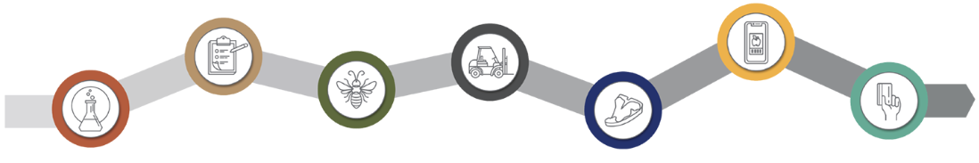
1
7
5

1)

2)

3)

4)

5)

6)

7)

Select one of the steps in the food value chain. Visit AgExplorer.ffa.org, browse through the different career focus areas and list three different careers that could relate to your selected step:

Career Option 1:

Career Option 2:

Career Option 3:

Stakeholders in the
AFNR Value Chain
Aligned to the following standards:
CS.01;CS.02;CS.05; CS.06; FFA.PL-A; FFA.PL-C.; FFA.PL-E; FFA.CS-M; FFA.CS-N; AG1; AG2; AG3; AG5; AG6; AGC05.02; AGC09.02; AGC10.03; CCSS.ELA.RI.9-10.1; CCSS.ELA.RI.9-10.2; CCSS.ELA.RI.9-10.4; CCSS.ELA.W.9-10.2; CCSS.ELA.SL.9-10.1; CCSS.ELA.SL.9-10.2; CCSS.ELA.SL.9-10.4; CCSS.ELA.RST.9.10.1; CCSS.ELA.RST.9.10.4; CCSS.ELA.RST.9.10.8; CCSS.ELA.WHST.9.10.6; HS-ETS1-3; AFNR Career Cluster, Statement 2, AFNR Career Cluster, Statement 7; CRP.04; CRP.05; CRP.06; CRP.07, CRP.08
Directions:
The agricultural value chain is complex. Investigating the complexities of each value chain entity provides more thorough insight to the movement and sustainability of products. Several resources are available online to gain a deeper understanding of the different stakeholders in the AFNR Value Chain.

Complete the following:
- Learn more about the AFNR Value Chain using resources similar to, but not limited to, the following:
  - United States Department of Agriculture, Agricultural Marketing Service manual on “Food Value Chains,” available at https://FFA.box.com/s/y6nkwouskl0z48fqmj2vu5e6s5187dxe.
  - Market Link’s “Value Chain Strategy Design: A Tool for Planning” website, available at http://www.marketlinks.org/library/value-chain-strategy-design-tool-planning.
  - National FFA Organization’s “Agriculture, Food and Natural Resources Value Chain,” available at FFA.org/value-chain/.

- Review the National FFA Organization’s Agriculture, Food and Natural Resources Value Chain diagram on the “Introduction to the Agriculture, Food and Natural Resources Value Chain” worksheet. Select one of the steps in the value chain that is of interest to you. Analyze your selected step and answer the following questions.

Selected AFNR Value Chain Step: _______________________________________________________


Research your AFNR Value Chain step. Diagram the key functions that make your step operate. Provide as much detail as possible. Feel free to find your own credible resources to guide your diagram.

Who are the key stakeholders involved in the selected step? Define their role in the process.

What are some of the strengths of this step? What are some of the key challenges of this step?

Innovations in the AFNR
Value Chain
Aligned to the following standards:
CS.01;CS.02;CS.05; CS.06; FFA.PL-A; FFA.PL-C.; FFA.PL-E.; FFA.CS-M; FFA.CS-N; AG1; AG2; AG3; AG5; AG6; AGC05.02; AGC09.02; AGC10.03; CCSS.ELA.RI.9-10.1; CCSS.ELA.RI.9-10.2; CCSS.ELA.RI.9-10.4; CCSS.ELA.W.9-10.2; CCSS.ELA.SL.9-10.1; CCSS.ELA.SL.9-10.2; CCSS.ELA.SL.9-10.4; CCSS.ELA.RST.9.10.1; CCSS.ELA.RST.9.10.4; CCSS.ELA.RST.9.10.8; CCSS.ELA.WHST.9.10.6; HS-ETS1-3; AFNR Career Cluster, Statement 2, AFNR Career Cluster, Statement 7; CRP.04; CRP.05; CRP.06; CRP.07, CRP.08
Directions:
In the AFNR Value Chain there are numerous opportunities for innovation. Applying creativity and innovative ideas to the AFNR supply chain secures the possibility of sustainability in the industry.

Complete the following:
- Watch Cool Gadgets and Stuff’s “Five Amazing RENEWABLE ENERGY Ideas and Solutions for the Future” video, available at https://youtu.be/JKXnQnaiqI8.
  - If time is a constraint, watch one or two of the ideas before continuing (i.e., the first Graphene invention ends at 2:51).
  - Optional: If YouTube is not available, visit the Billions in Change website, available at https://billionsinchange.com.
- Determine a model for a new innovation to add to or support the AFNR Value Chain.

Using the four stages of innovation, describe a new, innovative solution (a product, method, technology, etc.) to address its function or need in the AFNR Value Chain.
Innovation Name: ______________________________________________________
Identify ideas, products or technologies to address a global issue.
Describe the specific need it addresses and how it will maintain safety, efficiency and effectiveness.
Describe technical expertise that will support the innovation and the customers.
Describe studies that can be conducted to ensure the quality of the innovation.

Using the four stages of innovation diagram, design and illustrate the new innovative solution (a product, method, technology, etc.).

  - Diagram of the innovation/product (provide labels and descriptions):

  - Describe its projected role in the AFNR Value Chain:

  - What is the projected cost of the innovation/product?

Securing Innovative Ideas
in the AFNR Value Chain
Aligned to the following standards:
CS.01;CS.02;CS.05; CS.06; FFA.PL-A; FFA.PL-C.; FFA.PL-E; FFA.CS-M; FFA.CS-N; AG1; AG2; AG3; AG5; AG6; AGC05.02; AGC09.02; AGC10.03; CCSS.ELA.RI.9-10.1; CCSS.ELA.RI.9-10.2; CCSS.ELA.RI.9-10.4; CCSS.ELA.W.9-10.2; CCSS.ELA.SL.9-10.1; CCSS.ELA.SL.9-10.2; CCSS.ELA.SL.9-10.4; CCSS.ELA.RST.9.10.1; CCSS.ELA.RST.9.10.4; CCSS.ELA.RST.9.10.8; CCSS.ELA.WHST.9.10.6; HS-ETS1-3; AFNR Career Cluster, Statement 2, AFNR Career Cluster, Statement 7; CRP.04; CRP.05; CRP.06; CRP.07, CRP.08
Directions:
The best way to empower innovative and creative ideas for the AFNR Value Chain is to observe other ideas.
Think critically about your classmates’ innovation presentations.

Complete the following:
- Following each presentation, capture takeaways from the innovations shared by your classmates.
- Record responses below.

Innovation(s) presented: ________________________________________________

Background/Need for the Innovation: | Impact of the Innovation: | Risks to Innovation:

What was the biggest takeaway from this presentation?

Innovation(s) presented: ________________________________________________

Background/Need for the Innovation: | Impact of the Innovation: | Risks to Innovation:

What was the biggest takeaway from this presentation?

