Tough Work for Tender Meats
Aligned to the following standards:
FFA.PL-A; FFA.PL-F; FFA.PG-I; FFA.PG-J; FFA.CS-N; FFA.CS-P; CCSS.ELA.RI.9-10.4; CCAA.ELA.W.9-10.1; CCSS.ELA.W.9-10.2
Directions:
Read the article “Tough Work for Tender Meats” found at FFA.org/the-feed/tough-work-for-tender-meats/. Complete the following activities to learn more.

Part 1
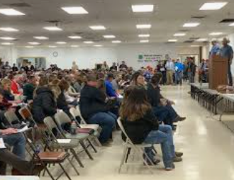
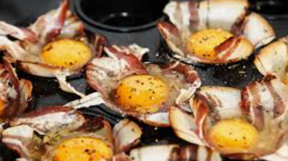

What role does the meat science industry play in our economy?
What skills can be gained from learning about meat science?
A school having a meat lab can be seen as a community service/support. What role do you think a school-based meat lab has/can have on the community?

Do you think a meat lab would work well in your school and community? Why or why not?
What skills can be learned from a Ham, Bacon and Egg show?
What is the purpose of the Ham, Bacon and Egg shows?

In what state did Makayla gain experience in a school meat lab?
- Virginia
- Minnesota
- West Virginia
- Maine
Why do you think schools have meat labs as part of their school programs?
Part 2
Directions:
Knowing the different cuts of meat is important to understand the way those cuts can be used. Use the images of each species (cattle, swine, lamb) and the resource identified below to complete the following:
- Take each species (cattle, swine, lamb) and draw lines to identify the different cuts on each image. Then label each cut. One cut has been completed for you as an example. Note that there are multiple cuts and labels for each species.
- Identify three specific cuts that comes from each area. There is an example below for you to reference. You will need two more examples from the Beef Round area.
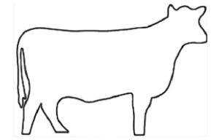
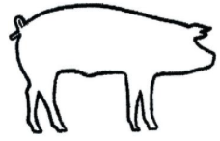
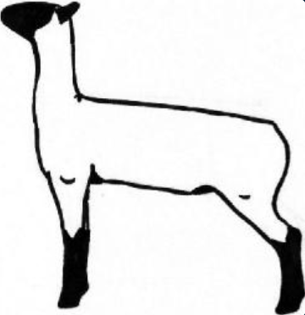
Resource: University of Nebraska-Lincoln, https://animalscience.unl.edu/meat-cut-identification/
Beef Round
Eye Round Roast
Part 3
Directions:
The ultimate goal of the different cuts of meat is to be able to create meals. Take one specific cut of meat (Ex. eye round roast) and develop a recipe for a main course of a meal.
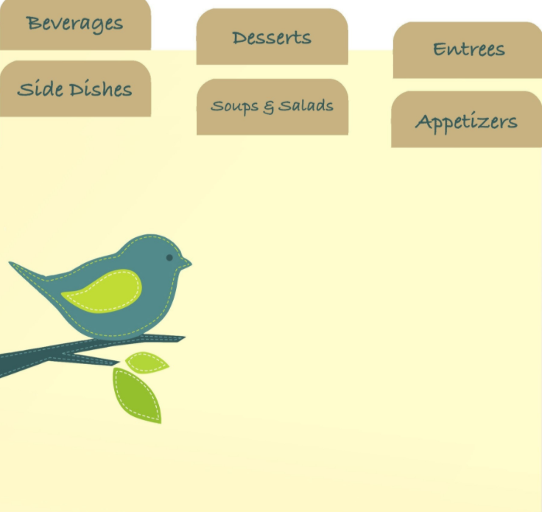
Why is understanding where the different cuts of meat come from important?
How will you use what you have learned about meat cuts?
Summarize what you have learned in this lesson in one sentence.
Directions:
Ingredients:

