Let’s Make a Plan
Aligned to the following standards:
CS.03; CS.04; NRS.01; NRS.02; NRS.04; FFA.PL-A; FFA.PL-C; FFA.PL-E; FFA.PL-F; FFA.PL-N; AG3; AG4; AG-NR1; AG-NR2; AG-NR4; CCSS.ELA.W.9-10.2; CCSS.ELA.W.9-10.7; CCSS.ELA.SL.9-10.4; CCSS.ELA.L.9-10.6; CCSS.ELA.RST.9.10.4; CCSS.ELA.WHST.9.10.7; HS-ETS1-3; CRP.02; CRP.04; CRP.05; CRP.06; CRP.08; CRP.11;
Part 1
Directions: Use the graphic organizer throughout the next few pages to create your water conservation plan.

Check the box for which type of water conservation plan you will be creating.
 |  Personal/Household |  |  School Agriculture Facilities |  |  Local Business

1. Current Water Use:
Where is water currently used in this setting? How much is being used?
List as many specific uses for water as you can think of and record actual usage if available or your best estimate of either volume (gallons, acre-feet, etc.) or percentages for each use.
Water Use | Amount Used

2. Identifying Areas for Improvement:
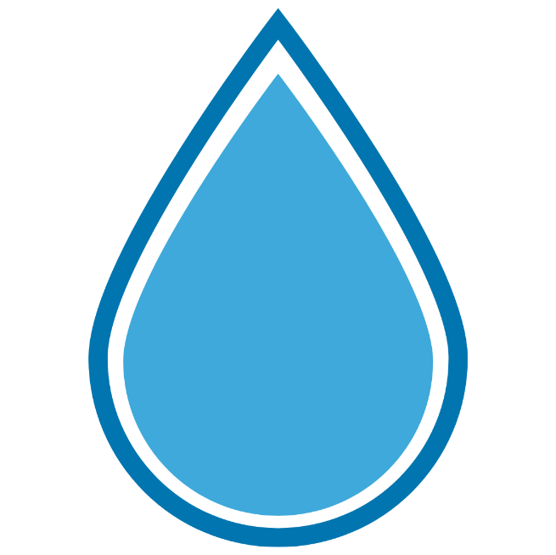
Highlight the three areas above that use the most water and write them at the tops of the water droplets below. Then, in each droplet, list two or three water-saving strategies that could be applied to that area.

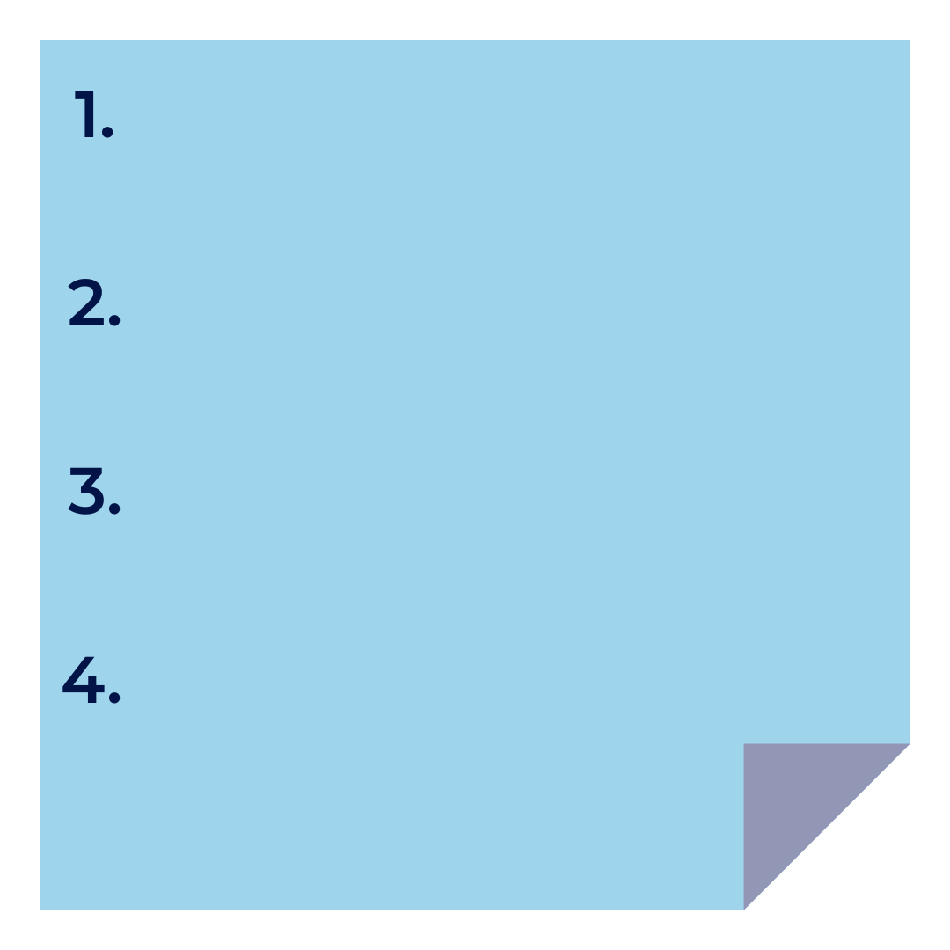
3. Proposed Water Conservation Strategies:
On the sticky note below, list four strategies you plan to implement.
Be specific and provide actionable steps.
Why do you think the strategies you listed are the best strategies for your plan? (Explain in two to three sentences.)
4. Measurable Goals:


What are your targets for water savings? Record one goal on each of the targets below.
Make sure your goals are measurable (amount of water saved, percentage of consumption reduced, etc.).
5. Resources and Help Needed:
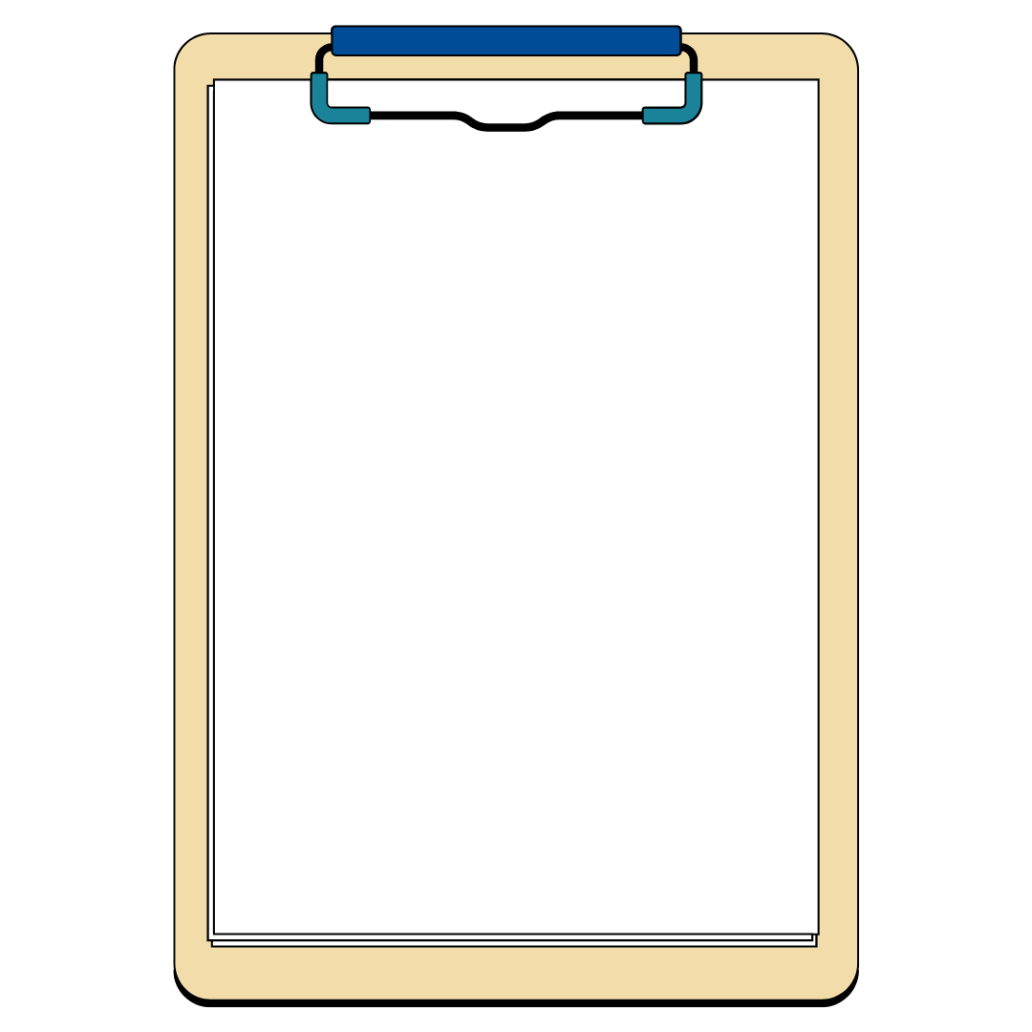
Conserving water does require certain resources and people to help us accomplish our goals. On one of the clipboards below, list out any materials or resources you will need to help implement your plan. On the other clipboard, list other people who you are going to need to partner with in order to accomplish your goals.
6. Timeline:
On the blank timeline below, record at least three projected milestones for your conservation plan as well as a projected start date and projected completion date for implementation. Of course, water conservation work is never fully complete; this timeline is merely projecting when your plan will be fully implemented.

Start Date:
Completion Date:

7. Reflection and Expected Outcomes:
Answer the questions below to reflect on your water conservation plan.

- How will you measure the success of your water conservation plan? What metrics will you use to track your progress?

- What are two challenges or obstacles you might face when implementing your plan?

- What new information or insights did you gain as you were developing your plan? List three things.

- In your own words, explain why water conservation is important to you and your community.
(Explain in four or five sentences.)

Water Conservation Plan Rubric

Category | Excellent  (5 pts) | Good  (3-4 pts) | Developing  (2 pts) | Needs Improvement  (0-1 pt)
Content and Accuracy | Plan is detailed, well-researched and shows deep understanding of water conservation techniques. Includes realistic, effective strategies | Plan is clear and accurate with relevant strategies, though some minor details could be further developed. | Plan is incomplete or has inaccurate details. Some strategies are unclear or unrealistic. | Plan lacks detail or accuracy. Strategies are missing or not applicable to the setting.
Creativity and Innovation | The plan is highly creative, offering unique and practical solutions. Shows original thinking | The plan demonstrates some creativity and includes practical solutions. | The plan has minimal creativity or overly basic solutions. | The plan lacks creativity and relies on obvious or impractical solutions.
Measurable Goals | Goals are clear, measurable and ambitious. Includes specific numerical targets | Goals are clear and measurable but could be more specific or ambitious. | Goals are vaguely defined and lack measurable criteria. | Goals are unclear or missing entirely.
Presentation | Presentation is well-organized, engaging and thoroughly covers all aspects of the plan. | Presentation is organized and covers most aspects but may lack some depth or clarity. | Presentation is disorganized or omits some key elements. | Presentation is unclear, incomplete or difficult to follow.
Implementation and Feasibility | The plan is highly feasible with clear steps for implementation and realistic timelines. | The plan is mostly feasible with a realistic approach to implementation and timeline. | The plan may be difficult to implement or has unrealistic steps. | The plan is not feasible with unclear or unachievable steps.
Reflection and Analysis | The reflection is thoughtful, analyzing the impact of the plan and its potential benefits in-depth. | The reflection is clear and provides a reasonable analysis of the plan’s impact. | The reflection is brief or lacks depth in analyzing the benefits of the plan. | The reflection is missing or lacks any analysis of the plan’s impact.
Total Score |  |  |  | /30

Comments: __________________________________________________________________________________________________________
________________________________________________________________________________________________________________________________________________________________________________________________________________________________________________________________________________________________________________________________________________________________________________________________________________________________________________________________________________________________________________________________________________________________________________________________________________________________________________________________________________________________________________________________________________________________________________________________________________________________________________________________________

