How Much Water Do You Use?
Aligned to the following standards:
CS.03; CS.04; NRS.01; NRS.02; NRS.04; FFA.PL-A; FFA.PL-C; FFA.PL-E; FFA.PL-F; FFA.PL-N; AG3; AG4; AG-NR1; AG-NR2; AG-NR4; CCSS.ELA.W.9-10.2; CCSS.ELA.W.9-10.7; CCSS.ELA.SL.9-10.5; CCSS.ELA.L.9-10.6; CCSS.ELA.RST.9.10.4; CCSS.ELA.WHST.9.10.7; MP1; MP2; MP4; CCSS.HSS.ID.A.1; HS-ETS1-3; CRP.02; CRP.04; CRP.05; CRP.06; CRP.08; CRP.11;
Part 1
Directions: Answer the pre-activity questions. Then go to https://watercalculator.org/ and complete the “What’s Your Water Footprint?” activity and answer the analysis questions afterward.
Terms to Know:
- Water Footprint – A calculation of water-use patterns at different levels, both direct and virtual
- Water Conservation – Beneficial reduction in water loss, waste or use; making choices to use water efficiently, use only what is needed and avoid waste
- Virtual Water – also called “embedded water” or “indirect water,” is the water needed to produce the products, services and processes that people buy and use every day. Although it is not directly used by the end-user of a product or service, that water has been consumed throughout the value chain and adds to one’s overall water footprint.
Sources: Water Footprint Calculator (https://watercalculator.org/) and Washington Department of Ecology (https://ecology.wa.gov/)
Pre-Activity Questions:
- The average American’s water footprint is 1,802 gallons of water per day (including virtual water). On the number line below, mark where you think your water footprint is compared to the average.
1,802 Gallons
(Average)
2,400 Gallons
3000 Gallons
1,200 Gallons
600 Gallons

Why did you place the mark where you did?

- How do you think the food you eat, the clothes you wear and the things you use at home impact water usage?

- Have you ever tried to reduce water waste in your daily routine before? What changes did you make? If you haven’t, why not?
- How do you think your daily activities could be different if water was more scarce?

Now, go to https://watercalculator.org/ and complete the “What’s Your Water Footprint?” activity.
Do NOT close the window of your results yet. You will need them again in Part 2.

Analysis Questions:

- Record your actual water footprint in the blank water drop below. Draw a greater than (>), less than (<) or equal (=) sign in the box to indicate how your water footprint compares to the average American’s.
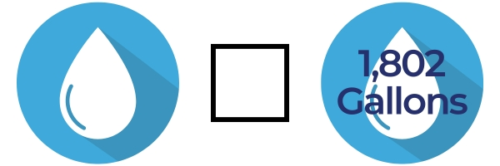

- What was your initial reaction when seeing your water footprint score?

- How did your actual water footprint compare to what you predicted before completing the activity? Why do you think it was/wasn’t different?
- What are three things that surprised you about your water footprint?

- What part of your lifestyle uses the most water?

- How does your diet and your clothing affect your score?
- How can understanding your water footprint change the way you use water in your daily life?
- Now that you know your actual water usage, do you think you should make changes to decrease that? Why or why not?

Part 2
Directions: There is a “learn more” column in the results section of the website where you can explore tips on how to conserve water in each area. Click to explore these different activities and tips. Select five of them that you could see yourself implementing easily and record them in the table below. When finished, answer the conclusion questions.

Activity | Type of Water Use (Indoor/Outdoor/Virtual) | Conservation Tip | Potential Impact
Example:  Washing dishes | Indoor water | Use one sink filled with warm water for washing and one filled with cold water for rinsing. | This could eliminate a lot of running water wasted when washing/rinsing and conserve several gallons every time I wash dishes.
 |  |  | 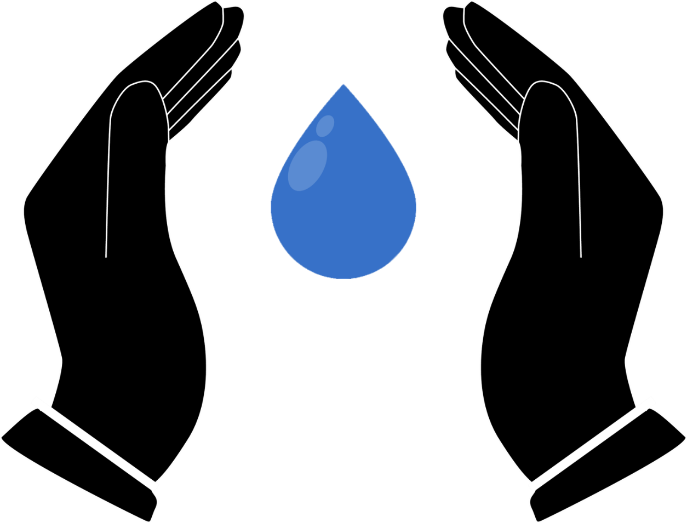

Conclusion Questions:

- Which of the tips above do you think would have the greatest impact on your water footprint? Why?

- Which tip could you most easily implement starting today?

- Why is it important for you to consider how much water you are using?
- How can you advocate for conserving water at home with your family?

Save Our Water!
Aligned to the following standards:
CS.03; CS.04; NRS.01; NRS.02; NRS.04; FFA.PL-A; FFA.PL-C; FFA.PL-E; FFA.PL-F; FFA.PL-N; AG3; AG4; AG-NR1; AG-NR2; AG-NR4; CCSS.ELA.W.9-10.2; CCSS.ELA.W.9-10.7; CCSS.ELA.SL.9-10.5; CCSS.ELA.L.9-10.6; CCSS.ELA.RST.9.10.4; CCSS.ELA.WHST.9.10.7; MP1; MP2; MP4; CCSS.HSS.ID.A.1; HS-ETS1-3; CRP.02; CRP.04; CRP.05; CRP.06; CRP.08; CRP.11;
Directions:
Select one of the five tips you explored in Part 2 of “How Much Water Do You Use?” This should be an action you could envision implementing in your life or in the school community. It should be something you consider important or impactful. You will use this tip to make a promotional poster.

Your poster should include the following items:
- A catchy title
- A brief explanation of the water conservation practice
  - What it is
  - How it helps conserve water
  - Why it’s important
- Visuals (drawings, images, diagrams, charts) that represent the water conservation practice
- One source where people can go to learn more about this practice (web URL, QR code, etc.)

- You may design the poster either by hand or by using a digital tool such as Canva, PowerPoint, Google Slides, etc.
- Be creative with your design. Your poster should be both informative and visually appealing so it will catch people’s attention and encourage them to practice water conservation.
- See the rubric on the next page for more guidelines on how the poster will be evaluated.
- Answer the conclusion questions below when you are finished with your poster.

Conclusion Questions:

- What inspired you to choose the water conservation practice that you did for your poster?

- Why is this practice important for others to adopt?

- Other than the poster, how can you use the information you learned through this activity to encourage others in your community or school to conserve water?

Water Conservation Poster Rubric

Category | Excellent  (4 pts) | Good  (3 pts) | Developing  (2 pts) | Needs Improvement  (1 pt)
Content Accuracy | Poster accurately and thoroughly explains the selected water conservation practice with clear details about its impact and importance. | Poster explains the selected water conservation practice with most details correct but may lack depth. | Poster explains the selected practice, but some important details may be missing or inaccurate. | Poster does not accurately explain the selected practice or is unclear.
Creativity and Visual Appeal | Poster is visually engaging, well-organized and creatively designed. It uses images, colors and text effectively to grab attention and convey the message. | Poster is visually appealing with good use of images, colors and text but could be more creative or organized. | Poster is functional but lacks creativity or visual appeal. It may be cluttered or too plain. | Poster is poorly designed, disorganized or lacks visual appeal.
Clarity and Readability | Text is clear and easy to read with a well-organized layout. Fonts, colors and images are chosen to enhance readability and communication. | Text is generally readable, though some parts may be harder to read due to font choices or layout. | Text is somewhat difficult to read or poorly organized. Font choices or layout may detract from the clarity. | Text is difficult to read or unclear. The layout makes the poster hard to follow.
Use of Visuals | Visuals (images, drawings, graphs, etc.) are highly relevant and effectively support the message of the poster. | Visuals are relevant and support the message but may not be as well integrated into the design. | Visuals are somewhat relevant, but their connection to the message is unclear or weak. | Visuals are irrelevant or missing altogether and do not enhance the message.
Persuasiveness and Impact | The poster is highly persuasive, making a compelling case for the importance of water conservation. The message is clear and inspiring. | The poster makes a good case for water conservation, but it may not be as compelling or inspiring as it could be. | The poster provides basic information about water conservation but lacks strong persuasive elements. | The poster does not make a strong case for water conservation or fails to persuade effectively.
Effort and Neatness | The poster is neat, well-crafted and shows a high level of effort. All elements are polished and carefully executed. | The poster shows good effort and is generally neat, but there may be a few areas that appear rushed or incomplete. | The poster shows some effort, but several areas appear unfinished or not well-thought-out. | The poster shows minimal effort with many areas rushed or poorly executed.
Total Score |  |  |  | /24

Comments: __________________________________________________________________________________________________________
________________________________________________________________________________________________________________________________________________________________________________________________________________________________________________________________________________________________________________________________________________________________________

