Aligned to the following standards:
CS.05; FFA.PL-A; FFA.PL-C; FFA.PG-I; FFA.PG-J; CCSS.ELA-RI.9-10.2; CCSS.ELA-RI.9-10.4; CCSS.ELA.W.9-10.2; CCSS.ELA.SL.9-10.2; CCSS.ELA.RST.9.10.4; CCSS. MP1; CCSS. MP2; CCSS. MP4; CCSS. MP6; CRP.02; CRP.04; CRP.08; CRP.11
Gone Fishing
Directions:
Answer the questions below as you watch the video “Minnow Trapping SAE | Joe Lindberg,” available at https://vimeo.com/901201858.

- What is Joe’s SAE, and which career pathway is it in?

- What are the steps Joe describes for his SAE?

- How did Joe find his minnow trapping SAE? Who helped him get started?

- How did Joe have to prepare to start his SAE?

- What did Joe say he has learned from his SAE?

- What is Joe’s favorite part of his SAE?

Fish Are Friends … AND Food
Aligned to the following standards:
CS.05; FFA.PL-A; FFA.PL-C; FFA.PG-I; FFA.PG-J; CCSS.ELA-RI.9-10.2; CCSS.ELA-RI.9-10.4; CCSS.ELA.W.9-10.2; CCSS.ELA.SL.9-10.2; CCSS.ELA.RST.9.10.4; CCSS. MP1; CCSS. MP2; CCSS. MP4; CCSS. MP6; CRP.02; CRP.04; CRP.08; CRP.11

Directions:
Visit each of the stations according to your teacher’s directions. As you visit each station, complete the associated activities on this worksheet.

Station 1: What Is Aquaculture?
Directions:
Watch the video at the station and read over the fact sheet. Answer the following questions as you do.

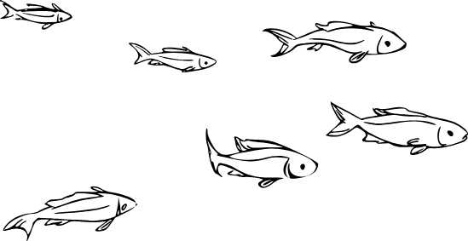
- How is aquaculture described in the video?

- In your own words, summarize why the speaker in the video believes that aquaculture is incredibly important for humanity’s future.

- Explain the two major differences between freshwater aquaculture and marine aquaculture.

- Efficiency can be calculated by taking the output and dividing it by the input. You can calculate the percentage of efficiency by multiplying that quotient by 100.

Output/Input x 100 = Efficiency

Using the values on the fact sheet, calculate the feed conversion efficiency percentage for each of the following species and fill in the table below. Fish is done for you.

Species | Cattle | Pigs | Broiler Chickens | Fish
Output |  |  |  | 1 lb. biomass
Input |  |  |  | 1.1 lbs. feed
Feed Efficiency Quotient |  |  |  | .909
Feed Efficiency Percentage |  |  |  | 90.9%

- What species is the most efficient? Why do you think that is?

Station 2: The Fishing Industry
Directions:
Read over the information sheet at this station and visit the website by scanning the QR code or navigating to the link. Then answer the following questions based on the information you’ve viewed.

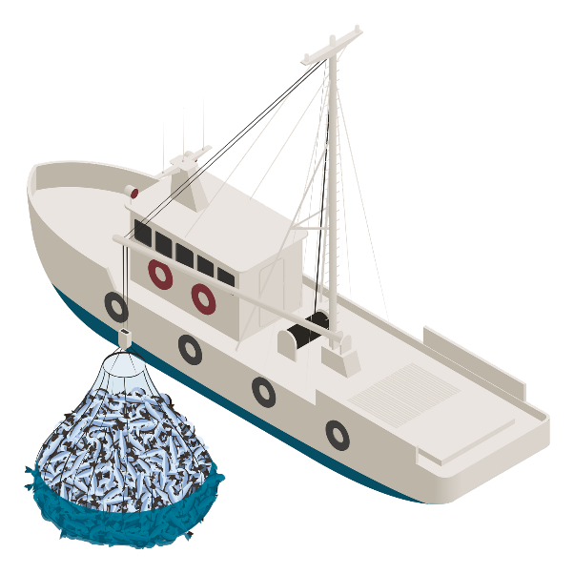
- List the five standards of sustainable seafood in the United States.

- What are the top five species groups by value?

- What was the combined value of all those species in 2020?

- What is the top port for seafood?
  - By pounds?
  - By value?
- Why is it important that the seafood industry be sustainably managed?

Station 3: Ornamental Fish and Aquariums
Directions:
Explore the information on the infographic and watch the video that is linked in order to answer the questions below.

- What do you notice about the percentages of freshwater and saltwater fish that are raised in aquaculture versus wild caught?

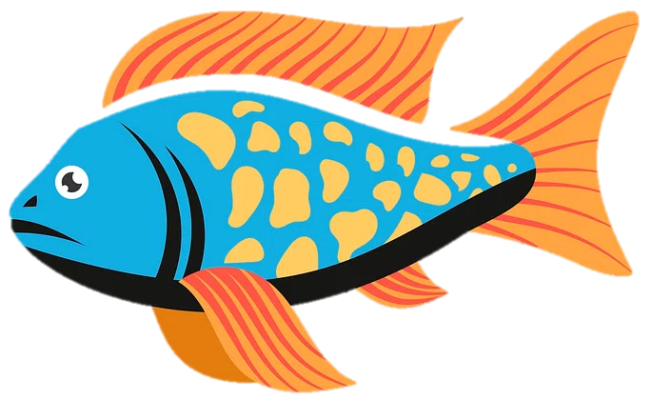

  - Why do you think the percentages are this way?

- Where do most of the imported ornamental fish come from?

  - Why do you think this is?

- List three observations you had about the ornamental aquaculture farm in the video.

Station 4: Fishy Careers
Directions:
Use the QR codes or links at the station to learn about four careers within the aquaculture and fisheries industry. Use the information from AgExplorer (AgExplorer.FFA.org/) to answer the questions below.
- Record the following information about each career.
  - One-sentence summary/description of the career
  - Salary
  - Two typical daily responsibilities
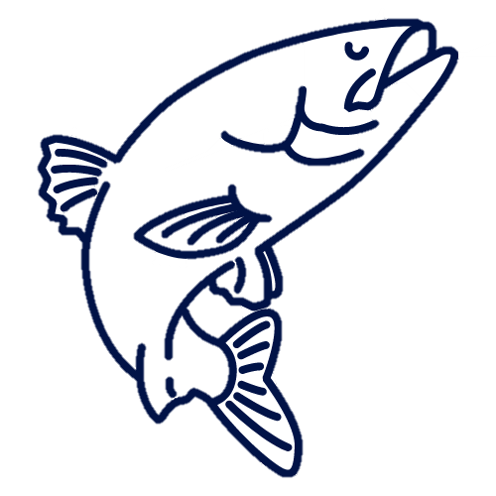
  - Education level or training required
Aquaculturist: | Salary:
One-Sentence Summary:
Typical Daily Responsibilities: | Education/Training Required:
Aquaculture Hatchery Manager: | Salary:
One-Sentence Summary:
Typical Daily Responsibilities: | Education/Training Required:
Fisheries Technician: | Salary:
One-Sentence Summary:
Typical Daily Responsibilities: | Education/Training Required:
Saltwater Husbandry Technician: | Salary:
One-Sentence Summary:
Typical Daily Responsibilities: | Education/Training Required:
How Is It All Connected?
Aligned to the following standards:
CS.05; FFA.PL-A; FFA.PL-C; FFA.PG-I; FFA.PG-J; CCSS.ELA-RI.9-10.2; CCSS.ELA-RI.9-10.4; CCSS.ELA.W.9-10.2; CCSS.ELA.SL.9-10.2; CCSS.ELA.RST.9.10.4; CCSS. MP1; CCSS. MP2; CCSS. MP4; CCSS. MP6; CRP.02; CRP.04; CRP.08; CRP.11

Directions:
Concept maps illustrate relationships between items, ideas or concepts. See below for a brief example.
Ocean

Boats/Ships
Living Things

Harvest from ocean
Coral
Animals
Plants

Military
Amphibians
Mammals

Transportation
Provides home for
Fish

Draw a concept map illustrating how the different industries and products related to fish and aquatic animals are connected to each other. Be sure to include at least two items or ideas from each station.

