Aligned to the following standards: FFA.PL-A; FFA.PG-J; FFA-CS-M; CCSS.ELA.RI.9-10.1; CCSS.ELA.RI.9-10.2; CCSS.ELA.W.9-10.2; CCSS.ELA.SL.9-10.1.C; CCSS.ELA.SL.9-10.4; CCSS.ELA.WHST.9-10.7; MP1; MP3; MP6; Buying Goods and Services, Benchmarks: Grade 12, Statement 7 Governments; Buying Goods and Services, Benchmarks: Grade 12, Statement 1; Buying Goods and Services, Benchmarks: Grade 12, Statement 2; CRP.02; CRP.04; CRP.05; CRP.06; CRP.07; CRP.08; CRP.09; CRP.11

Activity 1: Go Get It — Nutrition Facts
Directions:
When given permission, move about the classroom to find 3 cards that contain different descriptions of the different parts of a nutrition label, seen below. When you find a description in the room, match it with the correct location on the nutrition label shown below; write the information found on the card in the space provided. Two of the categories will have the same information. 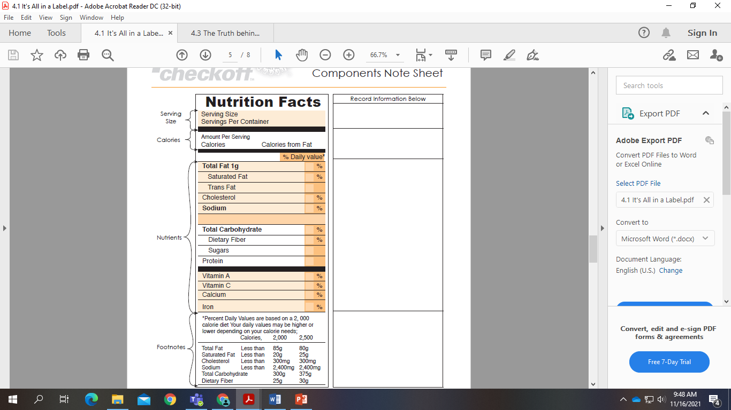
What would you tell someone about what is included on a nutrition label based on the above activity?
Aligned to the following standards: FFA.PL-A; FFA.PG-J; FFA-CS-M; CCSS.ELA.RI.9-10.1; CCSS.ELA.RI.9-10.2; CCSS.ELA.W.9-10.2; CCSS.ELA.SL.9-10.1.C; CCSS.ELA.SL.9-10.4; CCSS.ELA.WHST.9-10.7; MP1; MP3; MP6; Buying Goods and Services, Benchmarks: Grade 12, Statement 7 Governments; Buying Goods and Services, Benchmarks: Grade 12, Statement 1; Buying Goods and Services, Benchmarks: Grade 12, Statement 2; CRP.02; CRP.04; CRP.05; CRP.06; CRP.07; CRP.08; CRP.09; CRP.11

Activity 2: Nutritional Label Interpretation Challenge
Directions:
Study food labels A, B, C and D below. Use the information in each label to answer the questions at the bottom of the page.
A B C D
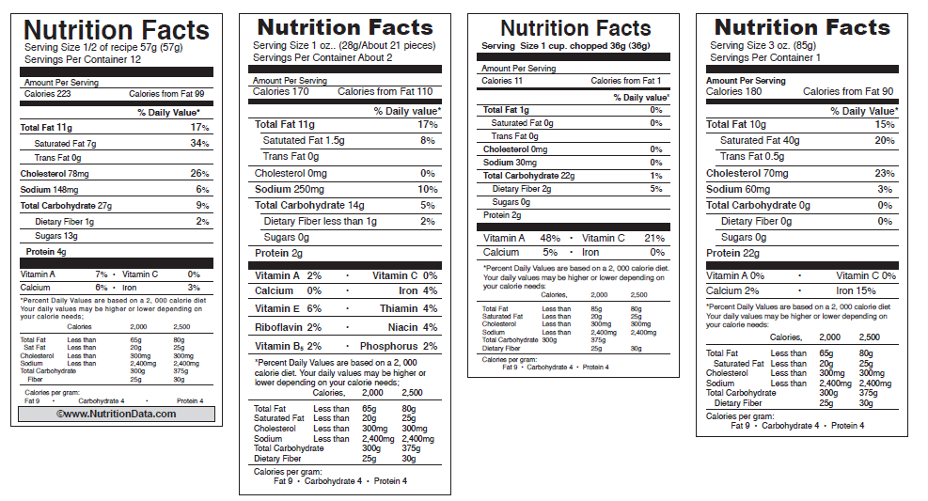
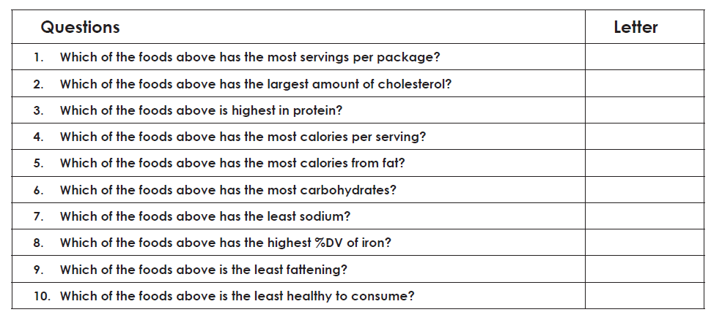
Why do you think it is important for all of the above information to be included on a nutrition label?
Activity 3: Product Development
Directions:
Complete the following as you learn about product development. Use what you learn to complete the following activities.
- Identify the possible product categories:
Categories | Platform | Market
Cereal | F | R
S | Refrigerated | Wholesale
M | Shelf-stable | Food Service
Side dishes | C | C
B | R
Supplements | Heat and Serve
Condiments | ___________________________________ | ___________________________________
D | ___________________________________ | ___________________________________
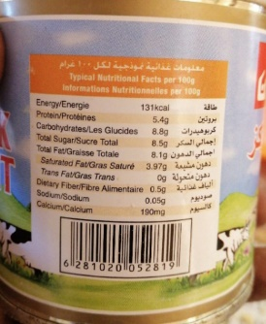
- What changed between the original label and the new label from the FDA?

- What questions should be considered when thinking about a product in development?

- Step 1: C________________ I____________________

- Step 2: D_______________ A____________________

  - What should the percentage equal? _________%

- Step 3: Calculate amounts.
  - In your own words describe how this calculation is completed. Give an example.

- Step 4: C ________________________ N _____________________________
  - In your own words describe how this calculation is completed. Give an example.

- Step 5: Determine percent D_____________________ V__________________
  - In your own words describe how this calculation is completed. Give an example.

- Step 6: Enter Values into N_________________________________________ F__________________ P_________________

- How should the ingredient list for the ingredient statement be listed?
Label Design Challenge
Aligned to the following standards: FFA.PL-A; FFA.PG-J; FFA-CS-M; CCSS.ELA.RI.9-10.1; CCSS.ELA.RI.9-10.2; CCSS.ELA.W.9-10.2; CCSS.ELA.SL.9-10.1.C; CCSS.ELA.SL.9-10.4; CCSS.ELA.WHST.9-10.7; MP1; MP3; MP6; Buying Goods and Services, Benchmarks: Grade 12, Statement 7 Governments; Buying Goods and Services, Benchmarks: Grade 12, Statement 1; Buying Goods and Services, Benchmarks: Grade 12, Statement 2; CRP.02; CRP.04; CRP.05; CRP.06; CRP.07; CRP.08; CRP.09; CRP.11

DIRECTIONS:
As the developer of a new product, you must now design a nutritional label to go on the product. Using all the information learned in class regarding food labels, complete the required information below as it pertains to the food item you create based up on the provided scenario and chart. Remember to include the 7 KEY features + any additional needed information. Add lines, use markers, etc. to make your label look as realistic as possible.
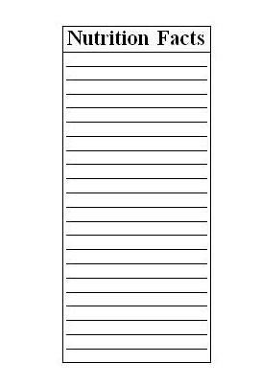

EXIT TICKET
Aligned to the following standards: FFA.PL-A; FFA.PG-J; FFA-CS-M; CCSS.ELA.RI.9-10.1; CCSS.ELA.RI.9-10.2; CCSS.ELA.W.9-10.2; CCSS.ELA.SL.9-10.1.C; CCSS.ELA.SL.9-10.4; CCSS.ELA.WHST.9-10.7; MP1; MP3; MP6; Buying Goods and Services, Benchmarks: Grade 12, Statement 7 Governments; Buying Goods and Services, Benchmarks: Grade 12, Statement 1; Buying Goods and Services, Benchmarks: Grade 12, Statement 2; CRP.02; CRP.04; CRP.05; CRP.06; CRP.07; CRP.08; CRP.09; CRP.11

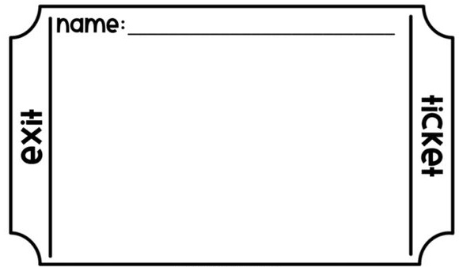
1. Sugar is an example of a ______________.
a. calorie
b. fat
c. carbohydrate
2. Calories are a source of _____________.
a. energy
b. fat
c. strength
3. If you consume a 4-oz. candy bar with 50 calories per each 1-oz. serving, how many calories are you consuming?

4. Why are nutrition labels important for food products on the market?

5. How do food labels impact you or someone you know on a daily basis?

GO GET IT: Nutrition Facts Cards (To be used in Activity 1)
Directions for TEACHERS:
Make as many copies of this sheet as needed. Cut along each section line and place the sections around the classroom.
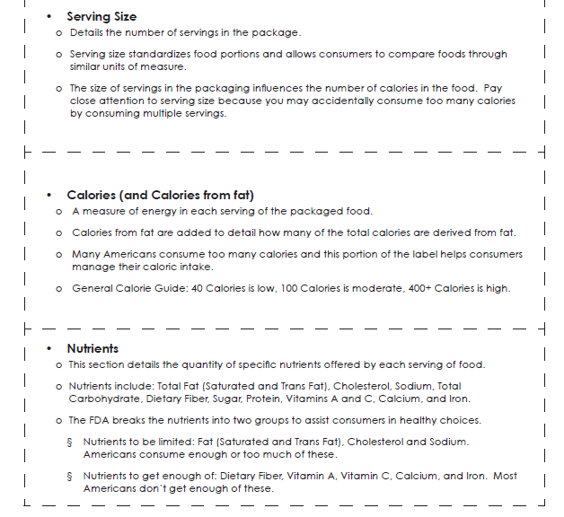

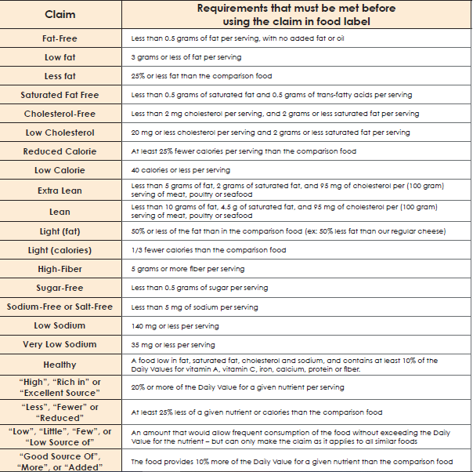
Food and Drug Administration’s Specifications for Health Claims and Descriptive Terms:

Product Development Chart
