Global Goals for the Future
Aligned to the following standards:
CS.01; CS.04; FFA.PL-A; FFA.PG-J; FFA.CS-M; FFA.CS-N; AG1; AG4; AGC02.02; CCSS-RI.9-10.1; CCSS.ELA-W.9-10.2; CCSS.ELA.SL.9-10.1; CCSS.ELA.SL.9-10.2; CCSS.ELA.SL.9-10.4; CCSS.ELA.RST.9-10.1; CCSS.ELA.RST.9-10.7; CCSS.ELA.WHST.9-10.1; CCSS.ELA.WHST.9-10.2; CCSS.ELA.WHST.9-10.4; CCSS.ELA.WHST.9-10.6; AFNR Career Cluster, Statement 2; AFNR Career Cluster, Statement 3; AFNR Career Cluster, Statement 7; CRP.02; CRP.04; CRP.05; CRP.06; CRP.11
Directions:
Visit each of the SDGs according to the directions given by your teacher. In your Sustainable Development Goals Passport, for each SDG, record the full goal, a two- to three-sentence description from the information you’ve read on the “Fast Facts” sheet and a drawing of the icon associated with that SDG.
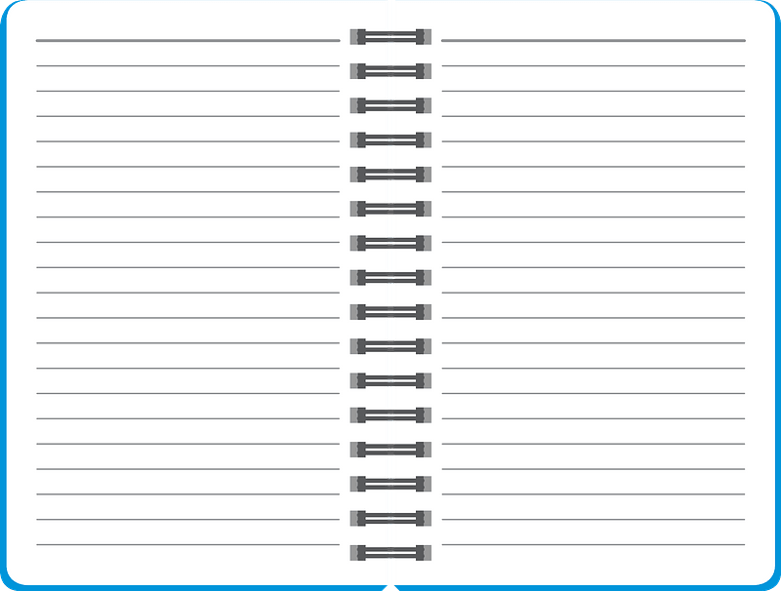
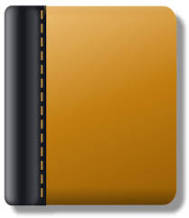

SDG 1:
Goal:
Description:
SDG Icon:
SDG 2:
Goal:
Description:
SDG Icon:
PASSPORT
Sustainable Development Goals

SDG 3:
Goal:
Description:
SDG Icon:
SDG 4:
Goal:
Description:
SDG Icon:
SDG 5:
Goal:
Description:
SDG Icon:

SDG 7:
Goal:
Description:
SDG Icon:
SDG 8:
Goal:
Description:
SDG Icon:
SDG 6:
Goal:
Description:
SDG Icon:

SDG 9:
Goal:
Description:
SDG Icon:
SDG 10:
Goal:
Description:
SDG Icon:
SDG 11:
Goal:
Description:
SDG Icon:

SDG 13:
Goal:
Description:
SDG Icon:
SDG 14:
Goal:
Description:
SDG Icon:
SDG 12:
Goal:
Description:
SDG Icon:

SDG 15:
Goal:
Description:
SDG Icon:
SDG 16:
Goal:
Description:
SDG Icon:
SDG 17:
Goal:
Description:
SDG Icon:

- Which SDG would you particularly like to see accomplished? Why?

- If you were to add an 18th SDG, what would you add? Explain why you would add it, then draw an icon for your new SDG.

- How is your new SDG different from the existing ones?

Getting the Word Out
Aligned to the following standards:
CS.01; CS.04; FFA.PL-A; FFA.PG-J; FFA.CS-M; FFA.CS-N; AG1; AG4; AGC02.02; CCSS-RI.9-10.1; CCSS.ELA-W.9-10.2; CCSS.ELA.SL.9-10.1; CCSS.ELA.SL.9-10.2; CCSS.ELA.SL.9-10.4; CCSS.ELA.RST.9-10.1; CCSS.ELA.RST.9-10.7; CCSS.ELA.WHST.9-10.1; CCSS.ELA.WHST.9-10.2; CCSS.ELA.WHST.9-10.4; CCSS.ELA.WHST.9-10.6; AFNR Career Cluster, Statement 2; AFNR Career Cluster, Statement 3; AFNR Career Cluster, Statement 7; CRP.02; CRP.04; CRP.05; CRP.06; CRP.11
Directions:
Use this sheet to brainstorm for the PSA (public service announcement) on your chosen SDG.

Which sustainable development goal will your PSA be about?

Supporting facts, statistics, stories or anecdotes for your video:

My “call to action” statement for viewers:

Additional Notes:

List all sources you used in your research:

Directions:
Use this side of the sheet to write the script for your public service announcement/video. Be sure your video meets all requirements outlined in the rubric on the next page.

Public Service Announcement Rubric
Area | 4 Points | 3 Points | 2 Points | 1 Point
Video Content  (2x multiplier) | All content is accurate. There are no factual errors.  (8 points total) | Most of the content is accurate, but there is one piece of information that seems inaccurate.  (6 points total) | The content is generally accurate and interview based, but one piece of information is clearly inaccurate.  (4 points total) | Content is confusing or contains more than one factual error.  (2 points total)
Clarity and Creativity | The video is easy to understand, and all elements are clearly written or spoken. Creativity was used. | The video is easy to understand, and most elements are clearly written or spoken. Some creativity was used. | The video is hard to understand with very quiet speaking or very hard to read writing. Little creativity was used. | The video is hard to understand, and one cannot follow the thought process. No creativity was used.
Quality of  Product | The video is clearly produced and presented with no mistakes.  All elements of the video (clips, graphics, text, voice) show quality and professionalism. | One or two mistakes are evident in the video.  Most elements of the video (clips, graphics, text, voice) show quality and professionalism. | Three or more mistakes are evident in the video.  Some elements of the video (clips, graphics, text, voice) show quality and professionalism. | The video is not well-produced and presents several mistakes.  Few elements of the video (clips, graphics, text, voice) show quality and professionalism.
Call to Action | There is a clear and compelling call to action for viewers to take next steps related to the goal. | The call to action is unclear or not compelling. Next steps are weak. | The call to action is confusing and weakly presented. No next steps are given. | There is no call to action present in the video.
Time | Video was 90 to 120 seconds in length. |  |  | Video was either under or over the allotted time frame.

Comments: Total: ________/24

