Aligned to the following standards: FPP.01; FPP.04; FFA.PL-A; FFA.PG-G; FFA.PG-J; FFA-CS-M; FFA.CS-N; AG-FD2; AG-FD4; AGPA01.01; AGPA01.02; AGAP01.03; AGPA01.04; CS.03; CS.01; CCSS.ELA.W.9-10.2; CCSS.ELA.SL.9-10.1.C; CCSS.ELA.SL.9-10.4; CCSS.ELA.RST.9-10.3; CCSS.ELA.RST.9-10.9; CCSS.ELA.WHST.9-10.2; CCSS.ELA.WHST.9-10.4; CCSS.ELA.WHST.9-10.5; MP1; MP3; MP6; AFNR Career Cluster, Statement 6; AFNR Career Cluster- Food Products and Processing Systems Pathway, Statement 1; AFNR Career Cluster-Food Products and Processing Systems Pathway, Statement 2; Buying Goods and Services, Benchmarks: Grade 12, Statement 1; Buying Goods and Services, Benchmarks: Grade 12, Statement 2; Buying Goods and Services, Benchmarks: Grade 12, Statement 7; CRP.02; CRP.04; CRP.05; CRP.06; CRP.07; CRP.08; CRP.11.

Activity 1: Steps to Creating a New Food Product
Directions:
Follow each step to begin the creation of your NEW food product! Read each step carefully and complete requirements as directed. Record your thoughts in the spaces provided. You may work with 1 partner if desired. You do not have to complete the steps in order if you find it easier to jump around.

STEP 1: Select and CIRCLE your Food Category, Platform and Market below:
“Product development scenarios will describe a category, platform and market. These may include but are not limited to the following categories, platforms and markets listed below:”

Category: (Circle 1)
i. Cereal
ii. Snacks (trail mix, etc.)
iii. Meals (frozen, ready to eat, etc.)
iv. Side dishes (macaroni, pasta salad, etc.)
v. Beverages (sodas, sport drinks, etc.)
vi. Supplements (vitamin/mineral based or supplemental meal bar)
vii. Condiments (ketchup, mustard, etc.)
viii. Desserts (cookies, pies, cakes, etc.)

Platform: (Circle 1)
i. Frozen
ii. Refrigerated
iii. Shelf-stable: food that can be kept at room temperature without spoiling. (Rice, canned goods, etc.)
iv. Convenience: food that saves time when preparing and cleaning up. (cake/baking mixes, instant potatoes, etc.)
v. Ready to eat: food that does not require preparation and is ready to eat. (cold meats, cheeses, precooked meals designed to eat cold, etc.)
vi. Heat and serve: food that has been prepared and frozen, which can then be heated and served. (frozen TV dinners, frozen pizza, frozen pies, frozen breakfast burritos, etc.)

Market (Domestic and International): (Circle 1)
i. Retail: selling of goods directly to a consumer (grocery stores such as Kroger, Walmart or small/locally owned grocery stores)
ii. Wholesale: buying of large quantities of items and reselling to customers or other retail stores (large stores such as Costco, Sam’s Club)
iii. Food service (used in a food service program cafeterias — school, college, government)
iv. Convenience store (gas station)

STEP 2: Processing of your product. Answer the following questions about how you plan to process/make your food product.
- Provide a description of how to make your product. (Think recipe style here.)
________________________________________________________________________________________________________________________________________________________________________________________________________________________________________________________________________________________________________________________________________________________________________________________________________________________________________________________________________________________________

- What equipment is needed? (meat processor, oven, dehydrator, etc.)
________________________________________________________________________________________________________________________________________________________________________________________________________________________________________________________________________________________________________________________________________________________________________________________________________________________________________________________________________________________________

- Flow diagram of how your processing will be set up.
Examples:
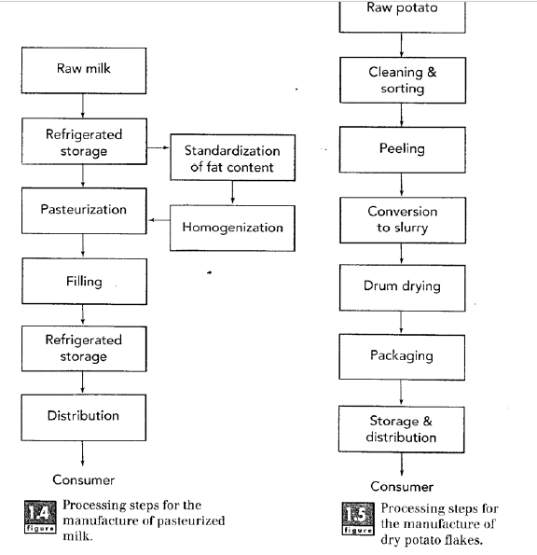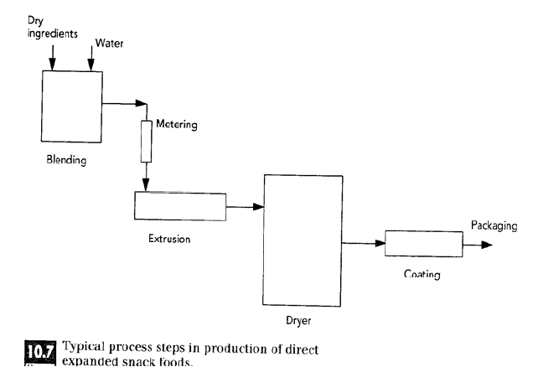

Use the space below to draw YOUR processing flow chart/plan:

- How many people and what type of people do you need working at your processing facility? (managers, machine operators, HR, quality control, packaging, etc.) Your response here will depend on how large you want your company to be. It can be as big or as small as you wish; just be sure to state the number of people required for each job you list.
Job Title/Role Number of People Needed for Role
____________________________________________________________________________________________________________________________________________________________________________________________________________________________________________________________________________________________________________________________________________________________________________________________________________________________________________________________________________________________________________________________________________________________________________________________________________________________________________________________________________________________________________________________________________________________________________________________________________________________________________________________________________________________________________________________________

STEP 3: Identify your target audience. Who do you want to purchase your product? (youth ages x to y; young adults ages x to y; middle-aged adults ages x to y; elderly, etc.) Is your target audience athletic? Parents of young children? Busy, working adults?
Target Audience is ________________________________________________________________.
Why this target audience? ________________________________________________________________________________________________________________________

STEP 4: Packaging. What are you going to package your item in? Consider multiple layer packaging depending on your product (like a cereal box) and what is the purpose of the multiple layers (to keep food fresh, from getting soggy, from getting firm, etc.). You must consider the materials used; be sure materials are appropriate for your food item, and be creative.
Describe your packaging plan:
________________________________________________________________________________________________________________________________________________________________________________________________________________________________________________________________________________________________________________________________________________________________________________________________________________________________________________________________________________________________________________________________________________________________________________________________________________________________________________________________________________________________________________________________________________

STEP 5: Food safety. What food safety concerns are associated with your product? Cross-contamination concerns? Over or under baking? Equipment operation concerns? Think about all phases of processing (from start to finish). How will you combat concerns?
Food Safety Concern: How to Prevent the Concern:
________________________________________________________________________________________________________________________________________________________________________________________________________________________________________________________________________________________________________________________________________________________________________________________________________________________________________________________________________________________________________________________________________________________________________________________________________________________________________________________________________________________________________________________________________________

STEP 6: Product ingredients and supplies
List all ingredients needed for your product. Consider if you will purchase items whole, like pizza dough or make your own. List all supplies needed to make your product (sticks for popsicle, boxes for pizza, etc.)
My Food Product INGREDIENTS List My Food Product SUPPLYS List
________________________________________________________________________________________________________________________________________________________________________________________________________________________________________________________________________________________________________________________________________________________________________________________________________________________________________________________________________________________________________________________________________________________________________________________________________________________________________________________________________________________________________________________________________________
________________________________________________________________________________________________________________________________________________________________________________________________________________________________________________________________________________________________________________________________________________________________________________________________________________________________________________________________________________________________________________________________________________________________________________________________________________________________________________________________________________________________________________________________________________

STEP 7: Cost of goods sold. You will need to calculate rough estimates for this portion. You must calculate using appropriate numbers and figures. This must be realistic. You may need to complete online research for pricing of raw goods. Do not forget about your packaging supplies costs. Reference Step 5 for all components to list here. List all costs here.
Item Name Cost/What Size? (oz, gram, pint?)
________________________________________________________________________________________________________________________________________________________________________________________________________________________________________________________________________________________________________________________________________________________________________________________________________________________________________________________________________________________________________________________________________________________________________________________________________________________________________________________________________________________________________________________________________________
________________________________________________________________________________________________________________________________________________________________________________________________________________________________________________________________________________________________________________________________________________________________________________________________________________________________________________________________________________________________________________________________________________________________________________________________________________________________________________________________________________________________________________________________________________

STEP 8: Quality control
What are the quality control measures you need to look for in your product? (Examples: flavor, texture, consistency, temperature, net wet, size, etc.)
List the quality control measures you need to look for in your product:
________________________________________________________________________________________________________________________________________________________________________________________________________________________________________________________________________________________________________________________________________________________________________________________________________________________________________________________________________________________________________________________________________________________________________________________________________________________________________________________________________________________________________________________________________________

STEP 9: Marketing and sales
- Use the space below to draw each side of your packaging for your product. You do not need to provide detailed nutrition or nutrition label information here.
- DO include the following areas on your packaging: name of product; net weight of product; nutrition facts panel (draw a box in the location where it would go on your packaging); ingredient list (provide space where this information will go); manufacturer information
My packaging will be made of: (plastic, cardboard, etc.) ________________________________________________________________________________________________________________________
The name of my product is: (Kreiders’ Korn, Sadis’ Sweet Syrup, etc.) Do not forget about your LOGO! (Created in “Anatomy of a Logo” worksheet) ________________________________________________________________________________________________________________________

FRONT of Packaging: Back of Packaging:

Side of Packaging? Other side of Packaging?

Where do you plan to market/sell your product? (Be specific on store location: front, back, side, etc. Free standing case? Or in another case?) ____________________________________________________________________________________________________________________________________________________________________________________

Do you plan to run promotions? If so, when and what kind? How will these promotions impact your overall profit?
____________________________________________________________________________________________________________________________________________________________________________________

STEP 10: Nutrition and nutritional labeling
Using the information you learned in our previous lesson on “Interpreting and Designing Food Labels,” design a food label for your product. All calculations must be correct.
Example Nutritional Label:
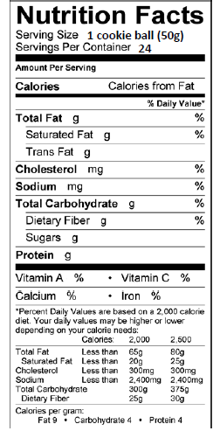

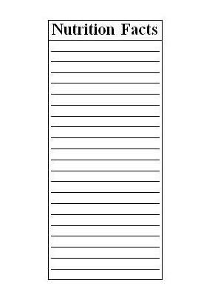
My Food Product Nutritional Label: Draw lines where needed and fill in the label below to represent your product. You may use the empty space around the label for notes, calculations, etc.

Activity 1: Nutritional Label Calculations
Aligned to the following standards: FPP.01; FPP.04; FFA.PL-A; FFA.PG-G; FFA.PG-J; FFA-CS-M; FFA.CS-N; AG-FD2; AG-FD4; AGPA01.01; AGPA01.02; AGAP01.03; AGPA01.04; CS.03; CS.01; CCSS.ELA.W.9-10.2; CCSS.ELA.SL.9-10.1.C; CCSS.ELA.SL.9-10.4; CCSS.ELA.RST.9-10.3; CCSS.ELA.RST.9-10.9; CCSS.ELA.WHST.9-10.2; CCSS.ELA.WHST.9-10.4; CCSS.ELA.WHST.9-10.5; MP1; MP3; MP6; AFNR Career Cluster, Statement 6; AFNR Career Cluster- Food Products and Processing Systems Pathway, Statement 1; AFNR Career Cluster-Food Products and Processing Systems Pathway, Statement 2; Buying Goods and Services, Benchmarks: Grade 12, Statement 1; Buying Goods and Services, Benchmarks: Grade 12, Statement 2; Buying Goods and Services, Benchmarks: Grade 12, Statement 7; CRP.02; CRP.04; CRP.05; CRP.06; CRP.07; CRP.08; CRP.11.

Directions:

Reference for this worksheet (with explanation of example): https://edisciplinas.usp.br/pluginfile.php/5516437/course/section/6014434/2017_Book_FoodAnalysisLaboratoryManual.pdf

EXAMPLE:

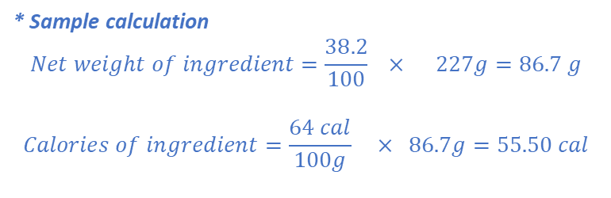

Grading Rubric for Product Development Verbal Presentation
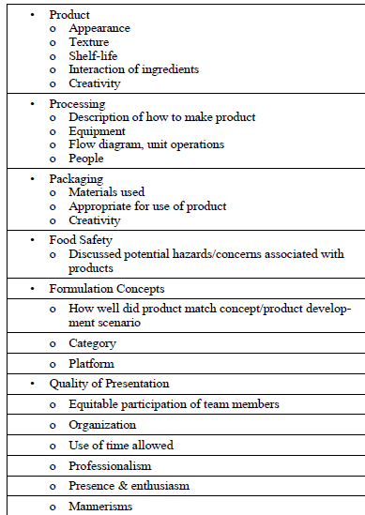
National FFA Scoring Rubric for Reference:
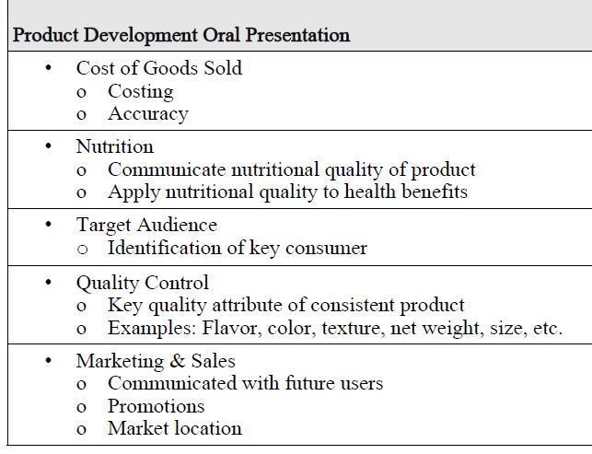

- Students declared: ___/___
  - Category (cereal, snack, etc.)
  - Platform (frozen, ready to eat, etc.)
  - Market (retail, food service, etc.)
- Clear processing plan of product shown: ___/___
  - Description of how to make product was provided:
  - Equipment needed to make product was provided: ___/___
- Target audience identified and explanation of why: ___/___
- Food safety issues addressed: ___/___
- Covered cost of goods sold: ___/___
- Discussed/shared quality control measures taken: ___/___
- Marketing and sales plan for product: ___/___
- Description of product packaging: ___/___
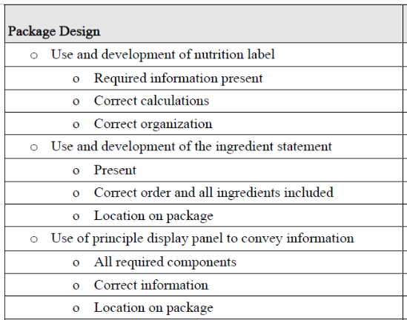

TOTAL SCORE: ______ /______

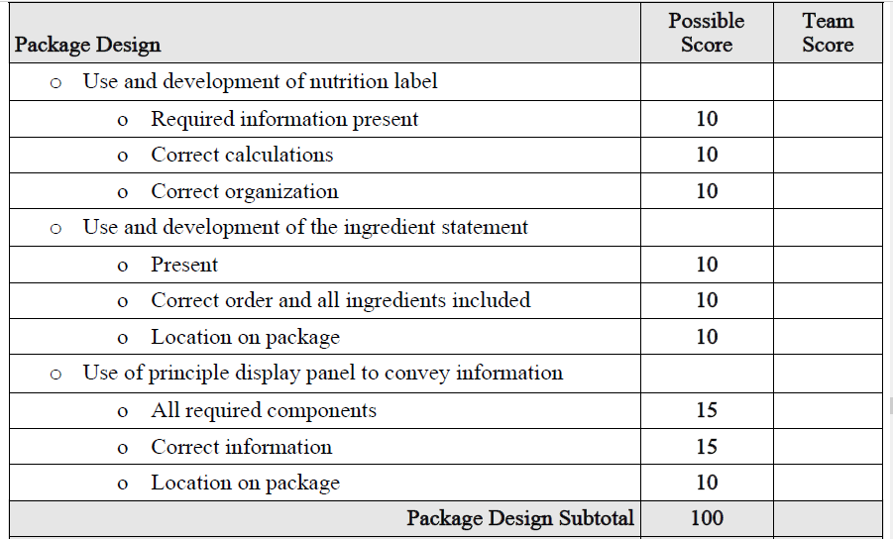
KEY: Product Development Packaging
Optional Use: National FFA Food Science and Technology CDE Grading Rubric for “Package Design”.

