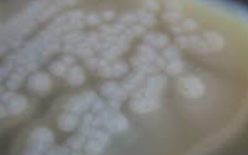
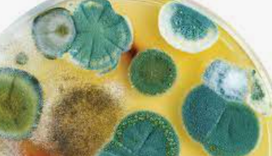
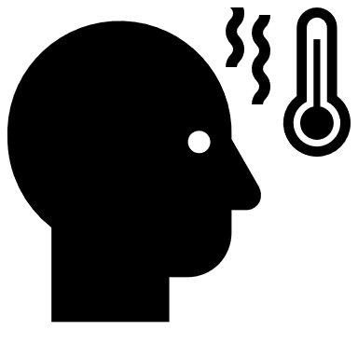
Don’t Eat That!
What do the items have in common?

Is there anything wrong with any of the items? If so, what?
Are all items safe to consume? How do you know?
What do you think our topic for class is today?
Aligned to the following standards: FPP.02.; FFA.PL-A; FFA.PL-C; FFA.PG-J; FFA-CS-M; AG-FD1; AGPA01.02; AGPA01.04; CS.03; CCSS.RI.9-10.1; CCSS. RI.9-10.2; CCSS.W.9-10.2; CCSS.SL.9-10.1.A; CCSS.SL.9-10.1.C; CCSS.RST.9-10.1; CCSS.RST.9-10.2; CCSS.RST.9-10.3; CCSS.RST.9-10.7; CCSS.WHST.9-10.2; CCSS.WHST.9-10.4; CCSS..MP6; AFNR Career Cluster-Food Products and Processing Systems Pathway, Statement 2; Buying Goods and Services, Benchmarks: Grade 12, Statement 2; Buying Goods and Services, Benchmarks: Grade 12, Statement 7; CRP.02; CRP.04; CRP.05; CRP.06; CRP.07; CRP.08; CRP.11

Directions:
Observe the items on the front counter but do not touch or eat the items.

Food Pathogens
Aligned to the following standards: FPP.02.; FFA.PL-A; FFA.PL-C; FFA.PG-J; FFA-CS-M; AG-FD1; AGPA01.02; AGPA01.04; CS.03; CCSS.RI.9-10.1; CCSS. RI.9-10.2; CCSS.W.9-10.2; CCSS.SL.9-10.1.A; CCSS.SL.9-10.1.C; CCSS.RST.9-10.1; CCSS.RST.9-10.2; CCSS.RST.9-10.3; CCSS.RST.9-10.7; CCSS.WHST.9-10.2; CCSS.WHST.9-10.4; CCSS..MP6; AFNR Career Cluster-Food Products and Processing Systems Pathway, Statement 2; Buying Goods and Services, Benchmarks: Grade 12, Statement 2; Buying Goods and Services, Benchmarks: Grade 12, Statement 7; CRP.02; CRP.04; CRP.05; CRP.06; CRP.07; CRP.08; CRP.11

Directions:
Complete the following chart as instructed.
Pathogen Name | Source of Contamination | Impact on Human Health | How to Avoid | Other Thoughts
In summary, what is the best way to avoid contamination of food pathogens?
Common Allergens in Food

Key Term: Allergen: any substance, often a protein, that induces an allergy; common allergens include pollen, grasses, dust and some medications

Concept: Describe the effects foodborne allergens have on people.

Objective: Identify 8 major food allergens.

Purpose: While more than 160 foods can cause allergic reactions (and even death) in people with food allergies, the law identifies the 8 most common allergenic foods. These foods account for 90% of food allergic reactions and are the food sources from which many other ingredients are derived.
Milk
Eggs
Fish (e.g., bass, flounder, cod)
Crustacean shellfish (e.g., crab, lobster, shrimp)
Tree nuts (e.g., almonds, walnuts, pecans)
Peanuts
Wheat
Soybeans

These 8 foods, and any ingredient that contains protein derived from one or more of them, are designated as “major food allergens” by FALCPA.

The law requires that food labels identify the food source names of all major food allergens used to make the food. This requirement is met if the common or usual name (e.g., buttermilk) of an ingredient that is a major food allergen already identifies that allergen's food source name (i.e., milk). Otherwise, the allergen's food source name must be declared at least once on the food label in one of two ways.

The name of the food source of a major food allergen must appear in parentheses following the name of the ingredient.
Examples: “lecithin (soy),” “flour (wheat)” and “whey (milk)”
– OR –
Immediately after or next to the list of ingredients in a “contains” statement.
Example: “Contains Wheat, Milk and Soy”

Food Allergen “Advisory” Labeling
FALCPA’s labeling requirements do not apply to the potential or unintentional presence of major food allergens in foods resulting from “cross-contact” situations during manufacturing, e.g., because of shared equipment or processing lines. In the context of food allergens, “cross-contact” occurs when a residue or trace amount of an allergenic food becomes incorporated into another food not intended to contain it. The FDA guidance for the food industry on potential allergens states that the food allergen advisory statements, e.g., “may contain [allergen]” or “produced in a facility that also uses [allergen]” should not be used as a substitute for adhering to current good manufacturing practices and must be truthful and not misleading. The FDA is considering ways to best manage the use of these types of statements by manufacturers to better inform consumers.

Part 1: Research

Your group will be assigned one food allergen from the list above. In your group decide how to develop a fact sheet about your allergen. Things to include on the fact sheet:
- Name
- What causes the allergic reaction
- Symptoms of the reaction
- Level of reaction
- Treatment for a reaction
- What foods to avoid
- Other useful information
- Your fact sheet should be one page in length and include all important information about the allergen and how to treat or avoid a reaction.
- Your teacher may make a copy of your fact sheet for all your classmates.
- You will share your information with your classmates and complete table in this worksheet.

Conclusion: Answer the following questions.
What causes foodborne allergens?

Why is food labeling important for people with food allergens?

What are the most dangerous food allergies?

Complete the table below with information you learn about the common allergens.

Allergen | Causes | Symptoms | Levels of Reaction | Treatment for Reaction | Foods to Avoid | Labeling Requirements
Milk

Eggs

Fish

Shellfish

Tree Nuts

Peanuts

Wheat

Soy

Extension Activity: Mixed-up Milk
Aligned to the following standards: FPP.02.; FFA.PL-A; FFA.PL-C; FFA.PG-J; FFA-CS-M; AG-FD1; AGPA01.02; AGPA01.04; CS.03; CCSS.RI.9-10.1; CCSS. RI.9-10.2; CCSS.W.9-10.2; CCSS.SL.9-10.1.A; CCSS.SL.9-10.1.C; CCSS.RST.9-10.1; CCSS.RST.9-10.2; CCSS.RST.9-10.3; CCSS.RST.9-10.7; CCSS.WHST.9-10.2; CCSS.WHST.9-10.4; CCSS..MP6; AFNR Career Cluster-Food Products and Processing Systems Pathway, Statement 2; Buying Goods and Services, Benchmarks: Grade 12, Statement 2; Buying Goods and Services, Benchmarks: Grade 12, Statement 7; CRP.02; CRP.04; CRP.05; CRP.06; CRP.07; CRP.08; CRP.11

Investigational Tools:
- 1 ½ cups of assigned milk
- 1 microwave-safe bowl
- 4 teaspoons white vinegar
- 1 mixing spoon
- 1 strainer
- 1 cheese cloth
- 1 airtight container
- Microwave

Directions:

1. Pour the milk into the bowl, and add the vinegar.

2. Microwave the bowl for 1 minute on high power.

3. Look at the mixture. What happened? Record your observations below.

4. Stir the mixture. Then, over the sink, pour it through the strainer, lined with a cheese cloth.

5. You have just made curds! What you have should look like large-curd cottage cheese.

6. Cool the solid and rinse it lightly before handling.

7. Squeeze out any remaining liquid and shape the solid with your hands.

8. Store it in the airtight container.

Outline the Facts:
- Share. Pick up your product. What does it feel like?

- Reflect. What role did the vinegar play in the experiment?

- Generalize. What kind of milk did you have? Would it work with other types of milk? Do you need white vinegar, or can you try another kind of vinegar?

- Apply. Heating the milk and vinegar caused a change in the milk’s form. What other liquids can change form when combined with other ingredients?

