Bell Ringer: Role of Consumers in the Market
Aligned to the following standards: CS.01; FFA.PL-A; FFA.PL-C; FFA.PL-E; FFA.CS-M; FFA.CS-N; AG1; AG2; AGC05.02; CCSS.ELARI.9-10.1; CCSS.ELA- RI.9-10.2; CCSS.ELARI.9-10.4; CSS.ELAW.9-10.2; CCSS.ELA.SL.9-10.1; CCSS.ELA.SL.9-10.4; CCSS.ELA.RST.9-10.1; CCSS.ELA.RST.9.10.4; CCSS.ELA.RST.9-10.8; CCSS.ELA.WHST.9.10.6; CRP.04; CRP.05; CRP.06; CRP.07; CRP.08; Buying Goods and Services, Benchmarks: Grade 12, Statement 1; Buying Goods and Services, Benchmarks: Grade 12, Statement 2.

Directions:
In a free market, Agriculture, Food and Natural Resources (AFNR) systems are driven by consumer demands. Consumer demands are shaped by several factors. Grasping how consumers influence the markets begins with understanding consumer purchasing power and motivations for buying agricultural products in a capitalist economy.

Complete the following:
- Visit the “Supply and Demand” and “Markets and Prices” webpages by The Library of Economics and Liberty (n.d.), available at https://www.econlib.org/library/Topics/College/supplyanddemand.html and “Economic Systems” by The Library of Economics and Liberty (n.d.), available at https://www.econlib.org/library/Topics/HighSchool/EconomicSystems.html.
- Visit the “Five Common Factors Influencing Consumer Behavior” by iResearch Services (2018) website, available at https://www.iresearchservices.com/5-common-factors-influencing-consumer-behavior/.
- Record your responses below.

Visit the “Supply and Demand,” “Markets and Prices” and “Economic Systems” webpages (links listed above) and define the following economic terms:

Capitalism | Supply | Demand | Equilibrium Prices | Market-Clearing Price

- Based on what you learned from these definitions, explain the role of a consumer in a capitalist economy.

- What is the role of a consumer in supply and demand?

- From what we learned on this worksheet, how do you think the food we purchase and consume fits in with consumer’s roles?”

Visit the “Five Common Factors Influencing Consumer Behavior” by the iResearch Services (2018) website, available at https://www.iresearchservices.com/5-common-factors-influencing-consumer-behavior/.

Define each of the factors pertaining to the purchasing patterns of consumers in a free market. Also, describe the connection to food science and give an example.
- What is a consumer’s role in each of these steps?

Introduction to the Agriculture, Food and Natural Resources Value Chain
Part 1
Directions:
The Agriculture, Food and Natural Resources Value Chain engages several players from production to the consumer.

Complete the following:
- Review the National FFA Organization’s “Agriculture, Food and Natural Resources Value Chain” diagram, and record your responses below.
  - If needed, use the Agricultural Marketed Resource Center (AMRC) website as an additional resource (https://www.agmrc.org/).

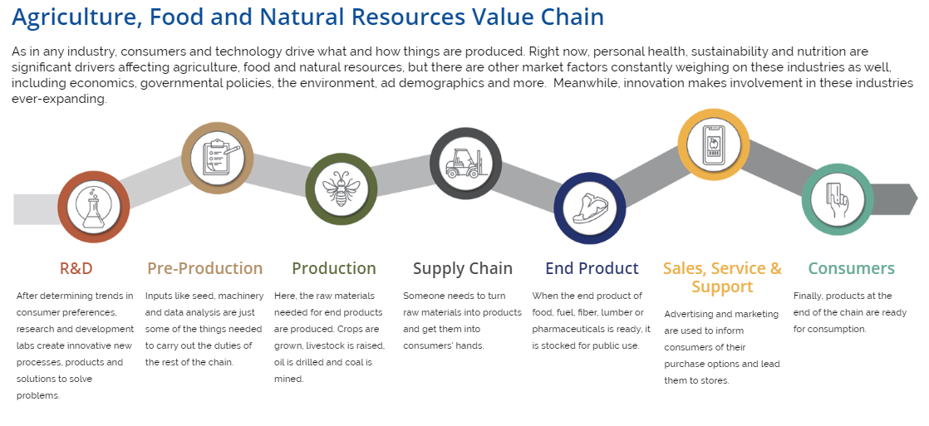
To best understand value chains, it is helpful to outline how products move from production to consumer in other contexts. For example, consider the steps it would take to send a birthday card to a family member who lives in a different state. As you read each step, refer to the Agriculture, Food and Natural Resources Value Chain diagram shown above. You do not need to write anything down in this step; simply consider the steps.

        - R&D: What type of card should you buy? What does your family member like? Is there a particular design that would appeal to your family member?
        - Pre-Production: How would the card get to the shelf? How would you travel to the store to get the card?
        - Production: What message will you write? What size stamp would it take?
        - Supply Chain: How will the letter get to your family member? How will you get it in the mail?
        - End Product: Once the letter gets to the postal service, who are the end-product players?
        - Sales, Service and Support: How will the mailperson get the letter to their mailbox?
        - Consumers: Once your family member gets the card, what will his or her reaction be?

Part 2
Using the birthday card example above, think through the value chain steps it will take to create a new value-added food product. List the key players and questions you must consider to get a new value-added food product on the shelves for consumers to purchase. Refer to the steps in the Agriculture, Food and Natural Resources Value Chain for ideas. Complete the following based on the new food product idea you develop.

*New, Value-Added Food Product NAME: _________________________________________
Describe your new food product: ________________________________________________________________________________________________________________________________________________________________________________________________________________________________________________

- R & D:

- Pre-Production:

- Production:


- Supply Chain:

- End Product:

- Sales, Service and Support:

- Consumers:

Agriculture, Food and Natural Resources Value Chain Review + Classroom Exit Ticket
DIRECTIONS:
Review the definitions for each of the seven sectors in the Agriculture, Food and Natural Resources Value Chain diagram.
- In your own words, label and describe each step.
- Give an example for each step.
- When finished, turn this worksheet in where indicated.
2
6
4
3
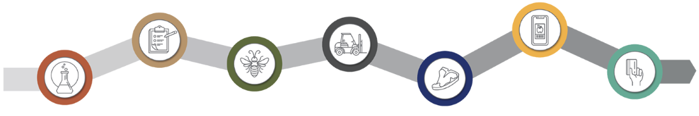
1
7
5

1)

2)

3)

4)

5)

6)

7)

