Click to Create
Aligned to the following standards:
ECL.03; ECL.04; FFA.PL-A1; FFA.PL-A3; FFA.PL-A4; FFA.PL-C2; FFA.PL-F3; FFA.PL-F4; FFA.PL-F5; FFA.PL-I5; FFA.PL-J1; FFA.PL-J2; FFA.PL-M1; FFA.PL-N1; FFA.PL-O1; CCSS.ELA-RI.9-10.4; CCSS.ELA-RI.11-12.7; CCSS.ELA-W.9-10.2; CCSS.ELA-W.9-10.4; CCSS.ELA-W.9-10.6; CCSS.ELA-SL.9-10.2; CCSS.ELA-SL.9-10.5; CCSS.ELA-L.9-10.1; CCSS.ELA-L.9-10.2; NGS Practice 8; CRP.02; CRP.04; CRP.06; CRP.08; CRP.11
Directions: Answer the questions below as you watch the video “Lily Carriker | Agricultural Communications SAE,” available at https://vimeo.com/1108190653.

- Circle the state Lily is from.

- Describe Lily’s SAE in two or three sentences.

- Explain how Lily got started on her SAE in two or three sentences.

- What kinds of skills did Lily begin to develop before starting her SAE?

- What is the number one skill Lily has learned from her SAE?

- What other SAE activity was helpful to Lily in her SAE journey?
How did it help her?

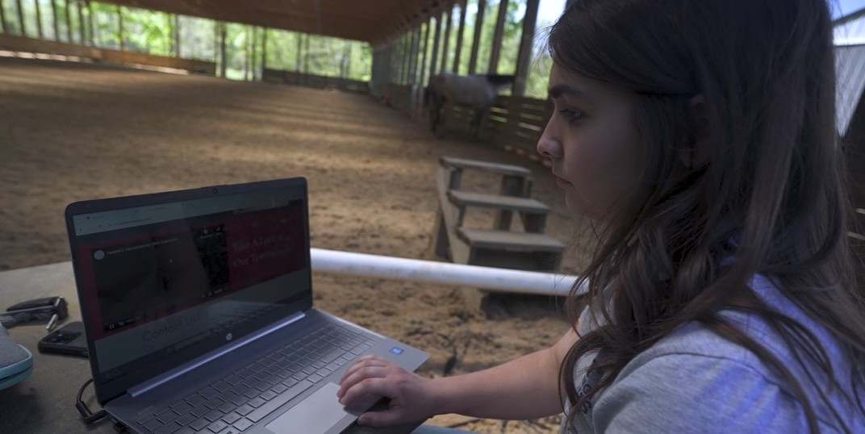
- What is Lily’s favorite FFA memory?

Homepages and First Impressions
Aligned to the following standards:
ECL.03; ECL.04; FFA.PL-A1; FFA.PL-A3; FFA.PL-A4; FFA.PL-C2; FFA.PL-F3; FFA.PL-F4; FFA.PL-F5; FFA.PL-I5; FFA.PL-J1; FFA.PL-J2; FFA.PL-M1; FFA.PL-N1; FFA.PL-O1; CCSS.ELA-RI.9-10.4; CCSS.ELA-RI.11-12.7; CCSS.ELA-W.9-10.2; CCSS.ELA-W.9-10.4; CCSS.ELA-W.9-10.6; CCSS.ELA-SL.9-10.2; CCSS.ELA-SL.9-10.5; CCSS.ELA-L.9-10.1; CCSS.ELA-L.9-10.2; NGS Practice 8; CRP.02; CRP.04; CRP.06; CRP.08; CRP.11

Part 1
Directions: Visit the three websites listed in the tables below and spend some time exploring them. Record your thoughts on each of the websites using the questions and prompts provided. Look for examples of both positive characteristics and areas of improvement for a website that you can use when thinking about creating a web design of your own in Part 2.
Website 1: National FFA Organization (FFA.org/)
What is your first impression upon visiting this site’s homepage? (one sentence)

What do you like about this website’s design? | What do you think could be improved upon?
Name three web elements that you think make this site useful and pleasant to navigate. | What is one design change or addition you would make to this site if you were the webmaster?  Why would this change improve the site?

Website 2: Twisted L Horsemanship (https://www.twistedlhorsemanship.com/) (The site Lily designed for her SAE.)
What is your first impression upon visiting this site’s homepage? (one sentence)

What do you like about this website’s design? | What do you think could be improved upon?
Name three web elements that you think make this site useful and pleasant to navigate. | What is one design change or addition you would make to this site if you were the webmaster?  Why would this change improve the site?

Website 3: Student’s Choice (Choose a school-appropriate website that you would like to analyze.)
Website Name:
Website URL:
What is your first impression upon visiting this site’s homepage? (one sentence)

What do you like about this website’s design? | What do you think could be improved upon?
Name three web elements that you think make this site useful and pleasant to navigate. | What is one design change or addition you would make to this site if you were the webmaster?  Why would this change improve the site?

Analysis Questions:

- What features or design choices did you see repeated across all three websites?

Why do you think these elements are so common?

- Which website was the easiest to navigate, and what made it feel that way?

- How did colors, images and layout impact your opinion of each site?

- Based on what you explored, what do you think is the most important factor in designing a website people will actually use?

Part 2
Directions: Select a local business or organization that either doesn’t have a website or could use a redesign of its current website. Use the space below and on the next page to design a homepage and one additional page for that site. Your basic design should include pictures, copy (the words on the website) and navigation to other pages of the website; it should be visually appealing and easy to navigate for users. You may choose to include any elements you found in your review of the websites in Part 1.

Homepage
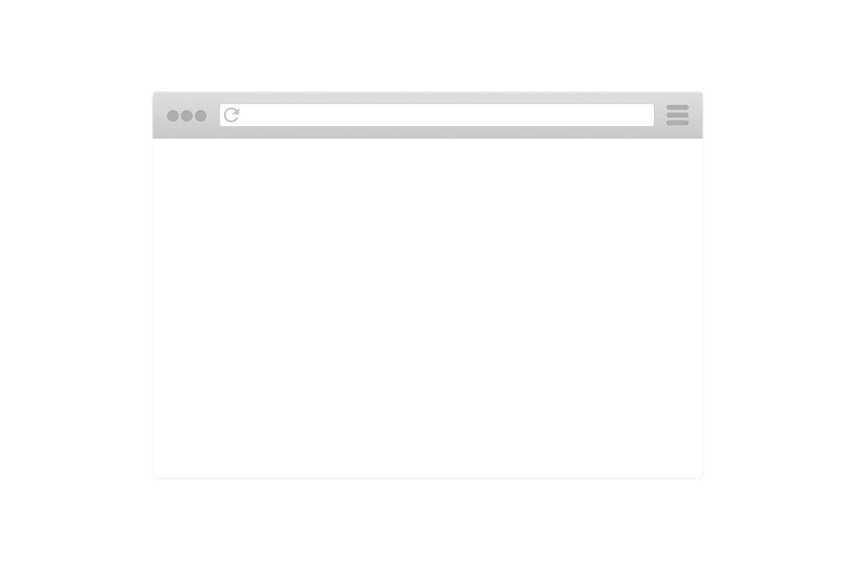
Second Page

How did you decide on your layout and what elements to include?

After creating your own web design, what do you think is the most important quality of a good website? Why?

