SAEs: Endless Possibilities
Aligned to the following standards:
FFA.PL-A1; FFA.PL-A3; FFA.PL-A4; FFA.PL-C2; FFA.PL-F5; FFA.PL-I5; FFA.PL-J1; FFA.PL-N1; CCSS.ELA-RI.9-10.4; CCSS.ELA-RI.11-12.7; CCSS.ELA-W.9-10.2; CCSS.ELA-W.9-10.4; CCSS.ELA-SL.9-10.2; CCSS.ELA-SL.9-10.5; CCSS.ELA-L.9-10.1; CCSS.ELA-L.9-10.2; CRP.02; CRP.04; CRP.06; CRP.08

Directions: Answer the questions below as you watch the video “Middle School SAEs,” available at https://vimeo.com/1108190439.

- What are the SAEs that students in the video are showcasing?
  - Tye:
  - Logan:
  - Madison:
- What are a few of the most common SAEs for Ms. Miller’s students?
- Choose one student from the video and explain how that student’s SAE started and how it has grown over the years into what it is now.
- What is one thing each student has learned from having an SAE?
  - Logan:
  - Madison:
  - Tye:
- What resources does Ms. Miller use with her students when covering SAEs?
  - What kinds of things does your agriculture teacher use to talk about SAEs?

- What is Ms. Miller’s favorite part of students doing SAEs?
- What impact have students’ SAEs had on Mount Pleasant Middle School?

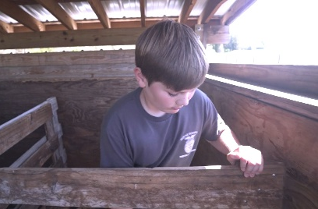
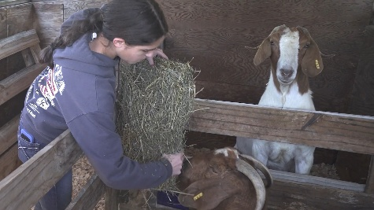
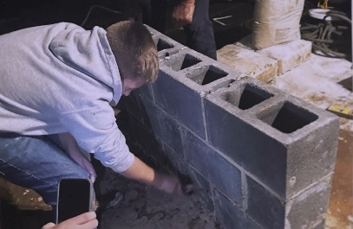
SAE Scavenger Hunt
Aligned to the following standards:
FFA.PL-A1; FFA.PL-A3; FFA.PL-A4; FFA.PL-C2; FFA.PL-F5; FFA.PL-I5; FFA.PL-J1; FFA.PL-N1; CCSS.ELA-RI.9-10.4; CCSS.ELA-RI.11-12.7; CCSS.ELA-W.9-10.2; CCSS.ELA-W.9-10.4; CCSS.ELA-SL.9-10.2; CCSS.ELA-SL.9-10.5; CCSS.ELA-L.9-10.1; CCSS.ELA-L.9-10.2; CRP.02; CRP.04; CRP.06; CRP.08

Directions: For each prompt below, find an SAE Idea Card that meets the criteria and record which career is represented on the card as well as one immersion SAE idea, one foundational SAE idea and one skill needed for that career. You must use a new card for each prompt (no repeating cards).

Find a card that contains the word “Engineer.”  Career:  Immersion SAE Idea:  Foundational SAE Idea:  One Skill Needed: | Find a card that fits in the Plant Systems pathway.  Career:  Immersion SAE Idea:  Foundational SAE Idea:  One Skill Needed:
Find a card that involves food or nutrition.  Career:  Immersion SAE Idea:  Foundational SAE Idea:  One Skill Needed: | Find a card with a career you’ve never heard of before.  Career:  Immersion SAE Idea:  Foundational SAE Idea:  One Skill Needed:
Find a card that lists “Strategic Thinking” as a skill.  Career:  Immersion SAE Idea:  Foundational SAE Idea:  One Skill Needed: | Find a card with an animal in the picture.  Career:  Immersion SAE Idea:  Foundational SAE Idea:  One Skill Needed:
Find a card that highlights technology or innovation.  Career:  Immersion SAE Idea:  Foundational SAE Idea:  One Skill Needed: | Find a card for something you didn’t know was related to agriculture.  Career:  Immersion SAE Idea:  Foundational SAE Idea:  One Skill Needed:
Find a card that fits in four or more pathways.  Career:  Immersion SAE Idea:  Foundational SAE Idea:  One Skill Needed: | Find a card with a career you’d be interested in.  Career:  Immersion SAE Idea:  Foundational SAE Idea:  One Skill Needed:
Reflection Questions

- What surprised you about the kinds of careers you saw connected to SAEs?

- Which SAE card made you think, “I could actually see myself doing this”? Why?

- How could the hobbies, chores or responsibilities you already have connect to possible SAEs?

- What skills that could help you in the future do you think you’d gain from doing an SAE?

- What career do you dream about right now? How could an SAE help you “try it on” before you get there?

- Imagine yourself in high school FFA: What kind of SAE could you picture yourself continuing or expanding then?

- If you were to start an SAE this month, what is one small step you could take?

