Aligned to the following standards:
CS.05; PS.01; FFA.PL-A; FFA.PL-C; FFA.PL-E; FFA.PL-F; FFA.PG-I; FFA.PG-J; FFA.CS-M; FFA.CS-N; CCSS.ELA-RI.9-10.4; •CCSS.ELA.W.9-10.1; CCSS.ELA.W.9-10.2; CCSS.ELA.RST.9.10.8; CCSS.ELA.WHST.9.10.1; CCSS.ELA.WHST.9.10.4; CCSS. MP1; CCSS. MP2; CCSS. MP3; CRP.02; CRP.04; CRP.06; CRP.07; CRP.08
Wrangling With Worms
Directions:
Answer the questions below as you watch the video “Catawba Worms SAE | Payden Criswell,” available at https://vimeo.com/857912603.

- What does Payden say the Catawba worms are used for after he collects them from the trees?

- How many trees does Payden’s farm have on it?

- What are the daily tasks associated with Payden’s SAE?

- Describe how the Catawba worms are harvested from the trees.

- What safety precautions does Payden take for his SAE?

- What advice does Payden have for students wanting to start a new SAE?
  - How can you implement his advice into your own SAE?
Integrated Pest Management (IPM)
Directions:
Read the following information about integrated pest management (IPM) and then use the principles you’ve learned to answer the two scenarios on the “Bugging Out” worksheet. As you read, underline important definitions of terms. When finished reading, draw an icon in the space in the margin to go along with each component of IPM. Also, choose a color to highlight each component of IPM (i.e., Identification = Blue, Setting Action Thresholds = Green, etc.)

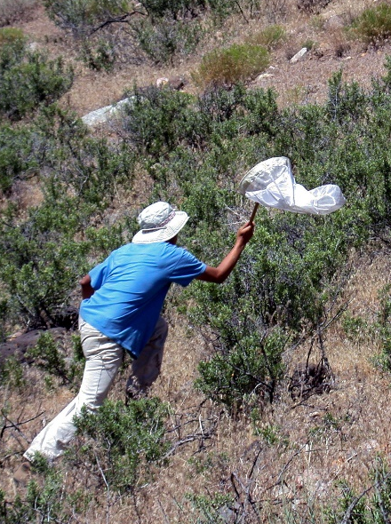
“Catawba Worm Farming”
You’ve just watched the video about Payden’s SAE, which involves removing Catawba (Catalpa) worms from Catalpa trees and selling them as fishing bait. The “worms” are the larval form of the Catalpa Sphinx Moth and exclusively eat the leaves of Catalpa trees thus technically making them a pest. Payden, through his SAE, has found a way to help control the population of these pests without using chemicals and in a beneficial way. This is one of the primary principles of a process called integrated pest management.

Integrated Pest Management
Integrated pest management (IPM) is “a science-based decision-making process that combines tools and strategies to identify and manage pests” (USDA). It is a wider look at the whole system in which the pests exist and how they come to be where they are rather than just focusing on the elimination of the pests that are already there. There are several considerations taken into account within the practices of IPM including the identification of pests, setting action thresholds, choosing and implementing an appropriate combination of management techniques (biological, cultural, mechanical/physical and chemical), and evaluating the results of the plan’s actions.

Identification and Monitoring of Pests: To best understand what is happening in any scenario, the first step is identifying the pest and what damage (if any) it is causing. This helps to determine if action needs to be taken.

Setting Action Thresholds: In most cases, there is a certain level of pests that can be tolerated within a system. It is up to each individual or organization to set the threshold or “tipping point” for when action to manage the pests will need to be taken. This could be economically driven, health-related or aesthetically motivated.

Methods of Control: There are different ways to control or manage pest populations. IPM considers each of the
following strategies for managing pests.
  - Biological Controls: Using “natural enemies” (predators, parasites, competitors, pathogens) to manage pests. This involves introducing another living organism into the system that will reduce the impact of the pests and will not cause further damage.
  - Cultural Controls: Making changes to the environment or “culture” of the system that will reduce pests establishing themselves. For example, if the identified pest thrives in standing water, this could mean reducing irrigation for plants (if possible) to limit the amount of excess water around.
  - Mechanical/Physical Controls: These methods are tangible things that kill, remove or prevent pests (traps, sealing holes, picking pests off of plants, etc.). Payden’s shaking the Catawba worms free from the trees and removing them is an example of mechanical control.
  - Chemical Controls: The use of pesticides does have its place in some instances; however, in IPM, spraying pesticides is an “only when absolutely necessary” measure and should be done in a way that minimizes harm to the environment, people, animals and other organisms in the system.

Evaluating Results: To ensure the best and most effective practices are always being used, it is essential
that pest populations, thresholds and controls are regularly evaluated and updated as needed.

References:
Environmental Protection Agency – Integrated Pest Management, https://www.epa.gov/safepestcontrol/integrated-pest-management-ipm-principles
Penn State Extension – Steps of Integrated Pest Management (IPM), https://extension.psu.edu/steps-of-integrated-pest-management-ipm
United States Department of Agriculture – Integrated Pest Management, https://www.usda.gov/oce/pest/integrated-pest-management
University of California, Agriculture and Natural Resources – Statewide Integrated Pest Management Program, https://ipm.ucanr.edu/what-is-ipm/
Bugging Out
Aligned to the following standards:
CS.05; PS.01; FFA.PL-A; FFA.PL-C; FFA.PL-E; FFA.PL-F; FFA.PG-I; FFA.PG-J; FFA.CS-M; FFA.CS-N; CCSS.ELA-RI.9-10.4; •CCSS.ELA.W.9-10.1; CCSS.ELA.W.9-10.2; CCSS.ELA.RST.9.10.8; CCSS.ELA.WHST.9.10.1; CCSS.ELA.WHST.9.10.4; CCSS. MP1; CCSS. MP2; CCSS. MP3; CRP.02; CRP.04; CRP.06; CRP.07; CRP.08
Part 1
Directions:
Using the information you’ve read, explain how the following scenario aligns with the principles of IPM in the spaces provided below. As you read, use the colors you highlighted in the article to highlight portions of the scenario to help you identify the components of IPM.

Scenario 1:
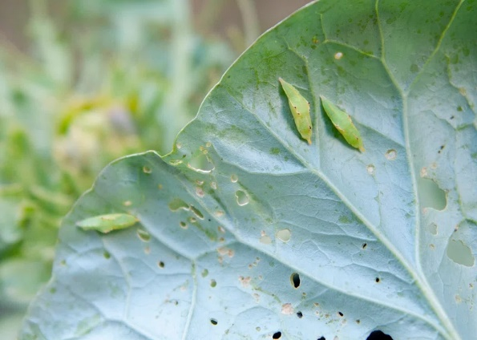
Students at a local elementary school notice the plants in their school garden are showing extensive leaf damage. One of the students identified the pest and uncovered that their garden is being overrun by an infestation of cabbage worms. The students realize that, if they do not act, they will not have any vegetables to harvest and share in their school celebration at the end of the school year. After conducting research on different techniques, they come up with a plan. They decide to implement companion planting by adding aromatic herbs such as basil, mint and rosemary around the perimeter of the garden beds. These herbs naturally repel cabbage worms and other pests. Additionally, the students introduce beneficial insects such as parasitic wasps and ladybugs, which prey on cabbage worm larvae and adults, respectively. Throughout the rest of the growing season, the students inspect the leaves of plants weekly and record an approximate percentage of leaves damaged as well as remove the worms from the surfaces of the leaves as they see them. They also count the number of cabbage worms they see and record those numbers in their classroom to determine if they are seeing any reduction in populations to determine if further action is needed.

Explain the actions students took that align with each principle of IPM.

- Identification and Monitoring of Pests: _________________________________________________________________________
________________________________________________________________________________________________________________________________________________________________________________________________________________________________________________________________________________________________________________________________________________
- Setting Action Thresholds: _____________________________________________________________________________________
________________________________________________________________________________________________________________________________________________________________________________________________________________________________________________________________________________________________________________________________________________
- Which types of controls did the students use? (Circle each that applies and explain your observations below.)
Biological Cultural Mechanical/Physical Chemical
________________________________________________________________________________________________________________
________________________________________________________________________________________________________________
________________________________________________________________________________________________________________
________________________________________________________________________________________________________________
________________________________________________________________________________________________________________
- Evaluating Results: ________________________________________________________________________________________________________________________________________________________________________________________________________________________________________________________________________________________________________________________________________________________________________________________________________________________________________________________________
Part 2
Directions:
Using the information you’ve read, explain how the orchard owner in the scenario has already completed the first two steps of IPM. As you read, use the colors you highlighted in the article to highlight portions of the scenario to help you identify the components of IPM.
Then conduct your own research and come up with the rest of the plan to help manage the identified pest.

Scenario 2:
A local orchard is facing a significant threat from an outbreak of codling moths, which are damaging the apple crop. The orchard estimates they have lost 10% of their apple crop for this year so far and are concerned for how much more they could lose before the season is over. The orchard owner wants to avoid using chemical pesticides due to environmental concerns and is seeking alternative solutions. She has enlisted your class to help her come up with solutions according to the principles of IPM.

- Without knowing much about it, the orchard owner has already completed the first two steps of IPM. Identify how she has done this.
  - Pest Identification/Monitoring: ________________________________________________________________________
________________________________________________________________________________________________________________________________________________________________________________________________________________________________________________________________________________________________________________________
  - Setting Action Thresholds: _____________________________________________________________________________
________________________________________________________________________________________________________________________________________________________________________________________________________________________________________________________________________________________________________________________
- Based on your research, explain in detail what controls you are recommending. Be sure to identify what kind of control each recommendation is (biological, cultural, mechanical/physical), and remember, the owner would like to avoid the use of chemical pesticides as much as possible.
________________________________________________________________________________________________________________________________________________________________________________________________________________________________________________________________________________________________________________________________________________________________________________________________________________________________________________________________________________________________________________________________________________________________________________________________________________________________________________________________________________________________________________________________________________________________________________________________________________________________________________________________________________________________________________________________________________________________________________________________________________________________________________
- Explain how you would suggest evaluating the IPM plan after implementation.
________________________________________________________________________________________________________________________________________________________________________________________________________________________________________________________________________________________________________________________________________________________________________________________________________________________________________________________________________________________________________________________________________________________________________________________________________________________________________________________________________________________________________________________________________________________________________________________________________________

