Celebrations Around the World
Aligned to the following standards: CS.01., AG1, AGC02.02, AGC10.03, AGC10.04, CCSS.RI.9-10.1, CCSS.RI.9-10.2, CCSS.RI.9-10.3, CCSS.RI.9-10.4, CCSS.RI.9-10.8, CCSS.RI.9-10.8, CCSS.W.9-10.2, CCSS.RST.9-10.7, CCSS.RST.9-10.9, CCSS.WHST.9.10.6, MP2, MP3, MP5, MP6, CRP.02., CRP.04., CRP.06., CRP.07., CRP.08., CRP.11
Part 1
Directions:
Match the foods to the celebration during which that food is commonly eaten by writing the letter of the food item next to the celebration. Then, use the internet to research the purpose of each celebration and fill in the third column with that information.
Food | Celebration | Purpose of Celebration
- Latkes  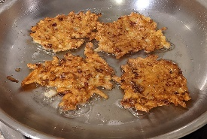 | Christmas
- Sheer khurma  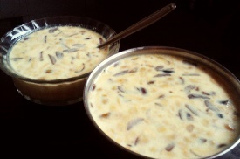 | Hannukah
- Samosa  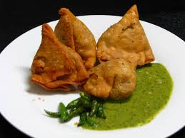 | Kwanzaa
- Toshikoshi Soba  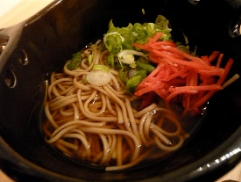 | Las Posadas
- Collard Greens  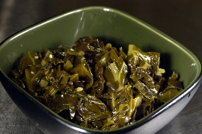 | Soyal
- Tamales  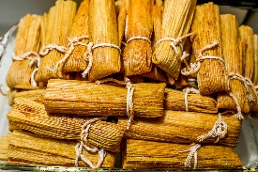 | Eid al-Fitr
- Squash  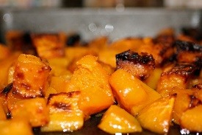 | Diwali

- Fish  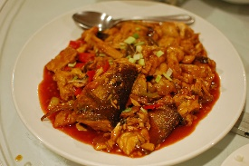 | Thanksgiving
- Ham  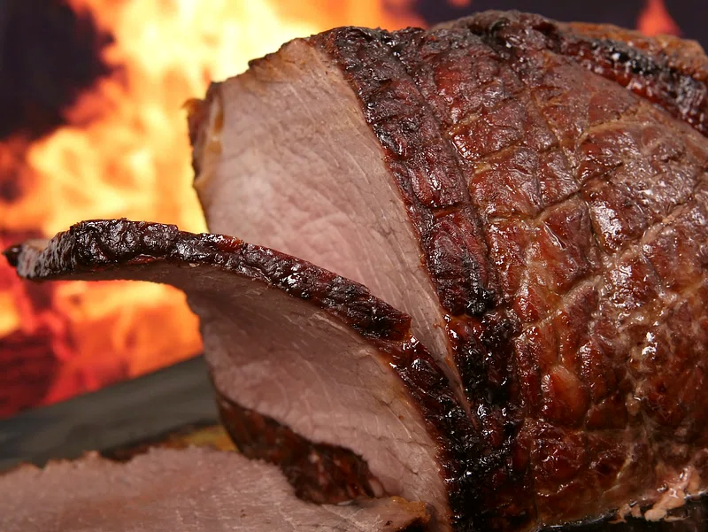 | Omisoka
J. Matzo Ball Soup  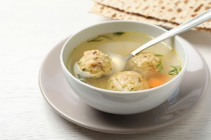 | Chinese New Year
K. Apples and Honey  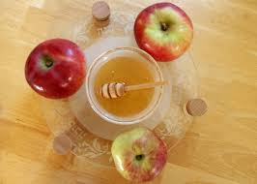 | Rosh Hashana
L. Rice  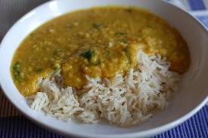 | Yom Kippur
M. Turkey  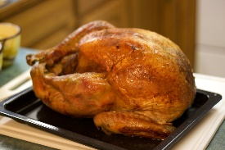 | Bohdi Day

- Which of these celebrations were unfamiliar to you?

- Which of these food items were unfamiliar to you and why?

Celebrations Around the World
Aligned to the following standards: CS.01., AG1, AGC02.02, AGC10.03, AGC10.04, CCSS.RI.9-10.1, CCSS.RI.9-10.2, CCSS.RI.9-10.3, CCSS.RI.9-10.4, CCSS.RI.9-10.8, CCSS.RI.9-10.8, CCSS.W.9-10.2, CCSS.RST.9-10.7, CCSS.RST.9-10.9, CCSS.WHST.9.10.6, MP2, MP3, MP5, MP6, CRP.02., CRP.04., CRP.06., CRP.07., CRP.08., CRP.11
Part 2
Directions:
- Research three different fall/winter celebrations and answer the questions below.
- At least one must be a celebration you do not celebrate.
- You can use the list from Part 1 or research other celebrations you might be interested in learning about.

- What is the name of the first celebration you are going to learn about?

- In what culture is this celebration primarily celebrated?

- Name three foods that are commonly eaten during this celebration, the agricultural product they come from and where that product is primarily produced.
Food Product | Agricultural Product | Area of Production
- Sketch the state or country that produces the most of each food product.

- What is the name of the second celebration you are going to learn about?

- In what culture is this celebration primarily celebrated?

- Name three foods that are commonly eaten during this celebration, the agricultural product they come from and where that product is primarily produced.
Food Product | Agricultural Product | Area of Production
- Sketch the state or country that produces the most of each food product.

- What is the name of the third celebration you are going to learn about?

- In what culture is this celebration primarily celebrated?

- Name three foods that are commonly eaten during this celebration, the agricultural product they come from and where that product is primarily produced.
Food Product | Agricultural Product | Area of Production

- Sketch the state or country that produces the most of each food product.

Celebrations Around the World
Aligned to the following standards: CS.01., AG1, AGC02.02, AGC10.03, AGC10.04, CCSS.RI.9-10.1, CCSS.RI.9-10.2, CCSS.RI.9-10.3, CCSS.RI.9-10.4, CCSS.RI.9-10.8, CCSS.RI.9-10.8, CCSS.W.9-10.2, CCSS.RST.9-10.7, CCSS.RST.9-10.9, CCSS.WHST.9.10.6, MP2, MP3, MP5, MP6, CRP.02., CRP.04., CRP.06., CRP.07., CRP.08., CRP.11
Part 3
Directions:
- Use the space below or a blank sheet of paper to create an eye-catching infographic about one celebration researched in Part 2 that you do not currently celebrate. Examples of infographics can be found at https://piktochart.com/blog/infographic-examples/. The infographic must be created with color and include the following:
  - Name of celebration.
  - The purpose of the celebration.
  - Culture this celebration is most commonly a part of.
  - Area of the country/world where the celebration primarily happens.
  - Main foods eaten during this celebration.
  - Agricultural products needed to produce foods eaten during this celebration.
  - Areas of the country/world where these agricultural products are produced.
  - A minimum of four pictures.

Celebrations Around the World
Aligned to the following standards: CS.01., AG1, AGC02.02, AGC10.03, AGC10.04, CCSS.RI.9-10.1, CCSS.RI.9-10.2, CCSS.RI.9-10.3, CCSS.RI.9-10.4, CCSS.RI.9-10.8, CCSS.RI.9-10.8, CCSS.W.9-10.2, CCSS.RST.9-10.7, CCSS.RST.9-10.9, CCSS.WHST.9.10.6, MP2, MP3, MP5, MP6, CRP.02., CRP.04., CRP.06., CRP.07., CRP.08., CRP.11
Part 4
Directions:
Complete a gallery walk to learn about different celebrations around the world and complete the table for ___ different celebrations.

Celebration | Purpose | One Food Eaten | Agricultural Product Needed for That Food | Area Where That Product Is Produced

Celebrations Around the World
Aligned to the following standards: CS.01., AG1, AGC02.02, AGC10.03, AGC10.04, CCSS.RI.9-10.1, CCSS.RI.9-10.2, CCSS.RI.9-10.3, CCSS.RI.9-10.4, CCSS.RI.9-10.8, CCSS.RI.9-10.8, CCSS.W.9-10.2, CCSS.RST.9-10.7, CCSS.RST.9-10.9, CCSS.WHST.9.10.6, MP2, MP3, MP5, MP6, CRP.02., CRP.04., CRP.06., CRP.07., CRP.08., CRP.11
Part 5
Directions:
Now that you have learned about different celebrations around the world, create your “perfect plate” of foods.
- Divide the plate into sections.
- On each section include the following:
  - Name of the food.
  - A sketch of the food.
  - The agricultural product that food is made from.
  - Where that agricultural product comes from.
  - What celebration(s) that food is connected to.
- You must include at least five food items, and two of those should be food items you have not tried before.

- What food item are you most excited to try and why?

- Pretend you are a reporter for your local newspaper, write an article in the space below about one of the celebrations you learned about today. Include the following information:
  - Title of the celebration.
  - Picture of the celebration.
  - Information about the celebration using at least four sentences.

