Who’s in My Soil?
Aligned to the following standards:
CS.03; CS.04; CS.06; NRS.02; NRS.04; FFA.PL-A; FFA.CS-M; FFA.CS-N; AG3; AG4; AG6; AG-NR2; AG-NR4; CCSS.ELA-RI.9-10.2; CCSS.ELA-W.9-10.2; CCSS.ELA-W.9-10.4; CCSS.ELA-W.9-10.5; CCSS.ELA-W.9-10.8; CCSS.ELA.RST.9-10.3; HS-ESS3-1; CRP.02; CRP.04; CRP.05

Directions:
Record information on each of the soil organisms as you visit their information sheets around the room.

Earthworms | Mycorrhizal Fungi
Springtails | Nematodes
Actinomycetes | Mites
Protozoa | Ants
Grubs (Larval Beetles) | Bacteria

What organism did you find most interesting? Why?

What organism surprised you most with its role in soil health? Why?
What do you think would happen if one of these organisms was not present in the soil?
Signs of Life
Aligned to the following standards:
CS.03; CS.04; CS.06; NRS.02; NRS.04; FFA.PL-A; FFA.CS-M; FFA.CS-N; AG3; AG4; AG6; AG-NR2; AG-NR4; CCSS.ELA-RI.9-10.2; CCSS.ELA-W.9-10.2; CCSS.ELA-W.9-10.4; CCSS.ELA-W.9-10.5; CCSS.ELA-W.9-10.8; CCSS.ELA.RST.9-10.3; HS-ESS3-1; CRP.02; CRP.04; CRP.05

Directions:
Record your observations as you examine each of the soil samples.
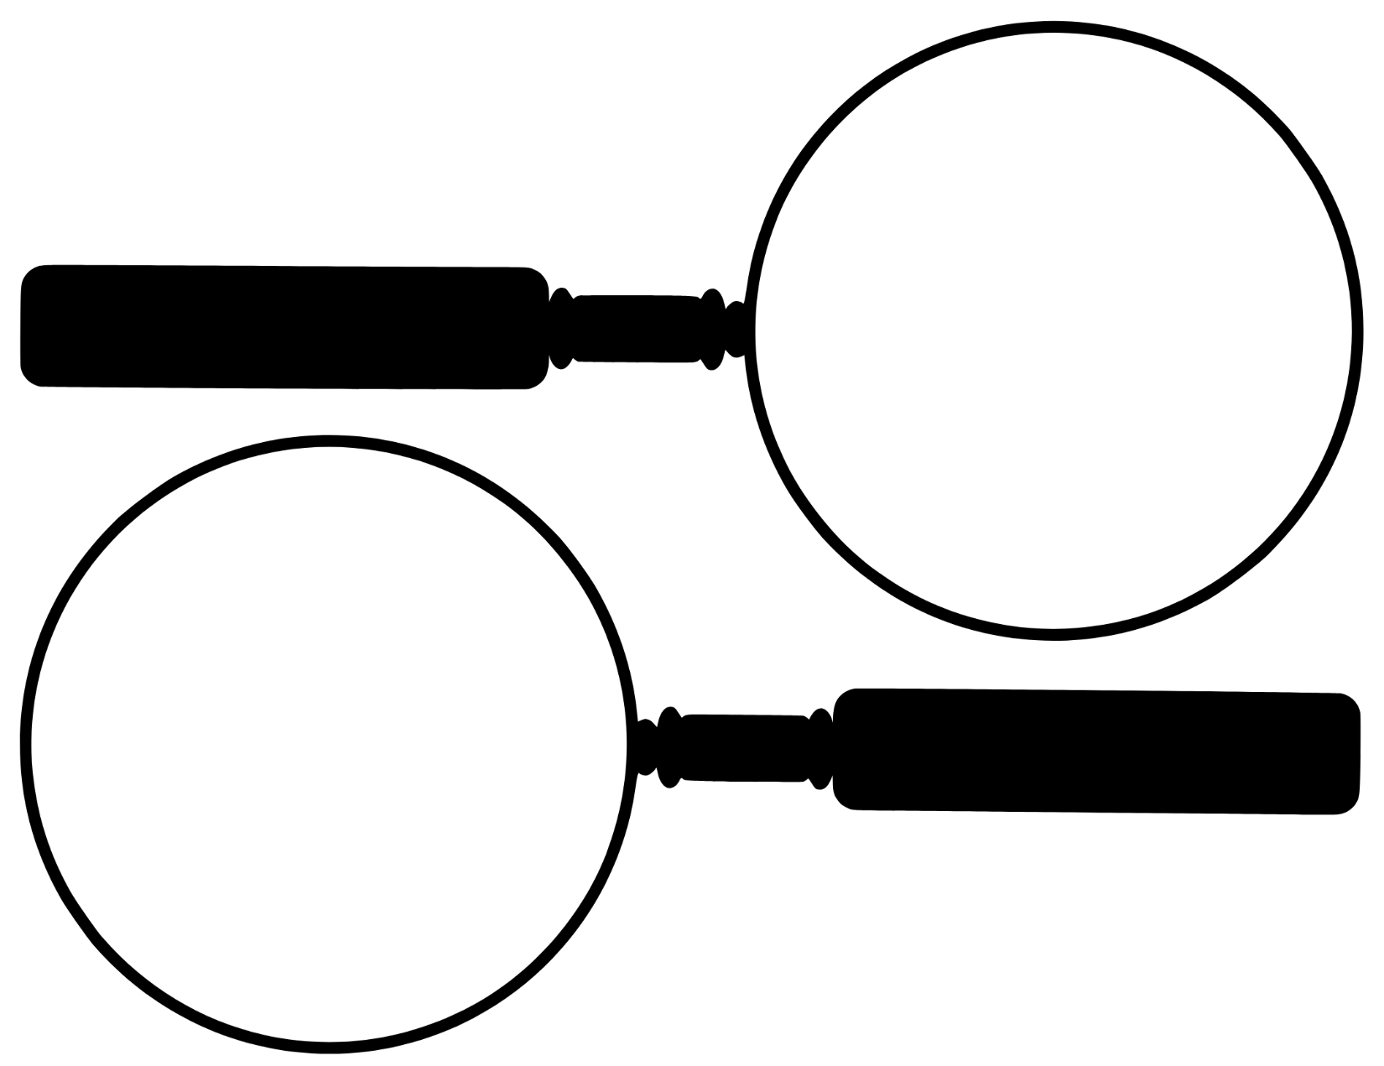
- In the magnifying glasses below, draw the organism you observed in each sample.
Soil Sample A
Soil Sample B

- What other observations did you make about each soil sample? (texture, color, etc.)
Soil Sample A | Soil Sample B
Analysis Questions:
- Which organism was the easiest to find or identify? Why do you think that is?
- Were you surprised by the variety or number of organisms you found? Why or why not?
- Why is soil biodiversity important for plant growth and agriculture?
- What kinds of human actions might harm the organisms you found today?
- How might the presence or absence of certain organisms be a clue to overall soil health?
- What additional questions do you have about soil organisms or soil ecosystems after this activity?
Soil City Detective
Aligned to the following standards:
CS.03; CS.04; CS.06; NRS.02; NRS.04; FFA.PL-A; FFA.CS-M; FFA.CS-N; AG3; AG4; AG6; AG-NR2; AG-NR4; CCSS.ELA-RI.9-10.2; CCSS.ELA-W.9-10.2; CCSS.ELA-W.9-10.4; CCSS.ELA-W.9-10.5; CCSS.ELA-W.9-10.8; CCSS.ELA.RST.9-10.3; HS-ESS3-1; CRP.02; CRP.04; CRP.05

Directions:
Soil City is a thriving community with many organisms working together in harmony. Suddenly, however, one of its valuable residents has gone missing. Randomly draw one of the organisms from the “Who’s in My Soil” activity and write a short story about a “missing organisms’ detective” trying to find out what happened to this organism and how to recover it. Be creative with your story! You may choose to include interviews with the other organisms, pieces of evidence found or anything else that might be found in a good crime drama story. You should also be sure to include a narrative about how other organisms are affected by this one’s disappearance.
While this is a fun and fictional story, you must also base it on fact, so you may need to do additional research on how soil organisms live and work together, what might lead to a decline in your selected organism and what might restore that organism.
Use the space below for brainstorming characters, plot lines, etc.

Use these pages to write your story (or use a word processing software if preferred and available). Use additional pages as necessary.
________________________________________________________________________________________________________________________________________________________________________________________________________________________________________________________________________________________________________________________________________________________________________________________________________________________________________________________________________________________________________________________________________________________________________________________________________________________________________________________________________________________________________________________________________________________________________________________________________________________________________________________________________________________________________________________________________________________________________________________________________________________________________________________________________________________________________________________________________________________________________________________________________________________________________________________________________________________________________________________________________________________________________________________________________________________________________________________________________________________________________________________________________________________________________________________________________________________________________________________________________________________________________________________________________________________________________________________________________________________________________________________________________________________________________________________________________________________________________________________________________________________________________________________________________________________________________________________________________________________________________________________________________________________________________________________________________________________________________________________________________________________________________________________________________________________________________________________________________________________________________________________________________________________________________________________________________________________________________________________________________________________________________________________________________________________________________________________________________________________________________________________________________________________________________________________________________________________________________________________________________________________________________________________________________________________________________________________________________________________________________________________________________________________________________________________________________________________________________________________________________________________________________________________________________________________________________________________________________________________________________________________________________________________________________________________________________________________________________________________________________________________________________________________________________________________________________________________________________________________________________________________________________________________________________________________________________________________________________________________________________________________________________________________________________________________________________________________________________________________________________________________________________________________________________________________________________________________________________________________________________________________________________________________________________________________________________________________________________________________________________________________________________________________________________________________________________________________________________________________________________________________________________________________________________________________________________________________________________________________________________________________________________________________________________________________________________________________________________________________________________________________________________________________________________________________________________________________________________________________________________________________________________________________________________________________________________________________________________________________________________________________________________________________________________________________________________________________________________________________________________________________________________________________________________________________________________________________________________________________________________________________________________________________________________________________________________________________________________________________________________________________________________________________________________________________________________________________________________________________________________________________________________________________________________________________________________________________________________________________________________________________________________________________________________________________________________________________________________________________________________________________________________________________________________________________________________________________________________________________________________________________________________________________________________________________________________________________________________________________________________________________________________________________________________________________________________________________________________________________________________________________________________________________________________________________________________________________________________________________________________________________________________________________________________________________________________________________________________________________________________________________________________________________________________________________________________________________________________________________________________________________________________________________________________________________________________________________________________________________________________________________________________________________________________________________________________________________________________________________________________________________________________________________________________________________________________________________________________________________________________________________________________________________________________________________________________________________________________________________________________________________________________________________________________________________________________________________________________________________________________________________________________________________________________________________________________________________________________________________________________________________________________________________________________________________________________________________________________________________________________________________________________________________________________________________________________________________________________________________________________________________________________________________________________________________________________________________________________________________________________________________________________________________________________________________________________________________________________________________________________________________________________________________________________________________________________________________________________________________________________________________________________________________________________________________________________________________________________________________________________________________________________________________________________________________________________________________________________________________________________________________________________________________________________________________________________________________________________________________________________________________________________________________________________________________________________________________________________________________________________________________________________________________________________________________________________________________________________________________________________________________________________________________________________________________________________________________________________________________________________________________________________________________________________________________________________________________________________________________________________________________________________________________________________________________________________________________________________________________________________________________________________________________________________________________________________________________________________________________________________________________________________________________________________________________________________________________________________________________________________________________________________________________________________________________________________________________________________________________________
What was the most challenging part of writing your story? Explain in one or two sentences.
Soil City Detective Story Rubric
Category | Excellent  (4 pts) | Good  (3 pts) | Developing  (2 pts) | Needs Improvement  (1 pt)
Accuracy | Includes accurate, detailed information about the selected soil organism’s role, needs, decline factors and recovery All facts are clearly supported. | Information mostly accurate and relevant; minor factual errors or gaps in detail | Some factual inaccuracies or misunderstandings of organism roles or conditions | Little to no factual accuracy; content is vague or incorrect.
Creative Storytelling | Story is highly engaging, original, and creatively presents the mystery. Characters, setting and dialogue are imaginative and well-developed. | Story is engaging and shows creativity. Some characters or story elements could be more developed. | Story has basic structure but lacks creative elements or detail. | Minimal effort in storytelling. Lacks clarity, organization or creativity
Connection to Soil Ecosystem | Clearly explains how the organism’s disappearance affects the broader soil ecosystem; other organisms' reactions are meaningful and based on ecological facts. | Some explanation of ecosystem impact is present; other organisms are mentioned with partial relevance. | Limited or unclear connection to other organisms or the soil system | No meaningful connection to ecosystem dynamics
Use of Evidence | Includes at least two realistic pieces of “evidence” (e.g., signs of habitat loss, soil conditions) that tie into the mystery | Includes at least one relevant piece of “evidence”  Some connections to the mystery may be weak. | Includes vague or generic “evidence” Connections to story logic or science are unclear. | No use of evidence, or evidence is irrelevant and unconnected to science.
Organization and Writing | Writing is clear, well-organized and free of errors. Follows a logical structure with a strong beginning, middle and end | Mostly organized; few errors  Logical structure is mostly followed. | Some confusion in organization or multiple errors in grammar/spelling | Writing lacks structure or is difficult to follow due to many errors.
Effort and Completion | All parts of the story are completed with care and attention to detail. | Most components are complete. | Some components are incomplete or rushed. | Incomplete or very minimal effort
Total Score |  |  |  | /24
Notes:
________________________________________________________________________________________________________________________________________________________________________________________________________________________________________________________________________________________________________________________________________________________________________________________________________________________________________________________________________________________________

