The Agriculture Career Matchmaker
Aligned to the following standards:
CS.05; FFA.PL-A; FFA.PL-E; FFA.PL-F; FFA.PG-I; FFA.PG-J; FFA.CS-M; FFA.CS-N; AG5; AGC09.02; CCSS.ELA.RI.9-10.2; CCSS.ELA.RI.9-10.4; CCSS.ELA.W.9-10.1; CCSS.ELA.W.9-10.2; CCSS.ELA.SL.9-10.1; CCSS.ELA.SL.9-10.4; CRP.02: CRP.04: CRP.07: CRP.08: CRP.10: CRP.11
Part 1
Directions:
You are the agriculture career matchmaker. People come to you looking for advice on what their next career move should be. Read each scenario below to learn more about your clients and what they are looking for in a career. As you read, highlight or underline keywords or phrases that will help you match the right career with each person. Then use AgExplorer to find a career to match them with and answer the questions under each scenario.


Paige Planterman
Paige is a high school senior who is looking forward to working in the agriculture industry but needs help deciding what to do. Paige has been in FFA for the last four years and has really enjoyed competing in career development events like nursery/landscape and agronomy. She is interested in going to either community college or university before entering her career and her best subjects in school are math and science. Ideally, she sees herself working in a hands-on environment, partially outside and partially inside. She would like to eventually work her way up to leading a team of some sort and having a real impact on making decisions in her workplace.

- What are two careers you think Paige should consider?

- Explain at least three reasons why you are recommending these careers. What aspects of Paige’s profile led you to select these careers for her?

- What additional kinds of classroom, FFA or SAE activities could Paige take advantage of to help prepare her for these careers? (Name at least three.)

- What is one additional piece of advice you would give to Paige as she explores her career options?


Skyler Steele
Skyler is entering his junior year of high school, and his parents are encouraging him to explore what he would like to do for his career. He is unsure exactly what he wants to do but enjoys working with his hands, and he enjoyed the mechanics unit in his introduction to agriculture class. He doesn’t necessarily see himself getting a four-year degree but is interested in more training after high school to help him in his future career. He is creative and enjoys making drawings of things he could build. He loves to follow a plan that makes sense and suggest design improvements.

- What are two careers you think Skyler should consider?

- Explain at least three reasons why you are recommending these careers. What aspects of Skyler’s profile led you to select these careers for him?

- What additional kinds of classroom, FFA or SAE activities could Skyler take advantage of to help prepare him for these careers? (Name at least three.)

- What is one additional piece of advice you would give to Skyler as he explores his career options?

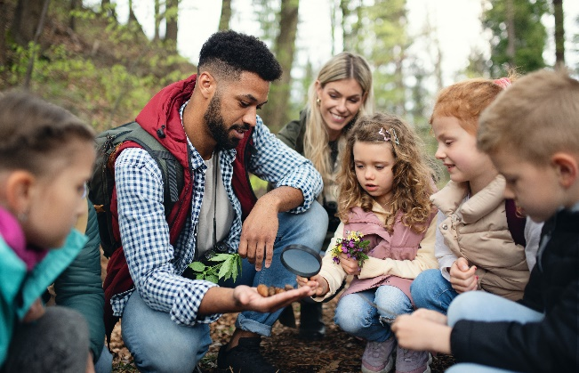
Nate Urehelper
Nate can be found outdoors more often than indoors. He is only a freshman but has already founded a camping and hiking club at his high school. In addition to going on recreational outings, Nate leads this club in cleanup and conservation efforts in their local parks and forests. Nate is very interested in learning about all things outdoors and could see himself studying anything related to the outdoors in college someday. While he loves working with people, he sees himself working mostly independently, just him and the great outdoors. He also wants to contribute to others better knowing and appreciating our natural world.

- What are two careers you think Nate should consider?

- Explain at least three reasons why you are recommending these careers. What aspects of Nate’s profile led you to select these careers for him?

- What additional kinds of classroom, FFA or SAE activities could Nate take advantage of to help prepare him for these careers? (Name at least three.)

- What is one additional piece of advice you would give to Nate as he explores his career options?

Andie Ann Imallover
Andie Ann is entering her sophomore year and just went to a two-week camp over the summer where she learned she has a passion for animals. She enjoyed every aspect of the camp from learning about the animals’ health and nutrition needs to caring for them and working with them one-on-one. While she knows she wants to do something with animals, she is not sure what to pursue. She believes she would like to pursue advanced education and degrees to know everything she can about animals. Andie Ann primarily sees herself working directly with animals rather than just around them. She hopes to make a difference in the lives of both people and animals and would like to help others better understand and care for animals as well.

- What are two careers you think Andie Ann should consider?

- Explain at least three reasons why you are recommending these careers. What aspects of Andie Ann’s profile led you to select these careers for her?

- What additional kinds of classroom, FFA or SAE activities could Andie Ann take advantage of to help prepare her for these careers? (Name at least three.)

- What is one additional piece of advice you would give to Andie as she explores her career options?

Concluding Questions:
- What kinds of details were the most helpful in the process of matching careers with people?

- What is one piece of advice you would give to anyone who is unsure of what to do for a career?

Part 2
Directions:
There are many things that may help you select a career that is a great fit for you. Everything from your hobbies to your values to what kind of lifestyle you see yourself living can contribute to what career may fit you best. On this sheet, fill out all the questions and determine what is most important for you in a career.

What is your favorite subject in school? | Name at least two hobbies/activities you enjoy.
What are two causes/issues you care a lot about? | If I could live anywhere, I would live in …
Would you identify yourself as an introvert or an extrovert? | List three personality traits that you believe best describe you:
Circle one:

Introvert Extrovert
My three favorite things in the world are … | I learn best when I am …
Circle one:
Seeing Hearing Doing

Next, consider your top five characteristics of a future career. Explain why each characteristic matters to you. (See the example in the first row.)

Career Characteristic | Why This Matters to Me
Ex: Working both indoors and outdoors | I don’t want to be at a desk all the time because that would be boring and repetitive, but I do want a “home base” to be able to work from and collaborate in.

Part 3
Directions:
You are now about to meet with your final client for this activity — one of your classmates! Trade papers from Part 2 with one of your classmates as directed by your teacher. Then, complete the following tasks in the spaces provided below:
- Read your classmate’s profile from Part 2.
- Develop two questions to ask your classmate to gain additional information to help you in your matchmaking.
- Interview your classmate and record their answers to your questions in the space provided.
- Use AgExplorer and/or other career sites to find a career to match your classmate with and provide an explanation in the space provided.
- Share your findings with your classmate and discuss why you selected the career you did for them.

Interview Questions for Your Classmate:

Notes from their answer:

Notes from their answer:

Classmate Career Selection:
- What career would you recommend for your classmate to consider?

- Why did you select this particular career for them? (Give at least three reasons.)

Personal Reflection:
- What career did your classmate recommend for you?

- What were their reasons for their recommendation?

- Do you feel the career they recommended could be a good fit for you? Why or why not?

