Read All About It!
Aligned to the following standards:
FFA.PL-A; FFA.PL-E; FFA.PL-F; FFA.PG-I; FFA.PG-J; FFA.CS-N; CCSS.ELA.WHST.9.10.4; CCSS.ELA.RI.9-10.2, CCSS.ELA.RI.9-10.4; CCSS.ELA.W.9-10.2; CCSS.ELASL.9-10.4; CRP.02; CRP.04
directions:
Select an article in the FFA New Horizons magazine and complete the activity below. Utilize these links to access an article: https://FFA.box.com/s/4nyqyx4fm95emghdoukry38l2y0idpm5, https://en.calameo.com/accounts/5107524
- Summarize the article in three sentences:

2. Choose a vocabulary or key word from the article and place it in the center circle of the chart below. Complete the rest of the model based on the word you selected.

Definition
Characteristics
Examples
Non-Examples



3. What are two facts you learned from this article?

4. Summarize this article in one word and then describe the word selected:

5. Create a social media post that summarizes this article:

6. From the bank below, choose two audiences, and write an article summary that is targeted for each audience you choose.

Circle the audience you have chosen.
Audiences: Animal Activists Elementary-Age Students Farmers/Ranchers Consumers
Researchers Retail Associates

Circle the audience you have chosen.
Audiences: Animal Activists Elementary-Age Students Farmers/Ranchers Consumers
Researchers Retail Associates

7. Draw a picture in the blank space below to summarize the article.

8. Circle the career focus area that the article fits best.
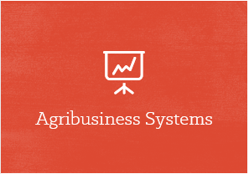

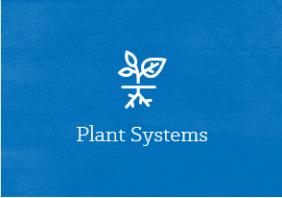


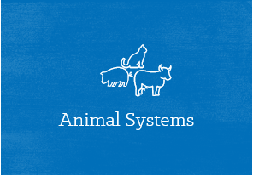
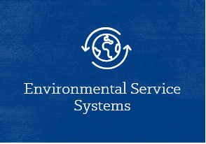
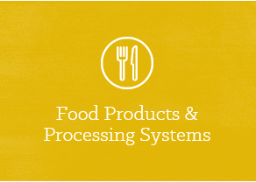
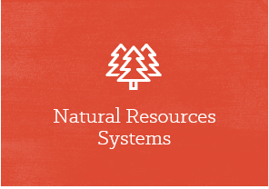

Descriptions of each career focus area:

Agribusiness Systems: The agribusiness field encompasses activities that contribute to successful agriculture production. This can include crop production, farm equipment, seed supply, marketing, natural resources and animal services.

Agricultural Education: Careers in agricultural education develop engaged citizens who understand the importance of the agriculture industry to our world, while teaching them technical skills in all areas of agriculture.

Animal Systems: Scientists and technicians in Animal Systems careers treat diseased or injured livestock, companion and exotic animals and work to keep them healthy.

Biotechnology Systems: Careers in this pathway help make plants more nutritious to eat and enable fish to grow twice as fast. They even use biotechnology to solve global issues.

Environmental Service Systems: People who work in the Environmental Service Systems career focus area may be involved with recycling, water and air pollution control, waste disposal and public health issues.

Food Products and Processing Systems: Some careers in food products and processing focus on diet, health and food safety by ensuring the quality of the foods we eat every day. Others work to develop new packaging, new products and new sales opportunities.

Natural Resources Systems: Career opportunities in Natural Resources Systems are available in both urban and rural settings, in the field and in the lab. Protecting wildlife, maintaining parks, consulting with research groups and keeping green areas are important needs everywhere.

Plant Systems: Plant Systems professionals help feed our growing population by monitoring the quality and safety of our food and helping consumers make sensible nutritional decisions.

Power, Structural and Technical Systems: Professionals in these fields apply knowledge of engineering, hydraulics, pneumatics, electronics, power, structures and controls to the field of agriculture. They also tackle exciting challenges such as how to conserve soil and water, how to create efficient production and how to conserve natural resources.

9. Which career focus area did you circle? Why?

10a. What are three careers that align with the career focus area you circled? Visit AgExplorer.ffa.org to help with this question.

10b. Align the careers that you highlighted in question 10a to one of the steps in the Agriculture, Food and Natural Resources (AFNR) Value Chain (FFA.org/value-chain/) and record your responses below. (Click on each step in the value chain to learn more.)
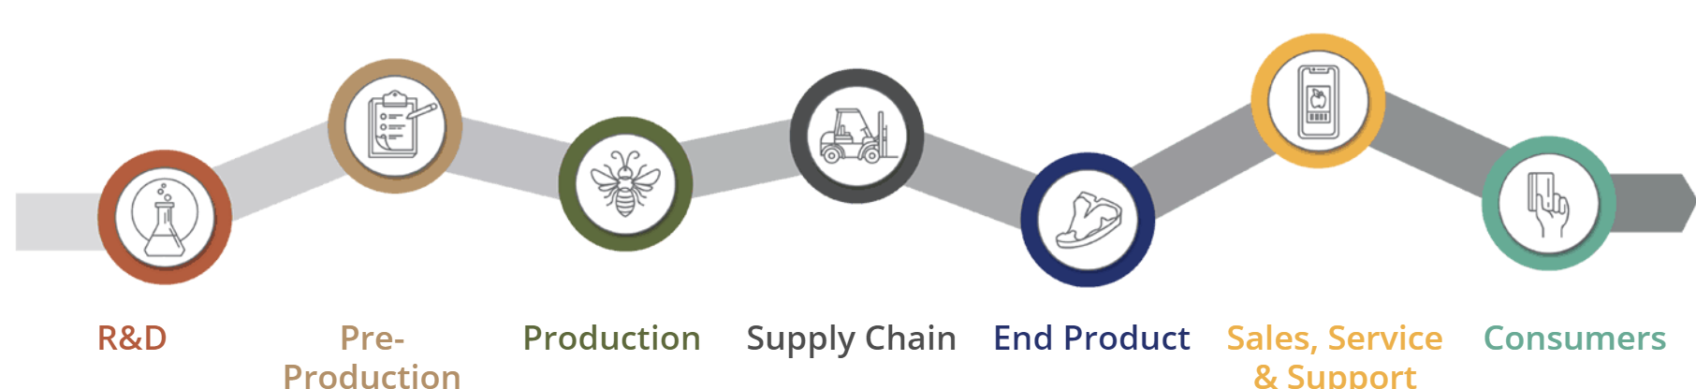
Career
Step in the AFNR Value Chain:
Career
Career
Step in the AFNR Value Chain:
Step in the AFNR Value Chain:
Why did you choose this step?
Why did you choose this step?
Why did you choose this step?

11. Based on what you have learned, create a new title and tag line for the article.

Create a hashtag for the new title and tag line:

