
Appendix 5: Ag 101: From Farm to School
Aligned to the following standards:
FFA.PL-A; FFA.PL-C; FFA.PL-E; FFA.PL-F; FFA.PG-I; FFA.PG-J; FFA.CS-M; FFA.CS-N; CCSS.SL.9-10.2; CCSS.SL.9-10.4;CCSS.SL.9-10.5; CCSS.W.9-10.2; CCSS.W.9-10.4;CCSS.RI.9-10.4; CRP.02; CRP.04; CRP.05;CRP.06

Created: Spring 2020 by the National FFA Organization

Part 1
directions:
Read the article “Ag 101: From Farm to School” in the spring 2020 issue of FFA New Horizons and answer the questions below.

- According to the National Farm to School Network, more than _____________ in ______________ children are at _______________ for _______________.

- What is key to improving children’s health?
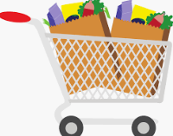

- Below are answers/facts from the article. Develop a question where these facts are the answer. Write your response in the thought bubble below.
Procurement: Schools serve foods from local farms.
School Gardens: Students participate in growing the food.
Education: School programs teach about agriculture, health, food and nutrition.



- Identify three impacts that the National Farm to School Network has had:
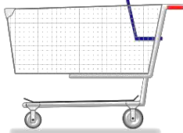

- What are examples of how FFA chapters have helped with the hunger issue? Identify two chapters and what they have done. Write your answers in the apples below.
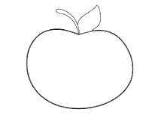

Part 2

Directions:
First, go to the website https://www.ffa.org/value-chain/, and glance at each part of the Food Value Chain (click on each icon; this will help you complete the next part). Then, select a product of your choice. Explain the development of that product throughout the value chain from research and development through consumers. Utilize the link above to help in your research.

Product: Example: Herbicides

R and D:
Example:
Find need and begin formulating herbicide
Pre-Production:
Example: Determine final formula by analyzing data

Production:
Example:
Put the components to the herbicide in production
Supply Chain:
Example:
Form final chemical
End Product:
Example:
Ship and stock
Sales, Service and Support:
Example: Advertise to homeowners and farmers

Customer:
Example: Uses product

What product did you select?



