Appendix 3: Soil
Aligned to the following standards:
FFA.PL-A; FFA.CS-N; FFA.PL-F; CCSS.RI.9-10.2; CCSS.ELA. RI.9-10.4; CRP.02; CRP.04; CRP.06; CRP.08

Created: Summer 2020 by the National FFA Organization
Part 1
Directions:
Read “Ag 101: Soil Horizons” in the summer 2020 issue of FFA New Horizons and complete the following activities.
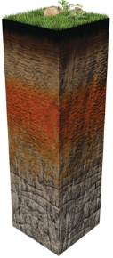
Image from Soils4Kids from the Soil Science Society of America.
Letter
Horizon Name
Short, one- to five-word description
____ __________________ _______________________________________
____ __________________ _______________________________________
____ __________________ _______________________________________
____ __________________ _______________________________________
____ __________________ _______________________________________
____ __________________ _______________________________________

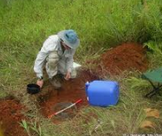
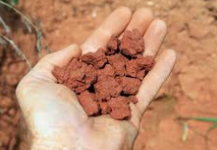
Why is it important to understand soil?
Identify two ways soil has impacted you today.

- ______________________________________________________

- ______________________________________________________

Part 2
Aligned to the following standards:
FFA.PL-A; FFA.CS-N; FFA.PL-F; CCSS.RI.9-10.2; CCSS.ELA. RI.9-10.4; CRP.02; CRP.04; CRP.06; CRP.08

Directions:
While thinking about each basic horizon of a soil profile, you are going to create your own soil profile using everyday items that could represent each horizon.
- Select a category of everyday item you would like to use. (Example: candy)
- Draw a soil profile and use different items from that category to develop each layer of the profile. (Example: Oreo cookies for bedrock) Be sure to select items from your category that match the color, look and texture of the actual soil profile horizons.
- Label each horizon with the representative letter and name. (Example: O layer = organic material)
Category Selected: ___________________________________________

Letter: _____

Name: _______________
Letter: _____

Name: _______________
Letter: _____

Name: _______________
Letter: _____

Name: _______________
Letter: _____

Name: _______________
Letter: _____

Name: _______________
Part 3
Aligned to the following standards:
FFA.PL-A; FFA.CS-N; FFA.PL-F; CCSS.RI.9-10.2; CCSS.ELA. RI.9-10.4; CRP.02; CRP.04; CRP.06; CRP.08

Directions:
Now let’s put together a physical representation of what soil profile looks like! In this lab, you will follow along with your teacher and complete the chart below. During this time, you will be adding items to a cup you have been provided by your teacher. In the cup diagram at the bottom of this page, draw and color the items being added. Be sure to label the cup with the letter and horizon as you go. To complete the conclusion questions, refer to the “Ag 101: Soil Horizons” article in the summer 2020 issue of FFA New Horizons.

Horizon Letter and Name | Represented by | Description of Appearance
Your Soil Profile Cup

- Which horizon of the soil would be the richest in nutrients for plant growth?

_____________________________________________

Why?
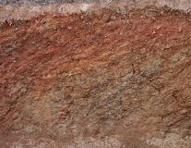
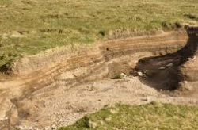
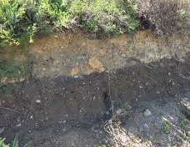
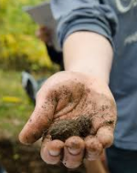
8.The bedrock layer is commonly made up of what materials?

- __________________________

- __________________________

- __________________________

- Using AgExplorer.FFA.org, identify 3 careers in which having background knowledge in soil science would be extremely important.
  - ___________________________________

  - ___________________________________

  - ___________________________________
- What is the deepest horizon in the soil pit before the bedrock?

________________________________________

- Which layer is most likely to be caused by disturbance from plants or animals?

________________________________________

Why?
5. What is the leaching process in horizon B called?
________________________________________

- Which horizon is known as the zone of accumulation?

________________________________________

Why?
- The E horizon is not always represented in all soil profiles. In what type of site would an E horizon be found?

- ______________________________________

- ______________________________________
- Which horizon of the soil do we test for the texture in a soil judging competition?

_____________________________________________

Part 4
Aligned to the following standards:
FFA.PL-A; FFA.CS-N; FFA.PL-F; CCSS.RI.9-10.2; CCSS.ELA. RI.9-10.4; CRP.02; CRP.04; CRP.06; CRP.08

Directions:
Now let’s find out what the soil profile looks like in your area. Using the following resource from UC Davis, https://casoilresource.lawr.ucdavis.edu/gmap/, find your home and school on the map by using the “menu” button in the top left corner. Once you have found these two points on the map, answer the following questions using the content in the left side bar. NOTE: You must click on a specific spot and drop a red dot to have specific information populate in the side bar.
How can understanding the soil in your local area help you in the future?
School

- Click on “map composition.” What types of soils are present?

- Looking at each of these types of soils, what conclusions can you draw about the soil where your home is located?

- Select one of the soil types present and identify the taxonomic order. __________________________________

- Draw the soil profile.
Home

- Click on “map composition.” What types of soils are present?

- Looking at each of these types of soils, what conclusions can you draw about the soil where your home is located?

- Select one of the soil types present and identify the taxonomic order. __________________________________

- Draw the soil profile.

