Appendix 2: Come Together
Aligned to the following standards:
FFA.PL-A; FFA.PL-F; FFA.PG-J; FFA.CS-N; CCSS.ELA.RI.9-10.2; CCSS.ELA.RI.0-10.3; CCSS.ELA.RI.0-10.4; CRP.02; CRP.04; CRP.05; CRP.06; CRP.07

Created: Spring 2020 by the National FFA Organization
Part 1
Directions:
Within your class, find someone who matches a box on the bingo board below. Write the classmate’s name in the box that describes him or her. The first student to get “Bingo!” and call it out, wins!

FIND SOMEONE WHO …
and write his or her first name in the box.

Has blue eyes | Plays a sport in school | Has a pet | Likes chocolate | Plays a musical instrument
Is left-handed | Was born in the same month as you | Has never flown on a plane | Has traveled outside of the United States | Likes the same genre of music
Has the same shoe size | Is the same height as you | FREE SPACE | Has a name that starts with the same letter as yours | Has the same hair color
Has the same SAE as you | Has competed in the same CDE | Likes the same genre of books | Has the same favorite color | Has the same type of phone
Likes the same type of food | Likes the same snacks | Has been to a national park | Has been to Washington D.C. | Has received a Greenhand or Discovery Degree
Identify three cool facts you learned about your peers.

1.

2.

3.
Identify two unique differences you found between you and your peers.

1.

2.




What does this activity say about your class?

Part 2
Directions:
Read the article “Come Together” in the spring 2020 issue of FFA New Horizons and complete the activities below.

What is pho?

- Mexican tortas
- Chinese broth soup
- Vietnamese broth soup
- Vietnamese bubble tea

In what state is the Clarksville FFA Chapter located?

- Alabama
- Arkansas
- Alaska
- Arizona
“The Clarksville FFA Chapter is the most __________________ diverse in the nation.”
What percentage of the total enrollment at Clarksville School District is considered active English learners?
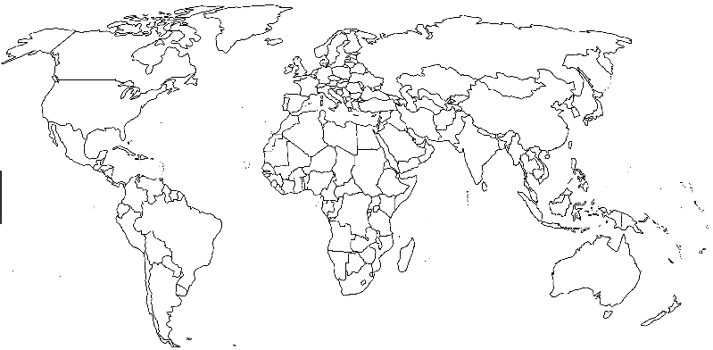
Part 3
Directions:
There is a lot of diversity within the Clarksville School District as well as in your own classroom. In the article “Come Together,” you learned about the different languages represented and identified three in the previous activity.

- Color in the country that speaks each of the languages you listed in Part 2.
- Draw an arrow and label each country you colored.
- Next to the name label, identify and list the country’s top three agricultural commodities
- Include one interesting fact about each country.
- How many different languages are represented in the Clarksville School District? _______
- Identify three:
1.
2.
3.
Why would having such a diverse school population be so beneficial for everyone?
Part 4
Directions:
Select one of the countries you highlighted in Part 3. Create a billboard that could appear on the side of the highway to advertise the country and its top agricultural commodity. Use the space below to draw your billboard or use a technology tool such as Canva.com to design your billboard.

Your billboard needs to meet the following requirements:

- Be colorful.
- Highlight the top agricultural commodity.
- Have the country’s name.
- Have a catchy slogan.

Why is being accepting of those with cultural and language differences so important?

