Appendix 5: Convincing Cotton Cynics
Aligned to the following standards:
FFA. PL-A;FFA.PL-C.; FFA.PL-D.;FFA.PL-E; FFA.PG-J.;FFA.CS-M.; FFA.CS-N.; FFA.CS-O; CCSS.RI.9-10.2;CCSS.RI.9-10.4; CCSS.W.9-10.2; CCSS.W.9-10.4; CCSS.ELA.WHST.9.10.4;CCSS.SL.9-10.4;CCSS.ELA.W.9-10.4 CRP.02; CRP.04
Created: Summer 2019 by the National FFA Organization
Directions:
Part 1
Read “Convincing Cotton Cynics” in the Summer 2019 issue of FFA New Horizons. Answer the questions below.

1. Circle the items made with cotton and cotton by-products.
2. How many acres of cotton did Garrett start with?
3. How many acres does Garrett currently have?
4. What happened to his first crop?
6. What has Garrett learned from producing cotton?
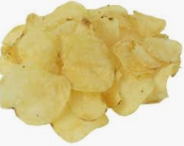
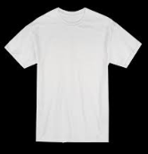

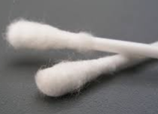
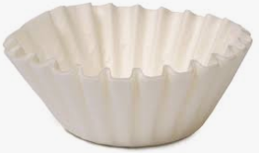
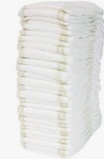




1. Look around your classroom. Identify 5 items produced from cotton.

5. “Growing cotton not only has been a ____________ ________________ _______________ (_____) project for me, but also has been a way for me to ____________ an ______________after it’s been ____________ and ______________.

7. How does cotton production affect your daily life?
Part 2
Aligned to the following standards:
FFA. PL-A;FFA.PL-C.; FFA.PL-D.;FFA.PL-E; FFA.PG-J.;FFA.CS-M.; FFA.CS-N.; FFA.CS-O; CCSS.RI.9-10.2;CCSS.RI.9-10.4; CCSS.W.9-10.2; CCSS.W.9-10.4; CCSS.ELA.WHST.9.10.4;CCSS.SL.9-10.4;CCSS.ELA.W.9-10.4 CRP.02; CRP.04
directions:
Reference this website, https://kids.kiddle.co/Cotton, to answer the questions below.

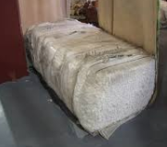
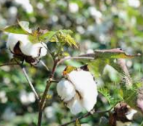
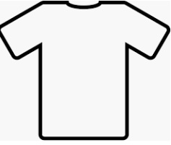
Aligned to the following standards:
FFA. PL-A;FFA.PL-C.; FFA.PL-D.;FFA.PL-E; FFA.PG-J.;FFA.CS-M.; FFA.CS-N.; FFA.CS-O.; CCSS.RI.9-10.2;CCSS.RI.9-10.4;
CCSS.W.9-10.2; CCSS.W.9-10.4; CCSS.ELA.WHST.9.10.4;CCSS.SL.9-10.4;CCSS.ELA.W.9-10.4 CRP.02; CRP.04

1. Describe the machines used to harvest cotton.
3. Describe the strength of cotton fibers.
2. What is the process after cotton is harvested?
4. What happens to the cottonseed after it is removed?

Aligned to the following standards:
FFA. PL-A;FFA.PL-C.; FFA.PL-D.;FFA.PL-E; FFA.PG-J.;FFA.CS-M.; FFA.CS-N.; FFA.CS-O.; CCSS.RI.9-10.2;CCSS.RI.9-10.4;
CCSS.W.9-10.2; CCSS.W.9-10.4; CCSS.ELA.WHST.9.10.4; CCSS.SL.9-10.4; CCSS.ELA.W.9-10.4 CRP.02; CRP.04

To further learn about cotton production, watch The Story of Cotton and answer the questions below. The video URL is https://www.youtube.com/watch?v=AAUQNMldp_Y. While watching the video, focus on the steps from planting to the finished product, flower of the cotton plant and how farmers know when it is time to harvest. If YouTube is blocked, read this article (or one similar), “Cotton is a Miracle of Nature,” to answer the questions. The URL for the article is http://www.nccotton.org/wp-content/uploads/2012/05/cottonmiraclewebformat.pdf.
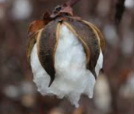
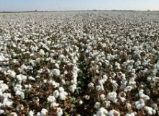
What are 10 cool facts you learned about cotton production while watching the video? List the facts below.
How does a farmer know when it is time for harvest?

Using the facts you listed, write a 2- to 3-sentence summary of the video.

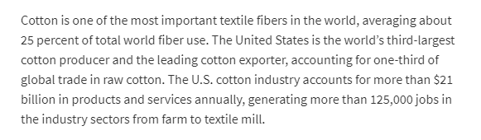
(https://www.ers.usda.gov/topics/crops/cotton-wool/)
Read the passage to the left. How does cotton contribute to the economy?

Aligned to the following standards:
FFA. PL-A;FFA.PL-C.; FFA.PL-D.;FFA.PL-E; FFA.PG-J.;FFA.CS-M.; FFA.CS-N.; FFA.CS-O; CCSS.RI.9-10.2;CCSS.RI.9-10.4; CCSS.W.9-10.2; CCSS.W.9-10.4; CCSS.ELA.WHST.9.10.4;CCSS.SL.9-10.4;CCSS.ELA.W.9-10.4 CRP.02; CRP.04

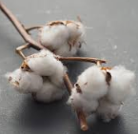

In the labeled areas below, draw a cotton plant and cotton boll and describe each.

Cotton Boll:

Cotton Plant:

Part 3
Aligned to the following standards:
FFA. PL-A;FFA.PL-C.; FFA.PL-D.;FFA.PL-E; FFA.PG-J.;FFA.CS-M.; FFA.CS-N.; FFA.CS-O; CCSS.RI.9-10.2;CCSS.RI.9-10.4; CCSS.W.9-10.2; CCSS.W.9-10.4; CCSS.ELA.WHST.9.10.4;CCSS.SL.9-10.4;CCSS.ELA.W.9-10.4 CRP.02; CRP.04
Directions
Utilize this website, https://www.cotton.org/pubs/cottoncounts/story/where.cfm, to answer the questions below.
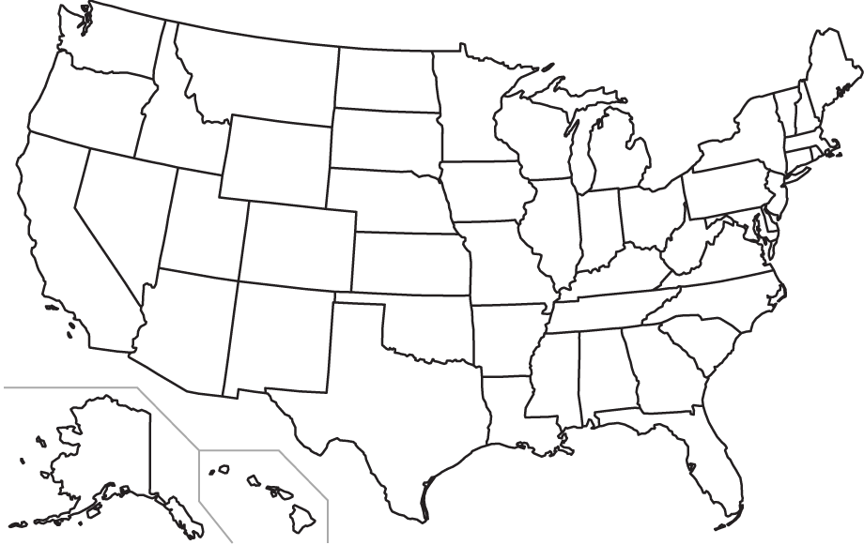
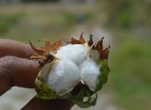
1. What climate can cotton grow in?
2. Why can cotton not be grown in certain climates?
3. What is the average yield for cotton?
What does yield mean?
4. What countries grow most of the world’s cotton?
Color the states/region where cotton is produced in the United States.

