Appendix 9: From the Ground Up
Aligned to the following standards:
FFA.PL-C.; FFA.PL-D.; FFA.PL-F.; FFA.PG-J.; FFA.CS-M.; FFA.CS-N.; FFA.CS-O.; CCSS.RI.9-10.4; CCSS.W.9-10.2; CCSS.W.9-10.4; CCSS.SL.9-10.4; CRP.04; CRP.06

Created: Winter 2018 by the National FFA Organization

Directions:
Read the article “From the Ground Up” in the Winter 2018 issue of FFA New Horizons. After reading the article, complete the activities below.

Part 1
Go to the USDA Natural Resources Conservation Service Soils webpage and answer the questions below.
(https://www.nrcs.usda.gov/resources/education-and-teaching-materials/a-soil-profile)

Draw and label a soil profile in the space to the left.

Why do you think it is important to know the soil horizons within
the soil profile?

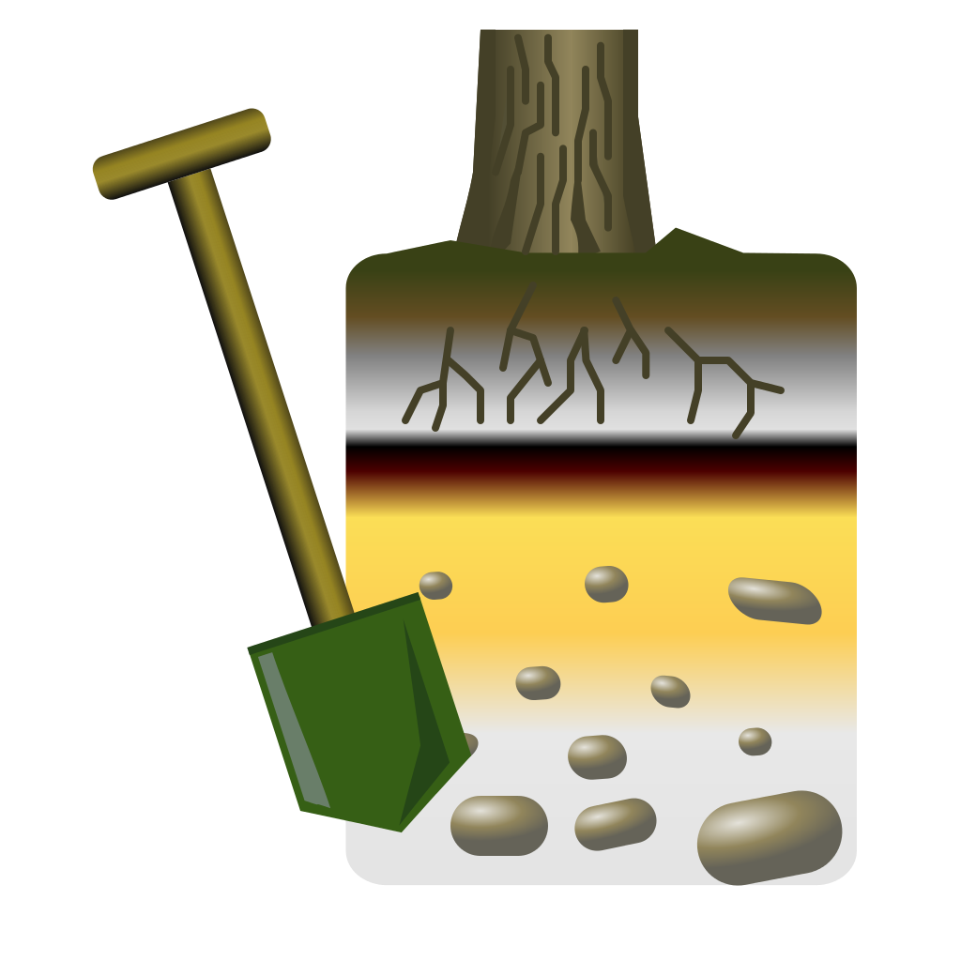

Define the term “soil horizon”:

Aligned to the following standards:
FFA.PL-C.; FFA.PL-D.; FFA.PL-F.; FFA.PG-J.; FFA.CS-M.; FFA.CS-N.; FFA.CS-O.; CCSS.RI.9-10.4; CCSS.W.9-10.2; CCSS.W.9-10.4; CCSS.SL.9-10.4; CRP.04; CRP.06

Part 2
Create and design a fact sheet for elementary students (see example page) about a soil profile. Information that should be included on the fact sheet: explanation of soil profile and soil horizons, explanation of each soil horizon and seven other facts about soil.
See grading rubric below:

Explanation of soil horizons | 4 points
Explanation of each soil horizon | 4 points
Explanation of soil profile | 4 points
Seven facts about soil | 7 facts x 2 points each = 14 points
Creative and colorful | 4 points
Includes websites used for research | 5 points
Total points | 35 points

Example: Fact Sheet
Aligned to the following standards:
FFA.PL-C.; FFA.PL-D.; FFA.PL-F.; FFA.PG-J.; FFA.CS-M.; FFA.CS-N.; FFA.CS-O.; CCSS.RI.9-10.4; CCSS.W.9-10.2; CCSS.W.9-10.4; CCSS.SL.9-10.4; CRP.04; CRP.06

This is an example of how to set up your fact sheet. Please be as creative as possible when designing your own fact sheet.

What is a soil horizon?

What is a soil profile?

Information About Each Soil Horizon:

Aligned to the following standards:
FFA.PL-C.; FFA.PL-D.; FFA.PL-F.; FFA.PG-J.; FFA.CS-M.; FFA.CS-N.; FFA.CS-O.; CCSS.RI.9-10.4; CCSS.W.9-10.2; CCSS.W.9-10.4; CCSS.SL.9-10.4; CRP.04; CRP.06

7 Facts About Soil

Websites used:
___________________________________________________________________________________

___________________________________________________________________________________

___________________________________________________________________________________

___________________________________________________________________________________

Part 3
Create your own soil profile! Bring in and use different materials such as food (candy, etc.), craft supplies, etc. to make a soil profile. The soil profie can be an edible profile (made entirely of food) or can be made of craft supplies. See the grading rubric below:

Soil horizons are clearly defined and labeled. | 5 points
Each soil horizon is present. | 5 points
Creative | 10 points
Total points | 20 points

Answer the following questions in the section below:
What items are you bringing in to use for your soil profile?
Which layer does it represent?
Why did you choose that material to represent that particular layer of soil?

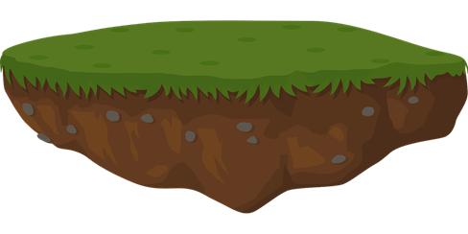

What are 2 facts you learned about soil profiles?

How can you use the information you learned about soil in the future?

Aligned to the following standards:
FFA.PL-C.; FFA.PL-D.; FFA.PL-F.; FFA.PG-J.; FFA.CS-M.; FFA.CS-N.; FFA.CS-O.; CCSS.RI.9-10.4;
CCSS.W.9-10.2; CCSS.W.9-10.4; CCSS.SL.9-10.4; CRP.04; CRP.06

