Appendix 10: The Future of Forestry
Aligned to the following standards:
FFA.PL-C.; FFA.PL-D.; FFA.PL-F.; FFA.PG-J.; FFA.CS-M.; FFA.CS-N.; FFA.CS-O.; CCSS.RI.9-10.4; CCSS.W.9-10.2; CCSS.W.9-10.4; CCSS.SL.9-10.4; CRP.04; CRP.06

Created: Winter 2018 by the National FFA Organization

Directions:
Read the article “The Future of Forestry” in the Winter 2018 issue of FFA New Horizons. After reading the article, complete the activities below.

Part 1
Go to the US Forest Service website (https://www.fs.usda.gov/learn/trees) and answer the questions below to learn more about forestry.

1. What are 4 benefits of trees?



2. Anatomy of a tree: https://www.fs.usda.gov/learn/trees/anatomy-of-tree
Draw, label and explain the various functions of each part of a tree in the space below.

Part 2
Use AgExplorer (AgExplorer.ffa.org) to search for two careers related to the forestry industry. (The search feature is located at the top of the page.) Answer the questions below to learn more about the two careers you identified.

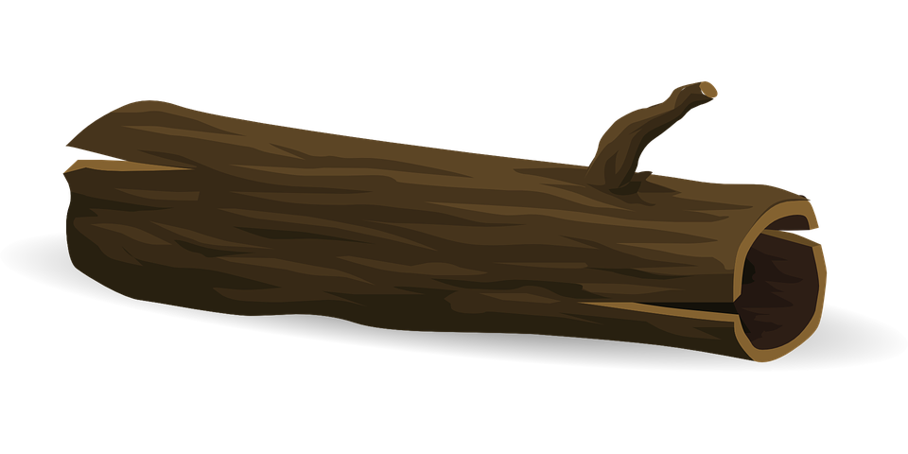Career One: __________________________________________________________
What are 4 responsiblities/duties of this career?

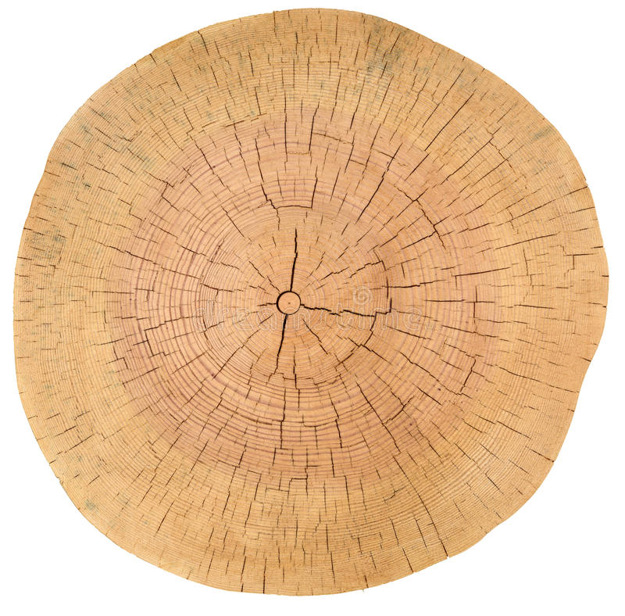

What educational requirements are needed for this career?

What is the future job market outlook for this career?
Aligned to the following standards:
FFA.PL-C.; FFA.PL-D.; FFA.PL-F.; FFA.PG-J.; FFA.CS-M.; FFA.CS-N.; FFA.CS-O.; CCSS.RI.9-10.4; CCSS.W.9-10.2; CCSS.W.9-10.4; CCSS.SL.9-10.4; CRP.04; CRP.06

Part 2, continued
Use AgExplorer (AgExplorer.ffa.org) to search for two careers related to the forestry industry. (The search feature is located at the top of the page.) Answer the questions below to learn more about the two careers you identified.

Career Two: __________________________________________________________
What are 4 responsiblities/duties of this career?

What educational requirements are needed for this career?

What is the future job market outlook for this career?

Aligned to the following standards:
FFA.PL-C.; FFA.PL-D.; FFA.PL-F.; FFA.PG-J.; FFA.CS-M.; FFA.CS-N.; FFA.CS-O.; CCSS.RI.9-10.4; CCSS.W.9-10.2; CCSS.W.9-10.4; CCSS.SL.9-10.4; CRP.04; CRP.06

Part 3
Create forestry-related SAE idea cards! Using the template found on the FFA website (https://ffa.box.com/v/saeideacards), create 4 SAE idea cards in the Natural Resource Systems or Environmental Service Systems pathways related to the forestry industry. If you do not have access to the internet, create your own SAE idea card template and answer the following questions:
-Would I enjoy working with this project?
-Do I currently have, or have access to, the needed resources for this project?
-Where could I take this project?
-Future careers
-Draw a picture to relate to this specific SAE topic.

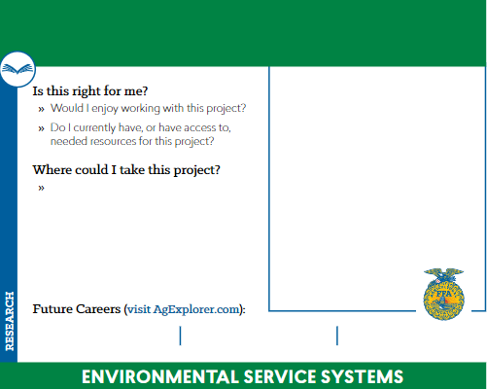

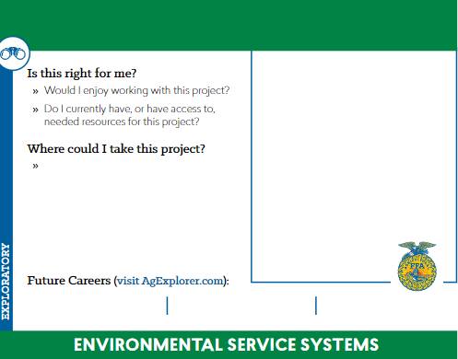

Aligned to the following standards:
FFA.PL-C.; FFA.PL-D.; FFA.PL-F.; FFA.PG-J.; FFA.CS-M.; FFA.CS-N.; FFA.CS-O.; CCSS.RI.9-10.4; CCSS.W.9-10.2; CCSS.W.9-10.4; CCSS.SL.9-10.4; CRP.04; CRP.06

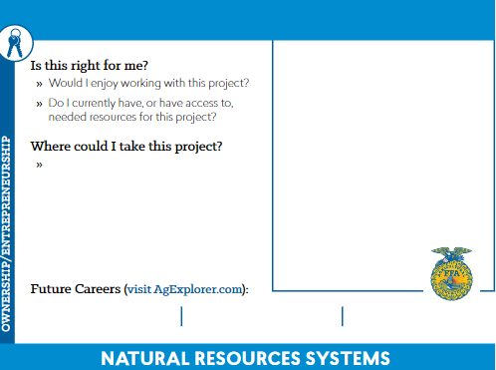

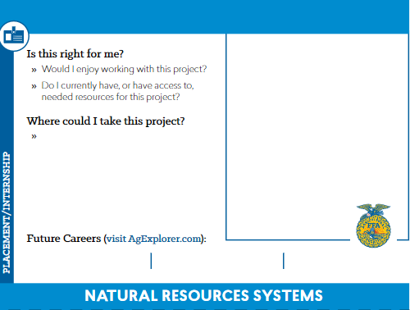

Aligned to the following standards:
FFA.PL-C.; FFA.PL-D.; FFA.PL-F.; FFA.PG-J.; FFA.CS-M.; FFA.CS-N.; FFA.CS-O.; CCSS.RI.9-10.4;
CCSS.W.9-10.2; CCSS.W.9-10.4; CCSS.SL.9-10.4; CRP.04; CRP.06

Aligned to the following standards:
FFA.PL-C.; FFA.PL-D.; FFA.PL-F.; FFA.PG-J.; FFA.CS-M.; FFA.CS-N.; FFA.CS-O.; CCSS.RI.9-10.4; CCSS.W.9-10.2; CCSS.W.9-10.4; CCSS.SL.9-10.4; CRP.04; CRP.06

