Appendix 4: Future
Aligned to the following standards:
FFA. PL-A;FFA.PL-C.; FFA.PL-D.;FFA.PL-E; FFA.PG-J.;FFA.CS-M.; FFA.CS-N.; FFA.CS-O.; CCSS.RI.9-10.2;CCSS.RI.9-10.4;CCSS.W.9-10.2; CCSS.W.9-10.4; CCSS.ELA.WHST.9.10.4;CCSS.SL.9-10.4;CCSS.ELA.W.9-10.4 CRP.02; CRP.04
Created: Summer 2019 by the National FFA Organization

Part 1
Directions:
Read “On the Record: Kip Tom” in the Summer 2019 issue of FFA New Horizons. Think about your future self — what you will be doing, what career you will have, etc. Answer the questions below from your future self’s perspective. (Think approximately 15 years in the future when answering the questions.)

1. What career will you have? (Identify the career and explain some of the duties and responsibilities of that career.)
2. What educational or technical goals will you have accomplished?
3. What hobbies will you have?

What might be your greatest obstacles?

Part 2
Aligned to the following standards:
FFA. PL-A;FFA.PL-C.; FFA.PL-D.;FFA.PL-E; FFA.PG-J.;FFA.CS-M.; FFA.CS-N.; FFA.CS-O.; CCSS.RI.9-10.2;CCSS.RI.9-10.4;CCSS.W.9-10.2; CCSS.W.9-10.4; CCSS.ELA.WHST.9.10.4;CCSS.SL.9-10.4;CCSS.ELA.W.9-10.4 CRP.02; CRP.04
directions
Read “On the Record: Kip Tom” in the Summer 2019 issue of FFA New Horizons. Answer the questions below. Visit these websites, http://www.fao.org/countryprofiles/index/en/?iso3=USA and https://www.state.gov/discoverdiplomacy/diplomacy101/people/170341.htm, to answer the questions.


1. What is the role of an ambassador?

2. What are qualities of a successful ambassador?

3. What is the goal of the FAO?

Ambassador Tom will be U.S. ambassador to the Food and Agriculture Organization of the United Nations in Rome, Italy.

4. What is the FAO?

5. Browse the FAO website (http://www.fao.org/countryprofiles/index/en/?iso3=USA), and write down three facts that are interesting to you.

Directions
Where are the ambassadors located? Reference this website, https://www.state.gov/discoverdiplomacy/explorer/, to learn where U.S. ambassadors (embassies) are located around the world. On the map below, color in the specific location within the country where an ambassador is located. Identify at least 25 ambassadors/embassies.

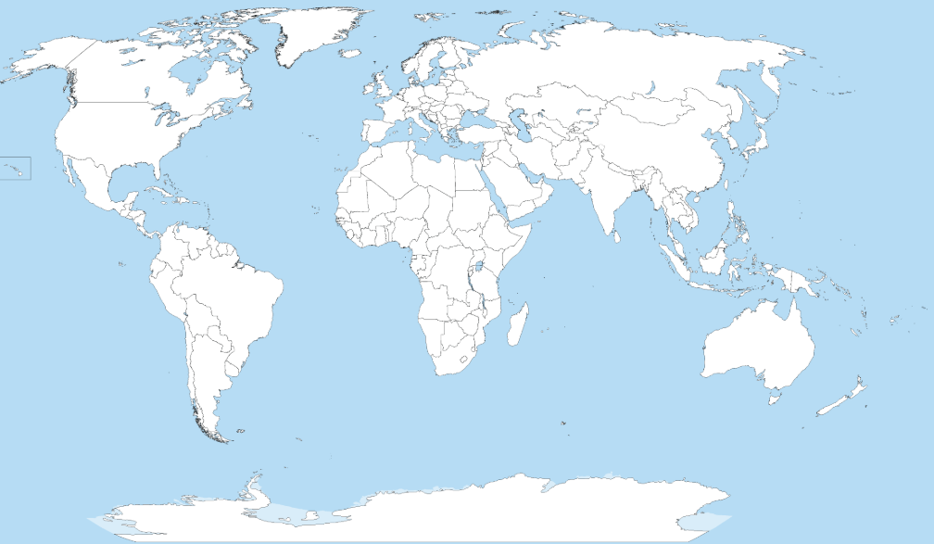
What would be the greatest challenge of being an ambassador? What might be the most exciting part of being an ambassador?

Aligned to the following standards:
FFA. PL-A;FFA.PL-C.; FFA.PL-D.;FFA.PL-E; FFA.PG-J.;FFA.CS-M.; FFA.CS-N.; FFA.CS-O.; CCSS.RI.9-10.2;CCSS.RI.9-10.4;CCSS.W.9-10.2; CCSS.W.9-10.4; CCSS.ELA.WHST.9.10.4;CCSS.SL.9-10.4;CCSS.ELA.W.9-10.4 CRP.02; CRP.04

