Appendix 1: Let’s Learn Sign Language!
Aligned to the following standards:
FFA.PL-C.; FFA.PL-D.; FFA.PL-F.; FFA.PG-J.; FFA.CS-M.; FFA.CS-N.; FFA.CS-O.; CCSS.RI.9-10.4; CCSS.W.9-10.2; CCSS.W.9-10.4; CCSS.SL.9-10.4; CRP.04; CRP.06

Created: Fall 2019 by the National FFA Organization

Part 1
Directions:
Read the article “Sign of the Times” in the Fall 2019 issue of FFA New Horizons and answer the questions below.

1. What year was the North Carolina School for the Deaf established?
a. 1994
b. 1894
c. 1899
d. None of the above

2. Explain why the North Carolina School for the Deaf launched an agricultural education program and why they chartered an FFA chapter.

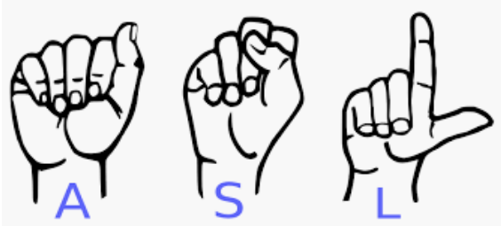
3. What did the FFA chapter accomplish in its first season?
What is one word that describes what you learned from this article?

4. How many FFA members did the North Carolina School for the Deaf start with? ________ How has their chapter membership grown? _______________

5. After you have identified one word that describes what you have learned (in the box above), draw your word using sign language images in the space below. (You might need to complete Part 2 of this worksheet first.)

Part 2
Aligned to the following standards:
FFA.PL-C.; FFA.PL-D.; FFA.PL-F.; FFA.PG-J.; FFA.CS-M.; FFA.CS-N.; FFA.CS-O.; CCSS.RI.9-10.4;
CCSS.W.9-10.2; CCSS.W.9-10.4; CCSS.SL.9-10.4; CRP.04; CRP.06

Directions:
Utilize the following websites, or similar sites, to complete the questions and activities below: https://lifeprint.com/asl101/topics/wallpaper1.htm and https://www.handspeak.com/.


Step 1: Learn how to sign your name.
Step 2: Learn how to sign the first line of your school’s fight song, the first line of your favorite college team’s fight song or the first line of your favorite song.

Step 3: With a partner, create a short video (at least 60 seconds in length). The video should include the following:

-you signing your name
-your partner signing his or her name
-you signing the first line of your chosen song
-your partner signing the first line of his or her chosen song
What is this sign?
What is this sign?
1. Click on one of the links above to learn how to spell your name in sign language.



2. How can you and your classmates talk with and interact with others
Aligned to the following standards:
FFA.PL-C.; FFA.PL-D.; FFA.PL-F.; FFA.PG-J.; FFA.CS-M.; FFA.CS-N.; FFA.CS-O.; CCSS.RI.9-10.4;
CCSS.W.9-10.2; CCSS.W.9-10.4; CCSS.SL.9-10.4; CRP.04; CRP.06

from different backgrounds and cultures?

