Appendix 6: Making a Global Impact
Aligned to the following standards:
CS.02; FFA.PL-A; FFA.PL-E; FFA.PG-J; FFA.CS-M; FFA.CS-N; AG2; CCSS.ELA.RI.9-10.4; CCSS.ELA.W.9-10.2; CCSS.ELA.SL.9-10.1; CCSS.ELA.SL.9-10.2; CCSS.ELA.SL.9-10.4; MP1; MP5; MP6; CRP.02; CRP.04; CRP.07
Created: Winter 2019 by the National FFA Organization
Part 1
Directions:
Read the article “Global Impact” in the Winter 2019 issue of FFA New Horizons and answer the questions below.

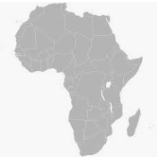
- What country did the FFA chapter decide to help?

_______________________________________

- Locate and color in this country on the map.

3. What animal does this country have a great dependence on?

_____________________

Part 2
Directions:
Using the Tractor Supply Company website (https://www.tractorsupply.com/know-how_pets-livestock_livestock-other_goat_goat-care-for-beginners-how-to-care-for-goats), explore the basics of goat care. If internet access is not available, ask your teacher for the Goat Information Sheet.
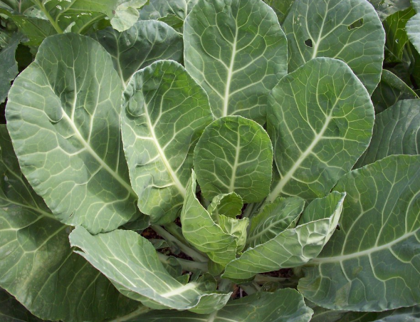
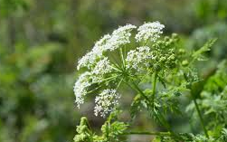
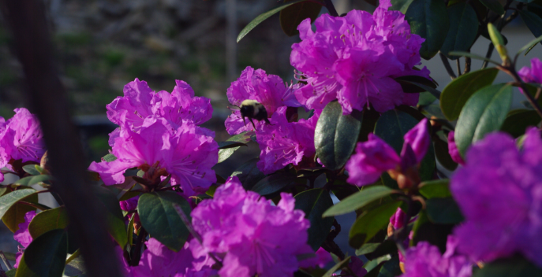
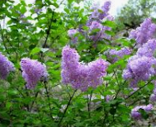
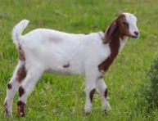
Which of the following plants are considered poisonous and should not be consumed by a goat? Place a red X over the poisonous plants.
Collard Greens
Hemlock
Azalea
Lilac
What does the term ruminant mean?

- The animal has four stomachs.
- The animal has a four-chambered stomach.
- The animal has a stomach like humans.
What does it mean if an animal is chewing its “cud”?

- The animal is eating.
- The animal is consuming salt.
- The animal is chewing regurgitated food.
Minerals are important for humans and goats. Goats should be given salt with trace amounts of selenium. Draw selenium’s square as shown on the periodic table.

Atomic Number
Symbol
Name
True or False

Cartoons show goats eating just about everything regardless of nutrition. Is this true or false?

Part 3
Directions:
Goats are incredibly important across the globe. Learn where goats are most commonly produced and why by completing the following activities.
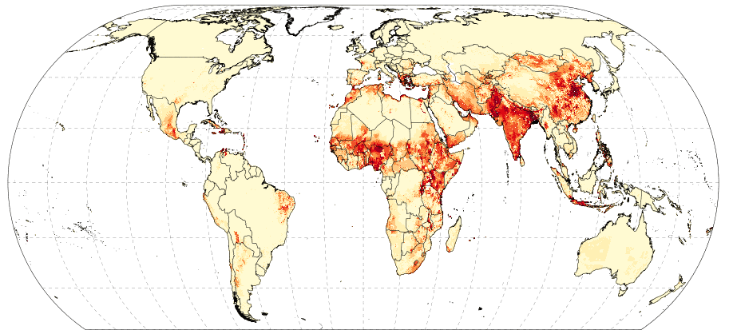
The map to the left depicts the density of goats in a region. The darker the red the more goats present. Why do you think the goat density is so high in some areas? What about those areas may lead to more goats being raised?
*Map sourced from FAO.
Directions:
Goats are beneficial because they can provide milk, meat and fiber, depending on the breed. Using the AgMRC website, https://americangoatfederation.org/goat-products/, complete the following activities to learn about goat products. If internet access is not available, ask your teacher for the Goat Information Sheet.

Goat Fiber

- What are the two main types of fiber acquired from goats?
- __________________________

- __________________________

- Identify two products that can be made from the fiber of goats.
- _________________________

- __________________________
Goat Milk

- Why is goat’s milk considered to be so nutritional?

- Identify three products that can be produced from goat’s milk.

- __________________________

- __________________________

- __________________________

Goat Meat

- What term is used to identify goat meat (40–60lb butcher weight)?

_____________________________

- Goat meat is a great option for those that need to do what in their diet?
Directions:
Develop a 30-minute radio segment to share with consumers how goat products affect their daily lives.
What is the economic impact of goats in the U.S.?

