Appendix 5: Organic vs. Conventional Food
Aligned to the following standards:
FFA.PL-A; FFA.PL-C; FFA.PL-E; FFA.PL-F; FFA.PG-I; FFA.PG-J; FFA.CS-M; FFA.CS-N; CS.05; AG5; AGC09.02; CCSS.SL.9-10.1; CCSS.SL.9-10.2; CRP.04; CRP.07; CRP.08; CRP.10

Created: Fall 2019 by the National FFA Organization

Part 1
Directions:
Read the article “Talking Points: Organic vs. Conventional Food” in the Fall 2019 issue of FFA New Horizons magazine and answer the following questions.

1. Review the food labels below and determine the differences and similarities in the labels.

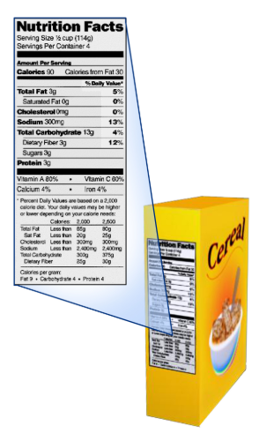
What is similar about the two food labels? Identify three.

What is different about the two food labels?
Identify three.

Non-Organic Food Label:

Organic label:

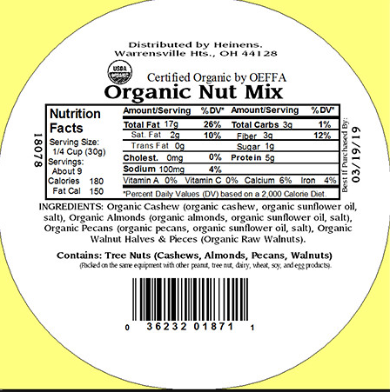
What is one fact that stood out to you? Explain how this information affects you as a consumer?
Part 2
Aligned to the following standards:
FFA.PL-A; FFA.PL-C; FFA.PL-E; FFA.PL-F; FFA.PG-I; FFA.PG-J; FFA.CS-M; FFA.CS-N; CS.05; AG5; AGC09.02; CCSS.SL.9-10.1; CCSS.SL.9-10.2; CRP.04; CRP.07; CRP.08; CRP.10

Directions:
Watch the video (or one similar) “How to Make a Paper Slideshow,” available at https://youtu.be/E5RXynA_D3I. You will create a paper-slide informational video about organic and conventional food. Videos should last between 45 and 90 seconds. Utilize the space below to script your video. (Illustrations will go in the boxes and your narration on the lines.)
Examples of suggested topics: nutritional information, how organic and conventional foods are grown, similarities and differences, etc.

Title:

Slide One:
Narration:

__________________________________________

__________________________________________

__________________________________________

__________________________________________

__________________________________________

Slide Two:

Narration: Narration:

__________________________________________

__________________________________________

__________________________________________

__________________________________________

__________________________________________

Aligned to the following standards:
FFA.PL-A; FFA.PL-C; FFA.PL-E; FFA.PL-F; FFA.PG-I; FFA.PG-J; FFA.CS-M; FFA.CS-N; CS.05; AG5; AGC09.02; CCSS.SL.9-10.1; CCSS.SL.9-10.2; CRP.04; CRP.07; CRP.08; CRP.10

Slide Three:
Narration:

__________________________________________

__________________________________________

__________________________________________

__________________________________________

__________________________________________

Slide Four:
Narration:

__________________________________________

__________________________________________

__________________________________________

__________________________________________

__________________________________________

Narration:
Slide Five:

__________________________________________

__________________________________________

__________________________________________

__________________________________________

__________________________________________
Paper Slide Video Rubric
Aligned to the following standards:
FFA.PL-A; FFA.PL-C; FFA.PL-E; FFA.PL-F; FFA.PG-I; FFA.PG-J; FFA.CS-M; FFA.CS-N; CS.05; AG5; AGC09.02; CCSS.SL.9-10.1; CCSS.SL.9-10.2; CRP.04; CRP.07; CRP.08; CRP.10

Area | 4 Points | 3 Points | 2 Points | 1 Point
Content | All content is accurate. There are no factual errors. | Most of the content is accurate, but there is one piece of information that seems inaccurate. | The content is generally accurate, but one piece of information is clearly inaccurate. | Content is confusing or contains more than one factual error.
Clarity and Neatness | The paper slide is easy to read, and all elements are clearly written, labeled and drawn. Creativity was used. | The paper slide is easy to read, and most elements are clearly written, labeled and drawn. Some creativity was used. | The paper slide is hard to read with rough drawings, labels and color. Little creativity was used. | The paper slide is hard to read, and one cannot tell what goes where or what the illustrations represent. No creativity was used.
Narration and Preparedness | The paper slideshow is clearly rehearsed and narrated with no mistakes.  Student spoke slowly and clear. | One mistake is heard in the paper-slide video. | Two mistakes are heard in the paper-slide video. | Three or more mistakes are heard in the paper-slide video.  Student spoke very fast and was unclear.
Time | Student stayed in the 45- to 90-second time frame. |  |  | Student was either under or over the allotted time frame.

Comments:
___________________________________________________________________________________________________

___________________________________________________________________________________________________

___________________________________________________________________________________________________

___________________________________________________________________________________________________

___________________________________________________________________________________________________

___________________________________________________________________________________________________

___________________________________________________________________________________________________

___________________________________________________________________________________________________

Part 3
Aligned to the following standards:
FFA.PL-A; FFA.PL-C; FFA.PL-E; FFA.PL-F; FFA.PG-I; FFA.PG-J; FFA.CS-M; FFA.CS-N; CS.05; AG5; AGC09.02; CCSS.SL.9-10.1; CCSS.SL.9-10.2; CRP.04; CRP.07; CRP.08; CRP.10

Directions:
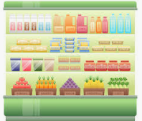
Visit your local grocery store, and use the space below to map out where the organic and conventional food items are located. Be sure to respond to the question below as well.

Why do you think the organic food is found where it is in the grocery store?

