Appendix 2: Space Farmer
Aligned to the following standards:
CS.02; CS.05; FFA.PL-A; FFA.PL-C; FFA.PL-E; FFA.PG-J; FFA.CS-N; AG2; AG5; CCSS.ELA.SL.9-10.2; CCSS.ELA.RI.9-10.3; CCSS.ELA.RI.9-10.4; MP4; MP5; MP6; CRP.02; CRP.04; CRP.06; CRP.08

Created: Winter 2019 by the National FFA Organization
Part 1
Directions:
Read the article “Futuristic Farming” in the Winter 2019 issue of FFA New Horizons and complete the following activities.
Grant is a part of the social media team working to promote which project?
- SpaceX Falcon 9
- Artemis Project
- Apollo Artemis 14
What is Grant majoring in that helped him to acquire an internship with NASA?

1. ______________________________

2. ______________________________

What skills has Grant learned through FFA to help prepare him for his future?
- ______________________________________
- ______________________________________
- ______________________________________

True False

Grant states in the article that FFA competitive events are what led him to pursue a career in space. (Circle the answer.)

Using AgExplorer.ffa.org, identify three careers Grant could have at NASA that utilize the skills he has learned in FFA.
- ______________________________________
- ______________________________________
- ______________________________________

Part 2
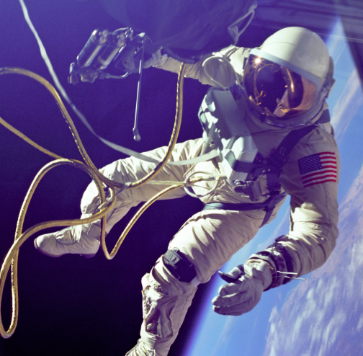
Directions:
Grant has used skills learned in FFA to land in a career area that is truly out of this world! Let’s learn about the food science side of how astronauts eat during their space missions. Watch “Tasting Astronaut Food: Inside NASA's Space Food Systems Laboratory,” https://youtu.be/6vVle67Tfjc?t=245 (end at 9:55), and answer the following questions about food during space travel.
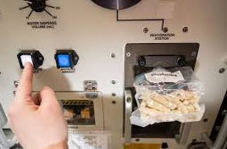
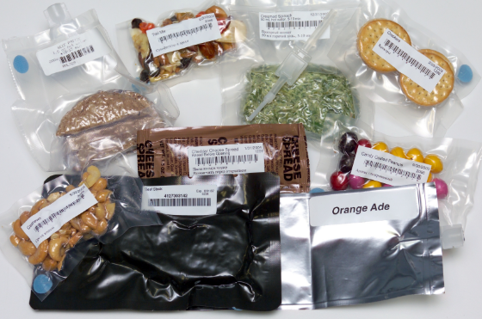
NASA uses packaging that promotes ease of use, product protection and freshness. For beverages, NASA purchases the packaging from which kid-favorite product?

- M&Ms
- Coca-Cola
- Capri Sun
- Juicy Juice
What method do food scientists use to prepare many solid foods for flight?

- Freezing
- Microwaving
- Boiling
- Freeze drying
Why can’t foods go into space in their original packaging?

- Some packaging could be flammable
- Off-gassing from packaging
- Cost effectiveness
- All of the above

Part 3
Directions:
Aligned to the following standards:
CS.02; CS.05; FFA.PL-A; FFA.PL-C; FFA.PL-E; FFA.PG-J; FFA.CS-N; AG2; AG5; CCSS.ELA.SL.9-10.2; CCSS.ELA.RI.9-10.3; CCSS.ELA.RI.9-10.4; MP4; MP5; MP6; CRP.02; CRP.04; CRP.06; CRP.08

Now that you have a basic understanding of the food science that goes into the feeding of astronauts, let’s look at what it may look like for your favorite meal! Complete the following activities to learn more about food in space.
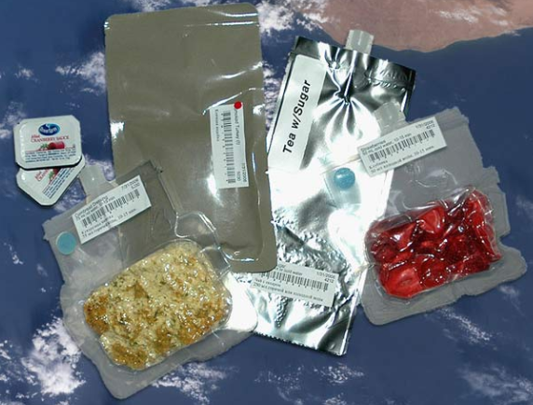
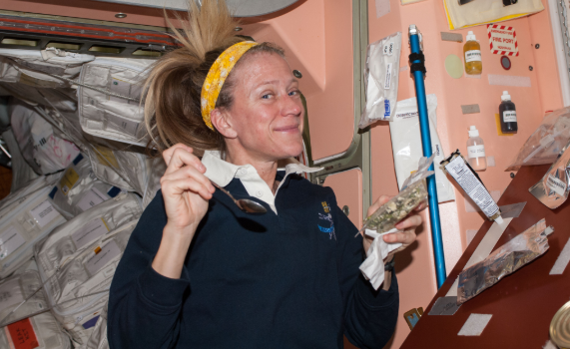

Draw a picture of the packaging and labeling for the beverage as it would appear for traveling to space:

How might this product have to be prepared before packaging for it to be suitable for flight? (Ex. powdered)

Draw a picture of the packaging and labeling for the main course of the meal as it would appear for traveling to space:

How might this product have to be prepared before packaging for it to be suitable for flight? (Ex. powdered)
List your favorite meal (lunch or dinner):

Main course (Ex. spaghetti):

Side(s) (Ex. broccoli):

Beverage (Ex. lemonade):

Dessert (Ex. brownie):

Draw a picture of the packaging and labeling for the side(s) as it would appear for traveling to space:

How might this product have to be prepared before packaging for it to be suitable for flight? (Ex. powdered)
Draw a picture of the packaging and labeling for the dessert as it would appear for traveling to space:

How might this product have to be prepared before packaging for it to be suitable for flight? (Ex. powdered)

- Prior to flight, astronauts are able to select a few favorite snacks to accompany them to space to cure those cravings from home. What is your favorite snack? ______________________________

- Looking at the food packaging, determine the weight of the product. (Ex. A box of Skittles weighs 2.17 oz.)

__________________

- According to NASA, to get your favorite food into space for a late-night snack, it costs approximately $10,000 to put one pound of payload into Earth orbit. So, with this cost in mind, calculate approximately how much it would cost to send your favorite snack into Earth orbit.

Skittles Example
Ex. 0.0625lb = 1oz.
2.17 oz x 0.0625 lb = 0.1356 lb
0.13 lb x $10,000 = $1,356

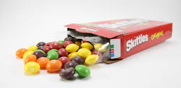
What role does food science play in the aeronautic industry?

