Agricultural Research
Aligned to the following standards:
CS.01; CS.05; CS.06; FFA.PL-A; FFA.PL-C; FFA.PG-I; CCSS.W.9-10.6; CCSS.W.9-10.8; CCSS.SL.9-10.2; CCSS.SL.9-10.5; CRP.02; CRP.04; CRP.06; CRP.07; CRP.11
Part 1
Directions:
Watch the SAE video “Farm and Research Associate SAE,” https://vimeo.com/857915280, and answer the questions below.
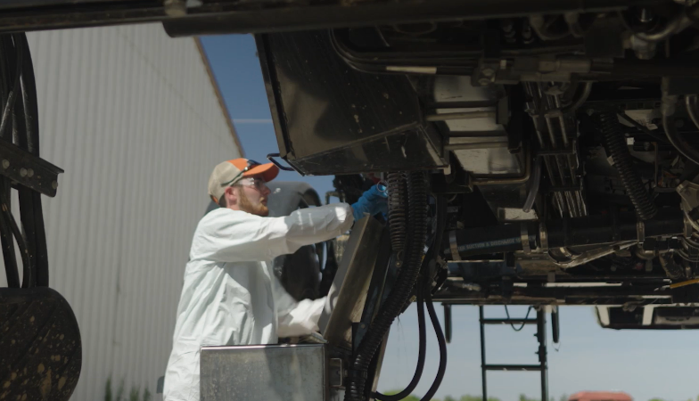
- Where does Lane work?

- List two tasks Lane does at his job.

- Name one thing he mentions he’s learned since starting his SAE.

- Which agriculture class helped him prepare for his SAE?
  - Animal science
  - Horticulture
  - Landscape management
  - Sustainable agriculture

- What other agriculture classes might be helpful for this SAE?

- How did Lane get his full-time position at Agricenter International?
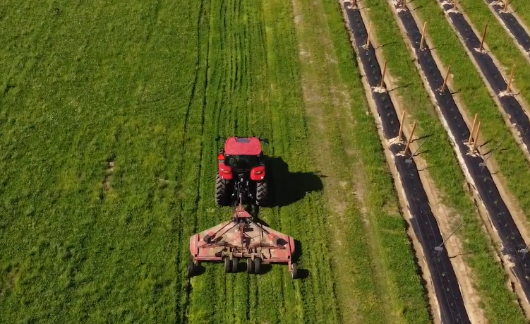
Part 2
Directions:
Explore the Agricenter International website to learn more about the company. Answer the questions below as you click through the website. Agricenter International website: https://www.agricenter.org/.

On the homepage, use the green circles to answer the matching questions below. Draw a line between the fact and the correct number.

The economic impact of Agricenter International 600

Total number of acres being farmed 10,000

Number of visitors to Agricenter International annually $524 million

Number of students educated in STEM 1.3 million

Total number of acres used for research 1,000

On the homepage, click on “Ag Research” to answer the next set of questions.

- What does Agricenter International strive to do?

- Circle the types of crops the company researches.
  - Corn
  - Cabbage
  - Tobacco
  - Cotton
  - Soybeans
  - Apples
  - Rice
  - Wheat
  - Sorghum
  - Bermuda
- Annually, Agricenter researchers conduct over ________________ research trials for more than ___________ companies including those in ____________ countries across the globe.
- List the types of trials Agricenter International conducts.

While Agricenter International is a private agricultural research company, there are agricultural research sites in every state that are operated by land-grant universities. Use Google or another search engine to help you answer the following questions.

- What is a land-grant university?

- What is the land-grant university in your home state?

- Name two agricultural research sites found in your home state.

Based on the information you learned above, answer the following questions.

- Why do you think agricultural research is important?

- How can local farmers benefit from agricultural research?

- How can agricultural companies (such as John Deere, Bayer, etc.) benefit from agricultural research?

- Search for an article on agricultural research and summarize it below.

