All About Quail
Aligned to the following standards:
CS.04; CS.05; CS.06; FFA.PL.A; FFA.PL.C; FFA.PG.I; CCSS.W.9-10.6; CCSS.W.9-10.8; CCSS.SL.9-10.2; CCSS.SL.9-10.5; CRP.02; CRP.04; CRP.06; CRP.07; CRP.11
Part 1
Directions:
Watch the SAE video “Quail Management SAE | Trace Ward,” https://vimeo.com/857657901, and answer the questions below.

- Which state is Trace Ward from?
  - South Carolina
  - Mississippi
  - Georgia
  - Alabama

- Describe what Coturnix quail look like.

- Create a to-do list for Trace based on the daily tasks he says are involved with caring for his quail.
Quail SAE Daily Task To-Do List:

- Circle the safety items he wears when cleaning the tray.
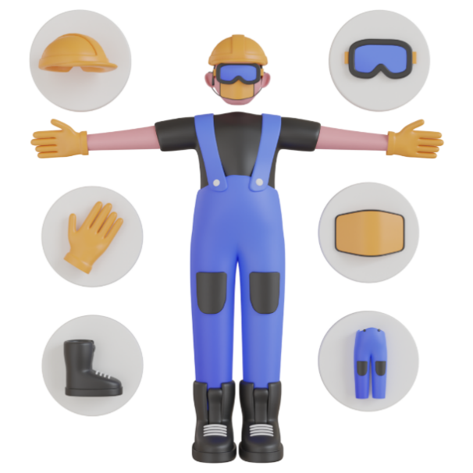

- Define the word “incubation.”

- How many days does it take for quail eggs to hatch?
  - 21 days
  - 12-14 days
  - 23-26 days
  - 17-19 days

- What does Trace say his favorite part of his SAE is?

- What advice does Trace give for students looking to start an SAE?

- After hearing Trace’s SAE story, how do you think raising quail connects with agriculture?

Part 2
Directions:
Five of the most common types of quail are Coturnix, bobwhite, California, button and blue scale. You will be assigned one of these types. You will be creating an informational poster about the type you are assigned. This poster can be hand drawn on a blank sheet of paper or digitally created on a platform such as Google Slides or Canva.

Please include the following information on your quail:
- Name of the type of quail
- Where this type can be found in the U.S.
- Description of its preferred habitat
- Average size it grows to
- List of food that it eats
- Description of its behavior
- Life expectancy
- A picture of what the type looks like (drawn in full color or photo found in full color)
- Two interesting facts you learned about the type of quail

The following rubric will be used to grade your poster:

Name of the type of quail selected | /5
Home: location within the U.S. where this type is found and a description of its preferred habitat | /10
Information: average size this type grows to, list of food this type eats, description of the behavior and life expectancy | /15
Two interesting facts learned about this type | /10
A picture of the type, showing all characteristics (drawn or digital) | /10
Neatness and appealing to look at | /5
Source list attached | /5
TOTAL | /60

