Hydroponics School-Based SAE
Aligned to the following standards:
FFA.PL-A1; FFA.PL-A3; FFA.PL-A4; FFA.PL-C2; FFA.PL-F5; FFA.PL-I5; FFA.PL-J1; FFA.PL-N1; CCSS.ELA-RI.9-10.4; CCSS.ELA-RI.11-12.7; CCSS.ELA-W.9-10.2; CCSS.ELA-W.9-10.4; CCSS.ELA-SL.9-10.2; CCSS.ELA-L.9-10.1; CCSS.ELA-L.9-10.2; CRP.02; CRP.04; CRP.06; CRP.08

Part 1
Directions: Answer the questions below as you watch the video “Hydroponics SAE,” available at https://vimeo.com/1108190707.

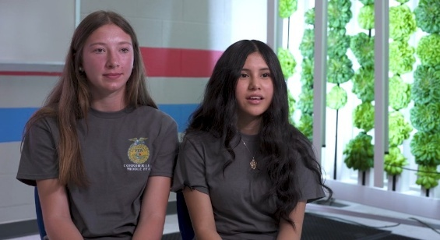
- What pathway is Mary Kate and Reyna’s SAE in?
- Describe their SAE in one or two sentences.
- How did Mary Kate and Reyna get started with their SAE?
- What supplies are needed for their SAE?
- What are three tasks that Mary Kate and Reyna regularly perform for their SAE?
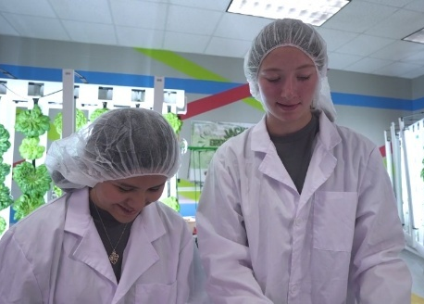

- What are four safety considerations that they take when working on their SAE?

- What have been Mary Kate’s and Reyna’s favorite memories from their SAE?
Mary Kate:
Reyna:
- What do they say their SAE has taught the students and staff at their school?
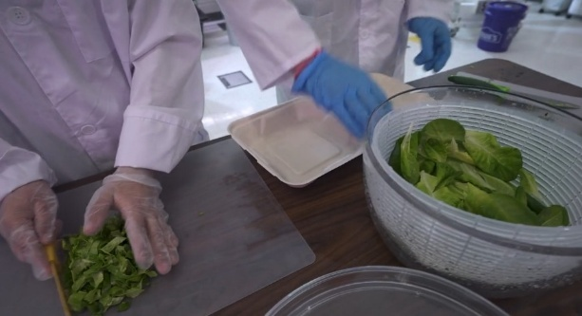

Part 2
Directions: Use the table below to analyze the “Jackets for the Future” SAE and list its goals, resources, challenges and benefits for the students involved. Not all of these were necessarily mentioned in the videos, but as you think about the SAE, list as many as you can think of, but write at least two for each category. Then, answer the questions below.
Jackets for the Future School-Based SAE
Goals | Resources | Challenges | Benefits
Analysis Questions
- Why do you think Mary Kate and Reyna’s SAE is so successful?

- Why is it important to have a plan for an SAE?

- What do you think are some of the benefits of students starting or working in a school-based enterprise for their SAE?

SAEs at School
Aligned to the following standards:
FFA.PL-A1; FFA.PL-A3; FFA.PL-A4; FFA.PL-C2; FFA.PL-F5; FFA.PL-I5; FFA.PL-J1; FFA.PL-N1; CCSS.ELA-RI.9-10.4; CCSS.ELA-RI.11-12.7; CCSS.ELA-W.9-10.2; CCSS.ELA-W.9-10.4; CCSS.ELA-SL.9-10.2; CCSS.ELA-L.9-10.1; CCSS.ELA-L.9-10.2; CRP.02; CRP.04; CRP.06; CRP.08

Part 1
Directions: Visit https://saeforall.org/immersion-sae/ and scroll down to click on the “School-Based Enterprise SAE” tab to learn more about school-based enterprises and answer the questions below.

- What kind of student might be the best fit for a school-based enterprise SAE?

- Fill in the blanks in the following statement about school-based enterprise SAEs.
“In a school-based enterprise SAE, students lead _______________________ that provide ________ or _________. These businesses are operated from the __________ ___________ utilizing __________, ___________ and other ____________ provided by the agricultural education program or the school and are owned by the school or FFA chapter. It is important to remember that school-based enterprises are __________-____. While the ____________ will be available to provide __________, they are not the primary __________________________ of the business. With regular input from the ____________________________, the student leadership team will be able to facilitate the ongoing processes and growth of the business.”
Watch the short video on the website and answer the following questions about school-based enterprise SAEs.

- How does an Immersion SAE build upon a Foundational SAE?

- In three or four sentences, briefly explain the Wildcat Landscaping school-based enterprise from the video.

- How did Jacob and Juan get started with their school-based enterprise?

- What is the difference between a school-based enterprise and a placement SAE at school?

- How do school-based enterprise SAEs benefit both the students and the community?
Student Benefits | Community Benefits

Part 2
Directions: Use the space and prompts provided below to brainstorm ideas for potential new school-based enterprises that utilize your school’s agriculture facilities, equipment and supplies. These are just ideas, not full plans yet, so come up with as many as you can!
- What resources does your school have that may be useful in conducting a school-based enterprise SAE?
(List as many as possible.)

- What are some tasks or skills you are particularly interested in learning for your future career or life after high school? (List as many as possible.)

- Who are some potential individuals who could assist you with a school-based enterprise SAE? (These could be mentors, members for your board of directors, other student workers, etc.) List both their name and position or area of expertise. (List as many as possible.)

- Looking at the three lists you have generated, brainstorm 10 ideas for your school-based enterprise SAE. Write a simple one-sentence description for each (see the examples below).
Examples:
- Utilize the school’s hydroponics system to grow and sell lettuce to the school’s teachers and staff.
- Use the school’s equipment to offer landscape design and installation services to the community.

- Reviewing your list above, which projects most align with your future goals?
- Which projects do you believe you would be most successful with?
- Reviewing your list above, star, circle or highlight the top five ideas you would be most interested in starting as a school-based enterprise SAE. These will be the ideas you share with your group in Part 3.

Part 3
Directions: Team up with other students to form a group as directed by your teacher. In your group, take turns sharing ideas with each other and record your teammates’ ideas below. Then select one idea and work together to create a plan for starting this school-based enterprise.
- Share your top five ideas with your group and listen to theirs. As your classmates share, record any ideas that you did not think of.

- As a group, select one idea to begin to create a plan for and record it below.

- Why did your group select this idea? (Explain in three or four sentences.)

- Fill out the chart below for your school-based enterprise SAE idea. List as many items as you can think of for each category, but write at least two items per category.
SAE Idea Title: ____________________________________________________________
Goals | Resources | Challenges | Benefits

- What are three specific tasks that would need to be performed regularly for this SAE?

- What are two safety considerations you would need to take for this SAE?

- List out individuals who would be a part of this SAE and their roles (list at least five).

- What will be your first step to begin this school-based enterprise SAE?

