Plant Systems Careers
Aligned to the following standards: CS.05; CCSS.SL.9-10.1; CCSS.SL.9-10.2; AG5; CRP.04; CRP.07; CRP.08; CRP.10

Part 1
Directions:
In your group, research one stage of the AFNR Value Chain, as assigned by your teacher, and fill out the research sheet below. When done, create a poster utilizing the information and provided rubric. You will use this to teach your classmates about your portion of the value chain.
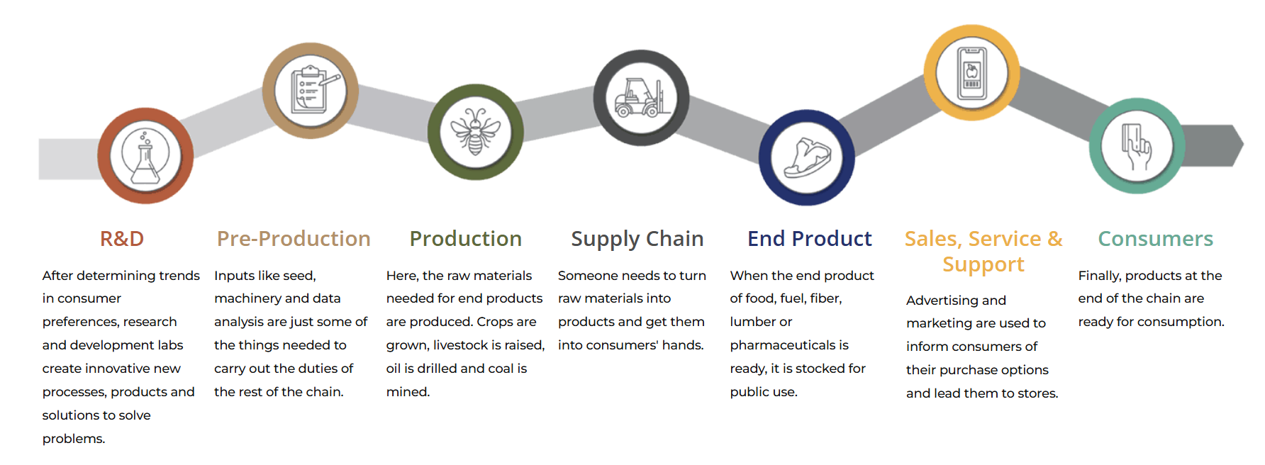
Your assigned value chain stage: _________________________________
Use the questions below to guide your research:
- What happens during this stage of the value chain?

- Why is this stage important to agriculture or the Plant Systems pathway?

- List two or three real-world examples from plant science that happen during this stage.

- What three or four careers are connected to this part of the value chain?

- What problems could happen if this stage fails or is skipped?
Poster rubric
Area | 4 Points | 3 Points | 2 Points | 1 Point
Content | All content is accurate. There are no factual errors. | Most of the content is accurate, but there is one piece of information that seems inaccurate. | The content is generally accurate, but one piece of information is clearly inaccurate. | Content is confusing or contains more than one factual error.
Clarity and Neatness | The poster is easy to read and all elements are clearly written, labeled and drawn. Creativity was used. | The poster is easy to read and most elements are clearly written, labeled and drawn. Some creativity was used. | The poster is hard to read with rough drawings, labels and color. Little creativity was used. | The poster is hard to read and one cannot tell what goes where or what the illustrations represent. No creativity was used.
Presentation and Preparedness | The presentation is clearly rehearsed and delivered with no mistakes.  Student spoke slowly and clear. | One mistake is heard in the presentation. | Two mistakes are heard in the presentation. | Three or more mistakes are heard in the presentation.  Student spoke very fast and was unclear.
Time | Student stayed in the three to five-minute time frame. |  |  | Student was either under or over the allotted time frame.

Comments:

___________________________________________________________________________________________________

___________________________________________________________________________________________________

___________________________________________________________________________________________________

___________________________________________________________________________________________________

___________________________________________________________________________________________________

___________________________________________________________________________________________________

___________________________________________________________________________________________________

___________________________________________________________________________________________________

Part 2
Directions:
As your classmates present each stage of the value chain, fill in the chart below:
Value Chain Stage | What Happens Here? | Example in Plant Systems | Career Spotlight | What Happens If This Step Were Skipped?
Research and Development
Pre-Production
Production
Supply Chain
End Product
Sales, Service and Support
Consumers

Part 3
Directions:
Watch the Syngenta “day in the life” video (https://www.youtube.com/watch?v=Xhojdm6BibY), and answer the questions as you watch.

- Syngenta is an innovative company rooted in ______________________________.

- Syngenta believes in _____________________________ and _____________________________.

- What examples from the video illustrate Syngenta’s approach to innovation?

- What do you think is important to the company and the people who work there?

- Based on the video, would you want to work for Syngenta? Why or why not? Explain in two or three sentences.

Part 4
Directions:
- You are going to play Plant Systems Careers Bingo! You’ll start by sitting across from someone in the class.
- Take turns sharing your career.
- You’ll each get about two to three minutes to talk.
- Read your career card and explain what that job is like.
- Then your partner will do the same with their card.
- Switch It Up!
- When the timer goes off, everyone rotates and finds a new partner
- You’ll bring your same card and repeat the process with someone new.
- Mark Your Bingo Card
- If your partner’s career is on your Bingo card, mark it off!
- The first person to get five in a row (across, down or diagonally) shouts BINGO!

Discussion Questions:

- What Plant Systems career stood out most to you? Why?

- Which career do you think best matches your own interests, strengths or hobbies?

- What surprised you most about the types of jobs that exist in this career pathway?

Part 5
Directions:
- Visit AgExplorer.FFA.org/focus/plant-systems/
Sketch a Photo of the Career
Job Description
Main Responsibilities

Recommended High School Courses

Name of Career:
Career Category:
Education Needed
- On that page, click on different Plant Systems careers and complete the career profiles below for two of the careers you are most interested in.

Sketch a Photo of the Career
Job Description
Main Responsibilities

Recommended High School Courses

Name of Career:
Career Category:
Education Needed

- What about these two careers interested you and why?

