Green Collar Careers
Aligned to the following standards:
NRS.01; AGPE01.01; CCSS.RI.9-10.3; CCSS.SL.9-10.1; RST.9.10.1; RST.9.10.2; RST.9.10.4; RST.9.10.5; RST.9.10.9; RST.9.10.10; WHST.9.10.7; WHST.9.10.9; MP3; MP6; AG-NR2; HS-LS2-6; HS-LS2-7
Part 1
Directions:
- Go to John Deere’s website, https://about.deere.com/en-us/careers/dealership-careers.
- Click on the “start your career search.”
- Choose five careers connected with John Deere dealerships that interest you.
- Complete the chart below for each career.

Career | Location | Job Responsibilities | Compensation | Why This Career Interests Me | What Role Does This Career Play in the Company?

Reflection Questions:

- Which career did you find most interesting and why?

- What three skills do you already have that would help you in one of these careers?

Part 2
Directions:
Choose one of the five careers from Part 1 and plan a video that showcases a day on the job. Use the prompts and rubric below to outline your content.
Career Selected: ______________________________________

Scene/Description | What You’ll Say/Show | Props or Actions
Morning Routine
Arriving to Work and Setup
Task 1:
Task 2:
Task 3:
Task 4:
Wrap-up and Reflection

“Day in the Life” Video Rubric
Area | 4 Points | 3 Points | 2 Points | 1 Point
Content | All content is accurate. There are no factual errors. | Most of the content is accurate, but there is one piece of information that seems inaccurate. | The content is generally accurate, but one piece of information is clearly inaccurate. | Content is confusing or contains more than one factual error.
Clarity and Creativity | The video is easy to understand, and all elements are clearly written or spoken. Creativity was used. | The video is easy to understand, and most elements are clearly written or spoken. Some creativity was used. | The video is hard to understand with very quiet speaking or very hard to read writing. Little creativity was used. | The video is hard to understand, and one cannot follow the thought process. No creativity was used.
Narration and Preparedness | The video is clearly rehearsed and presented with no mistakes.  Student spoke slowly and clearly. | One mistake is heard in the video. | Two mistakes are heard in the video. | Three or more mistakes are heard in the video.  Student spoke very fast and was unclear.
Time | Student stayed in the two- to three-minute time frame. |  |  | Student was either under or over the allotted time frame.
Total: _____________
Comments:

___________________________________________________________________________________________________

___________________________________________________________________________________________________

___________________________________________________________________________________________________

___________________________________________________________________________________________________

___________________________________________________________________________________________________

___________________________________________________________________________________________________

___________________________________________________________________________________________________

___________________________________________________________________________________________________

Part 3
Directions:
Prepare a one- to two-minute speech to persuade your classmates that your chosen career is the most essential dealership role. Fill in the bracket below as your classmates debate until you find the most essential dealership role.
Career: ______________________
Speech Planning:
- Opening Hook:
How will you grab attention?

- Main Argument 1:
What makes this role vital to dealership success?

- Main Argument 2:
How does this role support customers or the team?

- Closing Statement:
Why should this role win the bracket?

ROUND 2
ROUND 3

ROUND 4

ROUND 1

Reflection Questions:

- Which career won the bracket? Do you agree with the class’s final choice? Why or why not?

- Whose pitch (besides your own) stood out the most to you? What made it persuasive or memorable?

- What did you learn about dealership careers that surprised you?

- If you had to pick a dealership career to shadow for one day, which would you choose and what would you hope to learn or experience during that day?

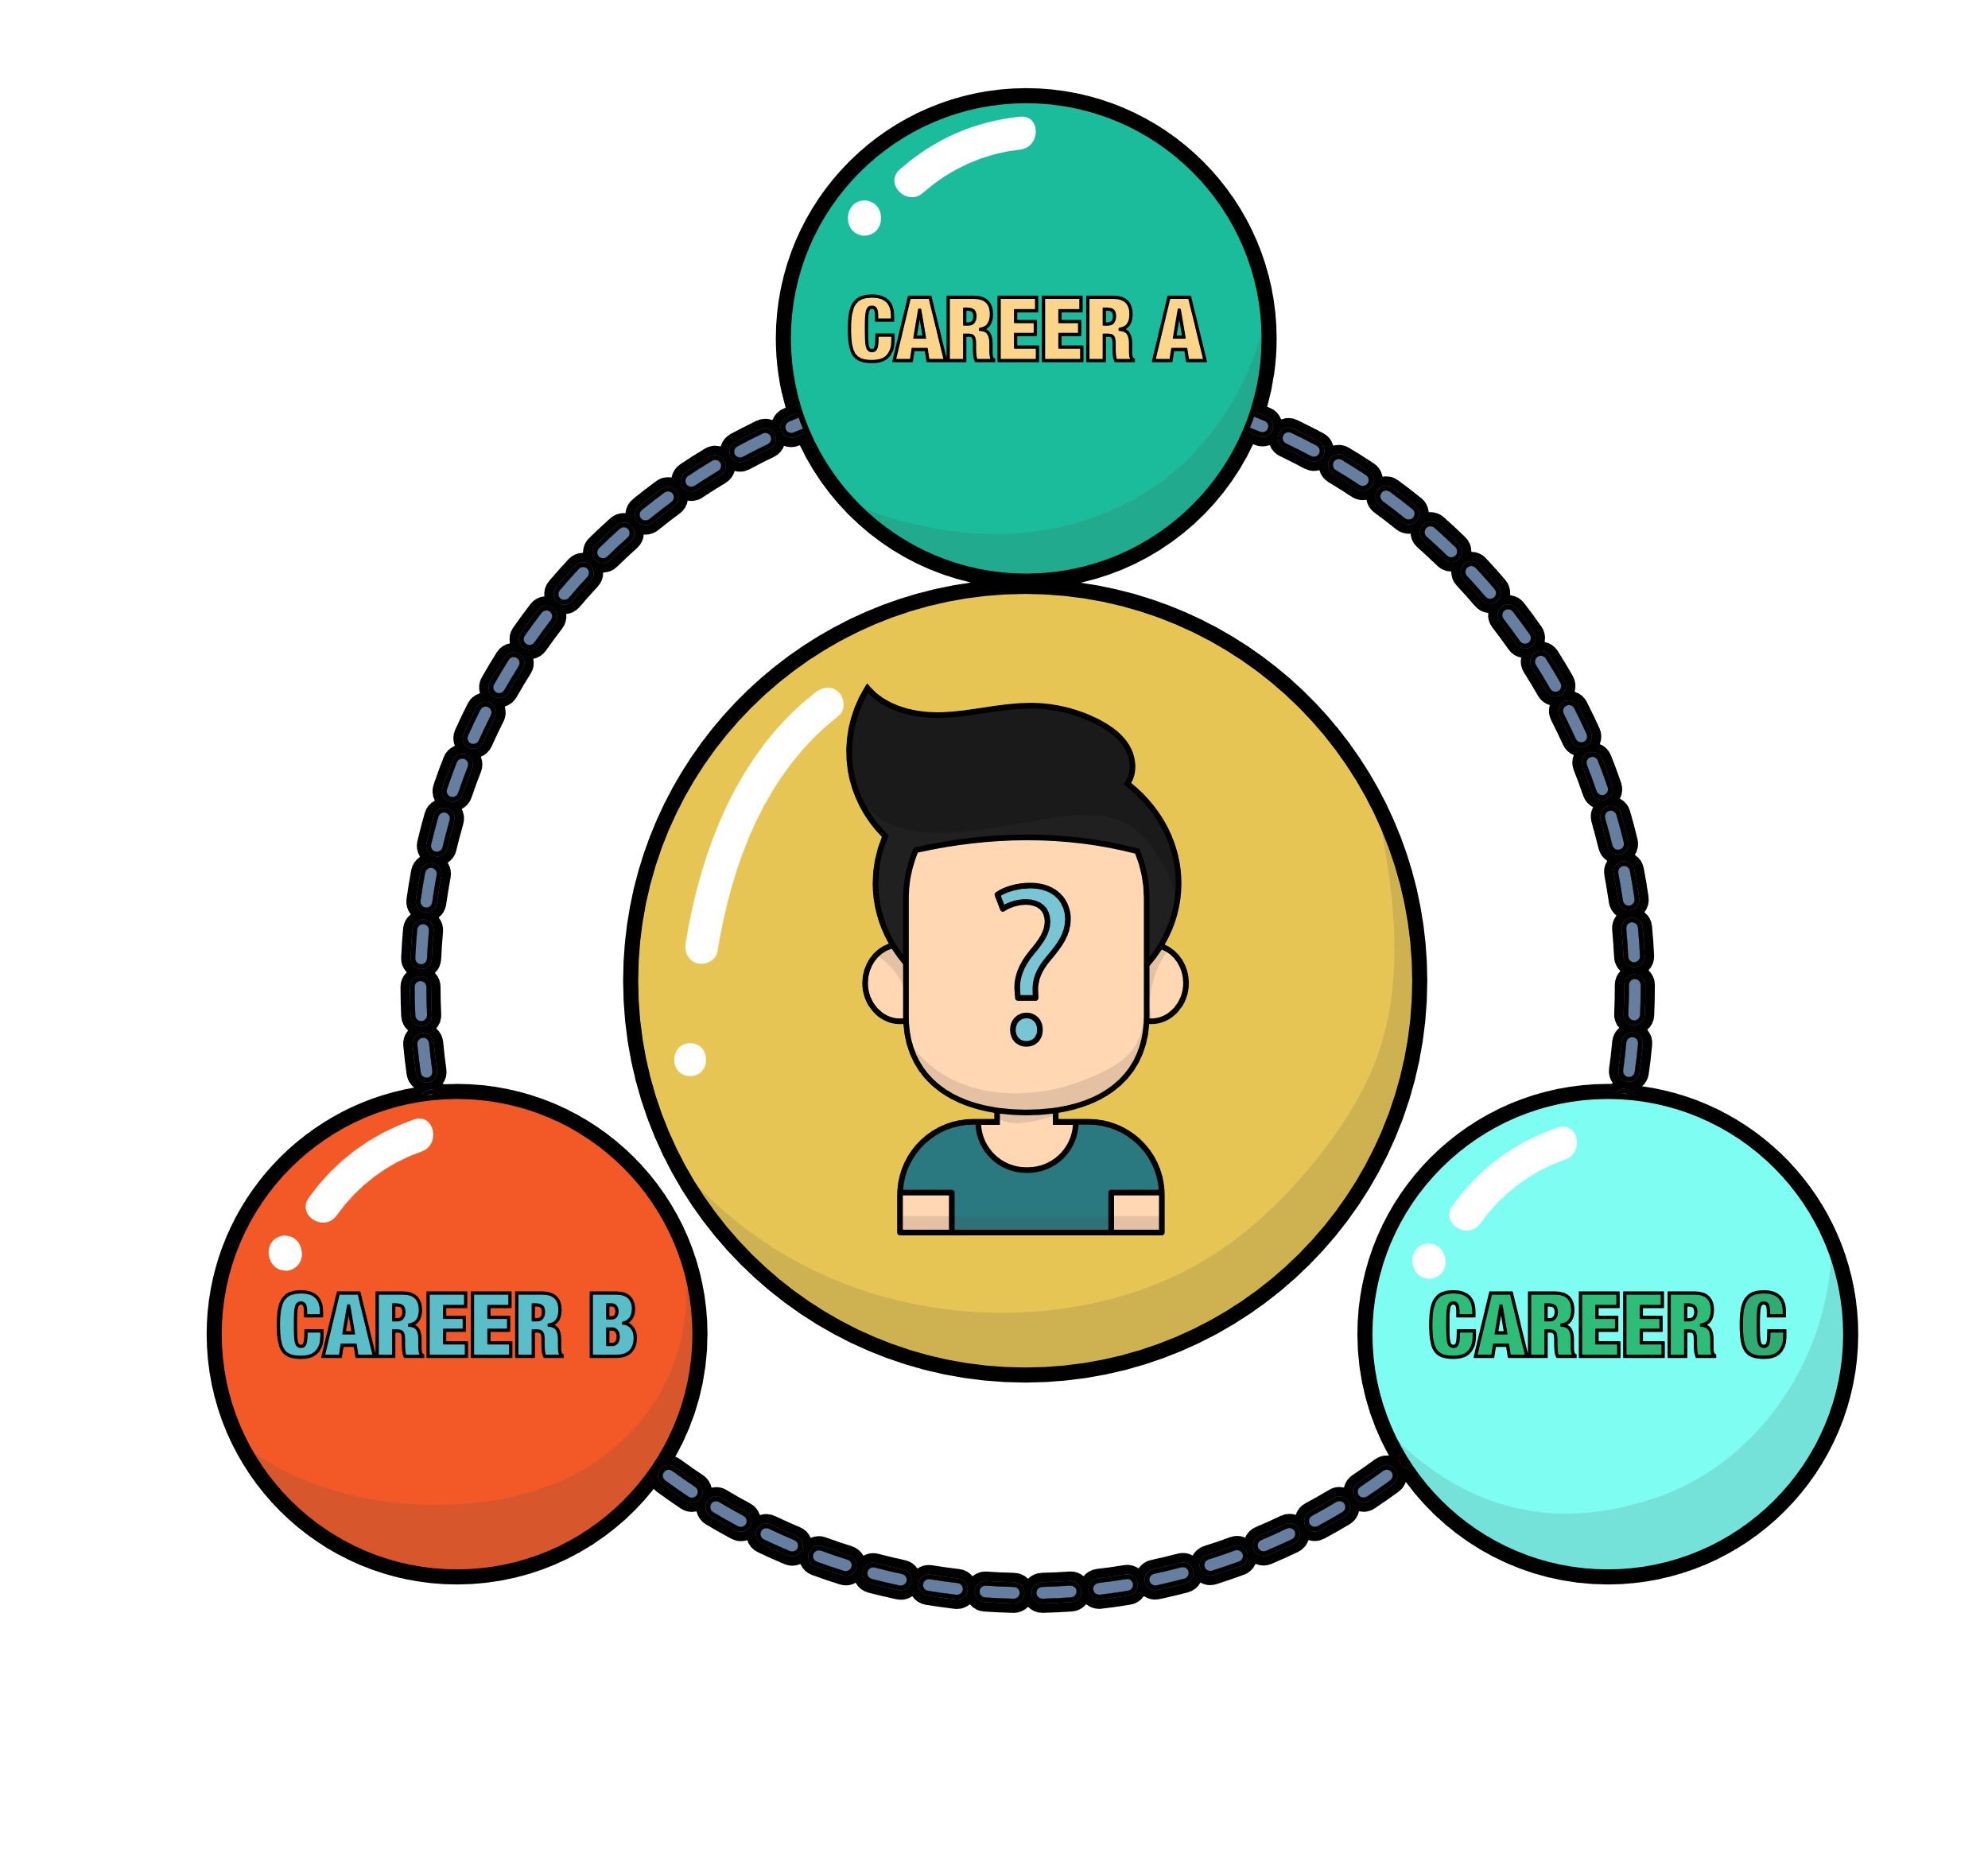
- What is your next step to prepare for a future career?

