Animal Bio Health Celebration

Directions:
Animal health is important in day-to-day animal operations and for companion animals. Watch the video, Merck Animal Health (https://vimeo.com/447509468), and complete the following activities.

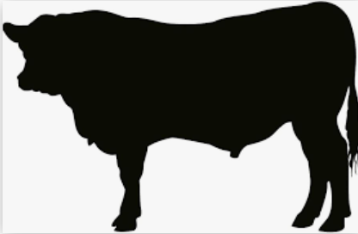
- What are some of the best biosecurity practices for shows? Identify 7 practices.

2. What has been the impact of COVID-19 on the animal health industry?

3. How is Merck Animal Health working with partners to help with animal bio health? Identify 4 ways.

5. What are some tips for those starting out with animal bio health with their animals?

6. What stress might show animals (animals in fairs, livestock shows, etc.) experience, and how will it affect the overall health of the animal?

4. How does animal bio health impact you and your friends and/or family?

7. Using AgExplorer, identify three careers (besides a veterinarian) that are directly related to animal health.

(1)

(2)

(3)

