Substitute Teacher Guide Vocabulary Activities
Created: 03/2025 by the National FFA Organization
These activities can be used with any vocabulary list. Each of the Substitute Teacher Guides has a list of terms that can be used with these activities while you are out of your classroom.

Vocabulary Activities:

- Short Story Vocabulary Activity
Students will choose 10 words from the list you provide and create a short story using all those words. They will then pick one word from their story and create an illustration for that word.
- Visual Dictionary Vocabulary Activity
Students will choose 10 words from the list you provide and define each term by drawing a picture-only, no-words, definition.
- Hexagonal Thinking Vocabulary Activity
Students will choose 10 words from the list you provide and use the hexagonal thinking graphic organizers to make connections between their selected terms and other words/ideas they are familiar with.

- Trading Card Vocabulary Activity
Students will partner up, and each will choose six words from the list you provide. They will create trading cards for their six words, “trade” them with their partners, and collect the information from each other so they both have the information for all 12 words recorded.

- Crossword Vocabulary Activity
Students will choose 10 to 15 of the vocabulary words from the list you provide and create a crossword puzzle using the word definitions as clues. Once they have completed the crossword, they will exchange crossword puzzles with a classmate and solve them. The creator can then “grade” the crossword.
- Acrostic Vocabulary Activity
Students will choose 10 words from the list you provide and create acrostics for them using related words and/or synonyms.

- Graffiti Word Wall Vocabulary Activity
Students will choose 10 words from the list you provide. For each word, they will write it in a graffiti style across the center of the piece of paper and then complete each corner of the Frayer model: a definition in one corner (and/or a synonym), antonyms in another, a sentence highlighting the word’s meaning in the third corner and an illustration showing the word’s meaning in the fourth.
- Vocabulary Checkers Activity
Students will fill out the Vocabulary Checkers gameboard with words from the list you provide. They will then partner up and play checkers with their partners. To make a move, they have to say a sentence using the vocabulary word on the space to which they want to move.

Short Story Vocabulary Activity
Part 1
Directions:
Choose 10 of the vocabulary words from the list provided by your teacher and create a short story. Please underline or bold the vocabulary words used throughout your story. Be creative and have fun! You may add additional pages as necessary.

Part 2
Directions:
Review your short story and select one vocabulary word that you used. In the space below, create an illustration of that vocabulary word.

Vocabulary word illustrated: ___________________________________________________________________________________________
Definition: _____________________________________________________________________________________________________________
________________________________________________________________________________________________________________________

Visual Dictionary Vocabulary Activity
Directions:
Choose 10 of the vocabulary words from the list provided by your teacher and define each by drawing a picture.
Vocabulary Word:
Picture:
Vocabulary Word:
Picture:
Vocabulary Word:
Picture:
Vocabulary Word:
Picture:
Vocabulary Word:
Picture:
Vocabulary Word:
Picture:
Vocabulary Word:
Picture:
Vocabulary Word:
Picture:

Vocabulary Word:
Picture:
Vocabulary Word:
Picture:

Hexagonal Thinking Vocabulary Activity
Directions:
Choose 10 of the vocabulary words from the list provided by your teacher and complete the hexagonal thinking organizers below. Write each word you’ve chosen in the center of one of the hexagonal thinking organizers, then in the outer hexagons, write words or phrases that are related to the word in the center. See the example below.
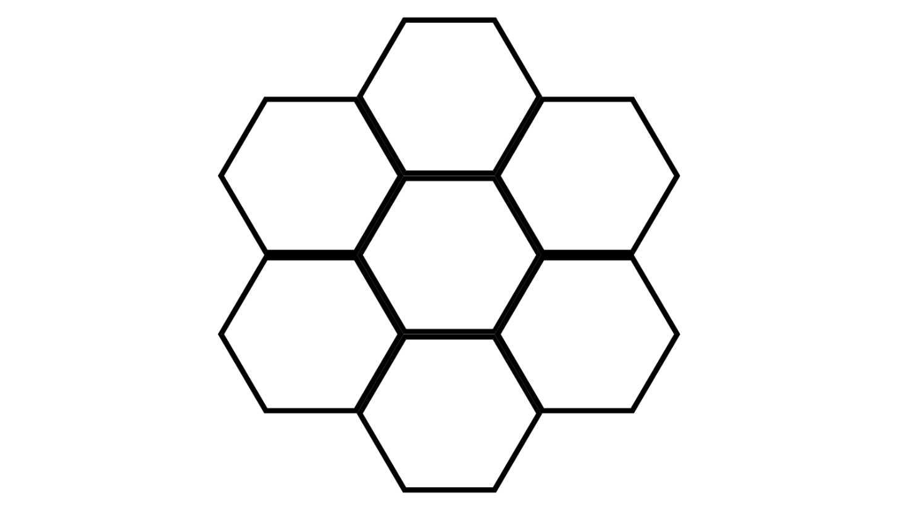
FFA
Agricultural Education
Blue Jackets
Leadership
Career Success
Youth in Agriculture
Plants and Animals
Example:

Trading Card Vocabulary Activity
Part 1
Directions:
Find a partner. Each of you will choose six of the vocabulary words from the list provided by your teacher and create trading cards for them using the templates below. (Ensure you and your partner are choosing different words.)

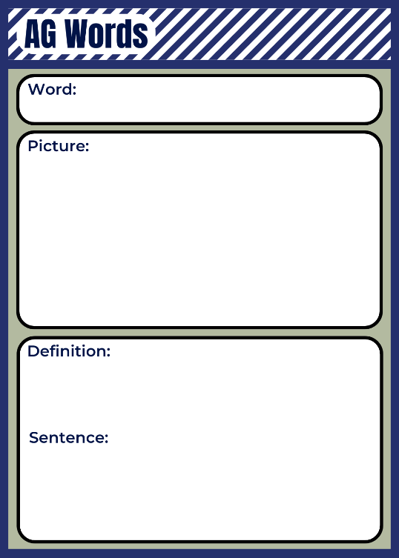

Part 2
Directions:
“Trade” your cards with your partner and review the information they collected for their words and record them below. Share your cards with them so they can record the information you found.

Partner’s Name: _________________________________________________________________

Crossword Vocabulary Activity
Directions:
Choose 10 to 15 of the vocabulary words from the list provided by your teacher and create a crossword puzzle (you can use the back of the page for more clues if needed). Use the vocabulary word definitions as clues. Once you have completed the crossword, exchange crossword puzzles with a classmate and solve it. The creator can then “grade” the crossword.

Acrostic Vocabulary Activity
Directions:
Choose 10 of the vocabulary words from the list provided by your teacher and create acrostics for them in the boxes below using related words and/or synonyms. See the example below.
Awareness
Growth
Resilience
Innovation
Cultivation
Understanding
Land
Tradition
Utilization
Renewal
Environment

Choose one of your acrostics from above and create a version of it on a full-sized sheet of paper; add color and visuals.

Graffiti Word Wall Vocabulary Activity
Directions:
Choose 10 words from the vocabulary provided by your teacher. For each word, write it in a graffiti style across the center of the piece of paper and then complete each corner of the graphic organizer: a definition in one corner, antonyms in another, a sentence highlighting the word’s meaning in the third corner and an illustration showing the word’s meaning in the fourth.

Illustration:
Antonyms:
Sentence:
Definition:

Illustration:
Sentence:
Antonyms:
Definition:

Illustration:
Sentence:
Antonyms:
Definition:

Illustration:
Sentence:
Antonyms:
Definition:

Illustration:
Sentence:
Antonyms:
Definition:

Illustration:
Sentence:
Antonyms:
Definition:

Illustration:
Sentence:
Antonyms:
Definition:

Illustration:
Sentence:
Antonyms:
Definition:

Sentence:
Illustration:
Antonyms:
Definition:

Sentence:
Illustration:
Antonyms:
Definition:

Vocabulary Checkers Activity
Directions:
Fill out the shaded spaces on the Vocabulary Checkers gameboard below with words from the list provided by your teacher. Then partner up and play checkers with another student (use anything you have available for the checkers pieces as long as you can tell the two sides apart from each other). To make a move, you have to say a sentence using the vocabulary word on the space to which you want to move. Likewise, if a player wants to “double jump,” the player must use both vocabulary words in the same sentence. If a word is used incorrectly, the move cannot be made, and you lose a turn. When finished, play again using your partner’s checkerboard.

